Acadia Junior High
Grade Seven Math Exam Review
2012

Name: ___________________

The following review is designed to help you prepare for the final exam. Multiple choice answers can be done in the booklet, but the short answer and problem sections should be done on a separate piece of paper and you must be sure to show your thinking.

Divisibility Rules

A-1 Students will be able to use the divisibility rules for 2, 3, 4, 5, 6, 8, 9, 10.
1. Complete the following chart without using a calculator. Put a √ in the boxes where the divisibility rule works, and leave the other boxes blank.

 | 2 | 3 | 4 | 5 | 6 | 8 | 9 | 10
314
7323
624
360

2. Which numbers can be placed in the blanks to make each statement true?
a) 41__ is divisible by 6
b) 3__21 is divisible by 9
c) 48___ is divisible by 8
d) 2___ 8 is divisible by 8 and 9

3. James has 681 trees to plant. He wants to put the same number of trees in each row with no extra trees. How many rows could James make? Could James make 9 rows? Using divisibility rules, explain how you know.

4. A farmer picked 126 peaches and he has 6 large baskets. Will he be able put the same number of peaches in each basket and have no peaches left over? Explain your answer using divisibility rules.

5. What are the first three numbers that are divisible by 4,6,and 8. Show your thinking.

Operations on Decimal Numbers

A-2: Students will be able to add, subtract, multiply and divide decimals and to solve problems using these operations.

Multiple Choice

____ 1. Identify the correct answer for the following calculation.
68.37 + 75.94 =
a. | 133.21 | b. | 143.64 | c. | 144.31 | d. | 158.31

____ 2. What is the correct answer?
37.6 + 86.93 =
a. | 113.99 | b. | 114.99 | c. | 123.53 | d. | 124.53
____ 3. Choose the best answer.
827.94 - 95.63 =
a. | 8112.57 | b. | 923.57 | c. | 732.31 | d. | 872.31

____ 4. Identify the correct answer for the following calculation.
739.4 – 95.68 =
a. | 217.4 | b. | 643.72 | c. | 655.72 | d. | 835.08

____ 5. What is the correct answer?
8.23 X 3.6 =
a. | 296.28 | b. | 29.628 | c. | 7.409 | d. | 0.7409

____ 6. Which answer is correct?
57.1 X 0.45 =
a. | 256.95 | b. | 228.45 | c. | 25.695 | d. | 22.845

____ 7. Choose the correct answer.
5.06 X 3.8 =
a. | 15.048 | b. | 15.48 | c. | 19.228 | d. | 19.28

____ 8. Select the correct answer.
101.13 ÷ 0.3 =
a. | 0.003 | b. | 33.71 | c. | 337.1 | d. | 3.371

____ 9. Which answer is correct?
0.284 ÷ 0.4 =
a. | 7.1 | b. | 0.71 | c. | 0.071 | d. | 0.0071

____ 10. Choose the correct answer.
4.6 + 3.25 X 0.7 =
a. | 5.495 | b. | 25.97 | c. | 6.875 | d. | 6.84

Short Answer
11. Identify the missing number in the following calculation. Show how you found the missing number.

87.9 + _______ = 123.54

12. What is the missing number in the following calculation? Show how you found the missing number.

89.34 – _______ = 51.7

13. Identify the missing number in the following calculation. Show your work.

_______ + 521.36 = 794.85

14. Calculate the missing number in the following calculation, showing how you found the missing number.
_______ – 97.17 = 137.43
15. Magic markers are $0.76 each or $5.69 for a box of 8 markers. Is it cheaper to buy 8 individual markers or a box of 8 markers? How much money would you save buying the markers by means of the cheaper method?

16. A bag has a mass of 3.85 g and contains 75 g of chips. The box in which the chips are shipped has a mass of 652.57 g and holds 24 bags of chips. What would be the mass of a full box of bags of chips?

17. School dance tickets sell for $5.50 each or $4.75 with a can of food for charity. The school sold 87 regular tickets and 153 tickets with a can of food. How much money was collected from the sale of dance tickets?

18. Add brackets to make the following statement true.

80 ÷ 0.4 + 6 X 0.3 = 3.75

19. Where should brackets be placed to make the following statement true?

80 ÷ 0.4 + 6 X 0.3 = 201.8

Problems

21. Kevin travelled 1105.7 km from Prince Rupert to Jasper, 360.4 km from Jasper to Edmonton, and 247.8 km from Edmonton to Lloydminster. Kevin then travelled 201.6 km back toward Edmonton. How far is Kevin from Prince Rupert?

22. A tree branch is cut into five pieces with lengths of 36.7 cm, 32.4 cm, 28.9 cm, 29.6 cm, and 31.5 cm. If you allow 1.24 cm for the lost cut material, how long was the branch?

23. Jen starts her shopping with a $50 bill but must keep $9.85, which she owes to her mother. She purchases a sweater for $21.67. How much money does she have available now for shopping?

24. You have partially finished drinking four bottles of water. Bottle A still has 0.17 L left, bottle B still has 0.12 L left, bottle C still has 0.3 L left, and bottle D still has 0.22 L left. You pour all of the water into the 1 L bottle you use on your bike. How much water will be in the bike bottle?

25. You have 0.145 kg of nacho chips, 0.280 kg of ketchup chips, 0.195 kg of cheezies, and 0.210 kg of nuts left in their bags. How much more snack food do you need to create a bowl of 1.0 kg of the mixed snacks?

26. Four pieces of wooden walkway are 0.89 m, 1.23 m, 2.1 m, and 0.91 m in length respectively. The pieces of wood are laid end to end across a muddy section in the school yard. The muddy section measures 4.37 m across. The walkway is placed so that there is exactly the same amount of walkway on each side of the mud. How much of the walkway will be out of the mud on each side of the mud?

27. NHL hockey crests are each 7.62 cm across. You are asked to mount them in rows on a display board so that there are 2.54 cm between each crest and the one next to it in a row. You are to leave 3.81 cm at each end of each row on the display board. How wide must the display board be to display 5 crests in a row?

28. The section of a belt where the holes are to be punched is 20 cm long. The holes must be placed 2.8 cm apart with the first hole being 2.8 cm from the end of the belt. What is the greatest number of holes that will fit in the space available?

29. Four packages of candy with masses of 275 g, 158 g, 200 g, and 225 g are used to fill party bags. Each filled party bag will have a mass of 71.5 g. How many party bags can be filled from the available candy?

30. Mannia and Sue each bought 2 CDs. One CD cost $10.16, while the second one cost $14.68. Eric, Brian, Sara, and Melody each bought 2 CDs for $20.33 each and a third one for $7.88.
a) Write an expression that can be used to calculate how much they spent altogether.
b) How much did the group spend altogether?
c) What was the average price of a CD bought by the group?

Fractions, Decimals, Percents

A-3: Students will be able to solve problems involving percent from 1% to 100%.
A-5: Students will be able to convert between repeating decimals and fractions, and between terminating decimals and fractions.
A-6: Students will be able to compare and order fractions, decimals, integers and percent.
Multiple Choice
____ 1. Which fraction is the equivalent of 0.65?
a. | 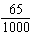 | b. |  | c. |  | d.

____ 2. Which fraction is greater than ?
a. |  | b. |  | c. |  | d.

____ 3. Write 0.75 as a fraction.
a. |  | b. |  | c. |  | d.

____ 4. Which fraction is smaller than 0.28?
a. |  | b. |  | c. |  | d.

____ 5. Which fraction is the same as 12%?
a. |  | b. |  | c. |  | d.

____ 6. Which fraction can be written as 18%?
a. |  | b. |  | c. |  | d. | 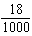

____ 7. Which fraction can be written as a percent greater than 68%?
a. |  | b. |  | c. |  | d.
____ 8. Which of the following shows two different ways of writing ?
a. | 0.03, 3% | b. | 0.3, 3% | c. | 0.03, 30% | d. | 0.3, 30%

____ 9. Batting averages (such as 0.475) can also be expressed as fractions out of _____.
a. | 10 | b. | 100 | c. | 1000 | d. | 10 000

Short Answer

10. Write three fractions that are equivalent to 0.75.

11. Write three fractions that are equivalent to $0.3$ .

12. Order these fractions from least to greatest.
$\frac{3}{5}$ $\frac{6}{8}$ $\frac{1}{2}$ $\frac{5}{12}$ $\frac{4}{6}$

13. Write three fractions that are equivalent to $0.6$
14. What are the decimal and percent equivalents of ?
15. Order these fractions from least to greatest. Explain your strategy.
16. Write each fraction as a percent.
a)
b)
c)
d)

17. Write each fraction as a percent. Round your answer to one decimal place.
a)
b)
c)
d)
18. Write each percent as a fraction.
a) 32%
b) 55%
c) 60%
d) 80%

19. Calculate 25% of each amount.
a) $20.00
b) $60.00
c) $50.00
d) $10.00

20. Calculate 75% of each amount.
a) $40.00
b) $80.00
c) $60.00
d) $5.00

21. Write each percent as a decimal.
a) 56%
b) 12.5%
c) 0.5%
d) 36.75%

22. Write each fraction as a decimal. Then, write the decimal as a percent.
a)
b)
c)
d)

23. Calculate 55% of each measurement.
a) 200 g
b) 3 m
c) 50 mL
d) 10 cm²

24. Each mass given below represents 75% of the total mass. Calculate each total mass.
a) 60 g
b) 90.75 g
c) 141 g
d) 1.2 g

Problems

25. A pizza cut into 16 equal slices is sold for fundraising. Kim buys 8 slices, Paul buys 4 slices, and Anita buys 2 slices.
a) Write a fraction to represent the portion of the pizza that each person buys. Draw a diagram to represent each fraction.
b) Write each fraction in a) as a decimal.
c) Write each decimal in b) as a percent.

26. Dax opens a new box of chocolates. There are a total of 60 pieces inside: 30% are white chocolate, 60% are milk chocolate, and 10% are dark chocolate. Dax eats 2 pieces each of white chocolate, milk chocolate, and dark chocolate. How many pieces of each type are left in the box?

27. Carolyn took a survey of her class to find out what types of music the students like. Her survey showed that 12 students like pop music, 6 like rock, 3 like jazz, and 9 like rap.
a) How many other students are there in Carolyn’s class?
b) Write a fraction to represent the number of students that like each type of music.
c) Write each fraction in b) as a decimal.
d) What percent of the students like each type of music?

28. Eja is going to save 25% of his allowance each month for a new bicycle. His allowance each month is $40.00, and the bicycle costs $120.00.
a) How much will Eja save each month?
b) How many months will it take for Eja to have enough money to buy the bicycle?
c) Suppose Eja wants to have his bicycle after only six months. What percent of his allowance should he save?
d) Suppose Eja saves 75% of his allowance each month. How long will it take him to save enough money to buy the bicycle?

29. Greg’s backyard measures 30 m by 30 m. He wants to build a small tennis court that measures 20 m by 15 m. What percent of Greg’s backyard will be used for the tennis court?
(Area = Length X Width)

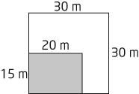

30. The area of a park is 60 m², and 15% of it is planted with flowers. What area of the park, in m², is planted with flowers?

31. Ariel has a 70 g package of chips. If she gives 95% to her friends, how many grams of chips does she save for herself?

Fraction Introduction

A-4: Students will be able to add and subtract fractions and mixed numbers

Multiple Choice
____ 1. What is the greatest common factor of 16 and 24?
a. | 16 | b. | 12 | c. | 8 | d. | 4

____ 2. In lowest terms, what is the sum of the addition statement represented by the following diagram?

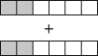
a. |  | b. |  | c. |  | d.

____ 3. What statement does this diagram represent?

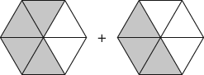
a. | 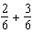 | b. | 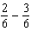 | c. | 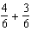 | d. | 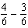

____ 4. What subtraction statement is represented by the diagram?

a. |  | b. |  | c. |  | d.

____ 5. Which fraction is equivalent to ?
a. |  | b. |  | c. |  | d.

____ 6. Which fraction is equivalent to ?
a. |  | b. |  | c. |  | d.

____ 7. Which fraction is equivalent to ?
a. |  | b. |  | c. |  | d.

____ 8. Solve - .
a. |  | b. |  | c. |  | d.

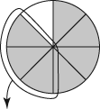

____ 9. Solve the subtraction statement shown in the diagram. What is the answer in lowest terms?
a. |  | b. |  | c. |  | d.

____ 10. What are the common factors of 6 and 24?
a. | 1, 2, 3, 6 | b. | 1, 2, 8 | c. | 1, 3, 12 | d. | 1, 6
Short Answer

11. Add each pair of fractions and give the answer in lowest terms.
a)
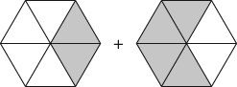
b)
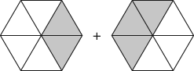

c)

12. Subtract each pair of fractions and give the answer in lowest terms.
a)
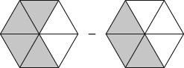

b)

c)
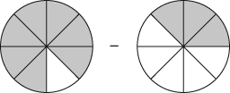
13. Write and solve an addition statement for each of the diagrams below.
a)

b)
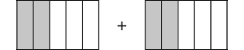

14. Write a subtraction statement for each diagram. Then, subtract. Write each answer in lowest terms.
a)
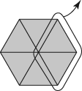

b)
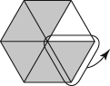

15. Write and solve a subtraction statement for each diagram.
a)
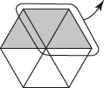

b)
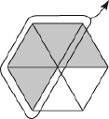

16. Write and solve an addition statement for each pair of figures. Express your answers in lowest terms.
a)
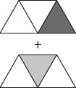

b)
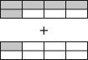

c)
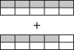

17. Evaluate each expression. Show your answers in lowest terms.

a)
b)
c) +

18. Evaluate the following and express your answers in lowest terms.

a) 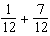

b)

c) 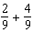

19. Write an addition statement for each pair of diagrams, then add. Express your answers in lowest terms.

a)
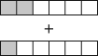

b)
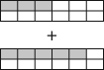

c)
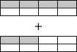

d)
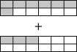

20. Write and solve each subtraction statement shown. Express your answers in lowest terms.
a)
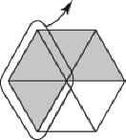
b)
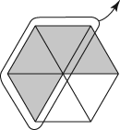
c)

Problems
21. Ms. Lohan’s art class has decided to put some money together to buy painting supplies for her birthday. The items they purchased and the total cost for each are as follows:
brushes | $15.00 | canvas boards | $35.00
sketchpads | $10.00 | sketch pencils | $5.00

a) What is the total cost of the painting supplies?
b) Write a fraction to represent the cost of each item out of the total cost. Write each fraction in lowest terms.

22. A sports store puts all of its bicycles on sale. There are 8 blue bicycles, 10 red, 6 green, 5 orange, 3 black, and 3 silver.
a) How many bicycles are on sale?
b) For each colour of bicycle, write a fraction to represent the number out of the total. Write each fraction in lowest terms.

23. Lauralee runs a pet daycare every weekend. This weekend, she looked after 6 dogs, 3 rabbits, 7 cats, and 2 hamsters. By Sunday evening, 2 dogs, 3 rabbits, 2 cats, and 1 hamster had been picked up.
a) How many pets were given to Lauralee to watch this weekend?
b) Write a fraction expressing each type of pet as a fraction of the total number of pets.
c) What fraction of the pets remained on Sunday evening? Show your thinking.

24. From a box of 28 candy bars, Adam takes 6 candy bars, Ben takes 11, and Candice takes 8.
a) Write an addition statement to find what fraction of the box has been taken.
b) How many candy bars are left in the box?

25. Write a fraction, in lowest terms, to represent each situation.
a) 12 marbles out of a bag of 36
b) 3 markers out of a box of 30
c) 10 sheets of paper used out of a pack of 200
d) 3 slices of pizza out of 12

26. Melanie took 5 red pens from a pack of 15 and 6 blue pens from a pack of 12 for her drawing class. Write a statement to describe what fraction of the red pack and blue pack Melanie took. Express your answer in lowest terms.

27. Kevin took 14 chocolate chip cookies from a bag of 20 and 12 oatmeal cookies from a bag of 30. Write a statement to describe the fraction of each bag of cookies that Kevin took. Express your answer in lowest terms.

28. Audrey works at a buffet restaurant. She began the Sunday brunch by cutting 10 sandwiches into quarters. She placed the sandwiches on a tray at the buffet table. In the first hour, 35 pieces were removed from the tray.
a) How many sandwich pieces did Audrey make?
b) In lowest terms, what fraction of sandwiches was taken from the tray during the first hour?
c) Calculate the fraction of sandwiches left in the tray after the first hour.
Fraction Addition & Subtraction
A-4: Students will be able to add and subtract fractions and mixed numbers

Multiple Choice
____ 1. What is the sum, in lowest terms, of the fractions shown by the shaded parts of the figure?

a. |  | b. |  | c. |  | d.

____ 2. What is as an improper fraction?
a. |  | b. |  | c. |  | d.

____ 3. Express as an improper fraction.
a. |  | b. |  | c. |  | d.

____ 4. Which option represents the result of 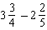?
a. |  | b. |  | c. |  | d.

____ 5. The equation that best represents the sum of the shaded areas in the following diagram is

a. | 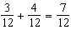 | c. | 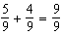
b. | 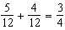 | d. | 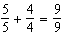

____ 6. Which equation best represents the sum of the shaded parts of the figures below?

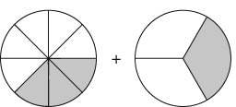
a. | 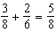 | c. | 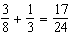
b. | 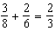 | d. | 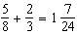

____ 7. Identify the equation that best represents the addition of the shaded parts of the figures below.
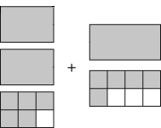

a. | 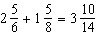 | c. | 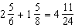
b. | 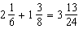 | d. | 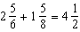

____ 8. Calculate 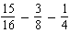 and express the answer in lowest terms.
a. |  | b. |  | c. |  | d.

____ 9. What is 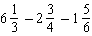, expressed in lowest terms?
a. |  | b. |  | c. |  | d.

____ 10. Express the solution for 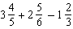 in lowest terms.
a. |  | b. |  | c. |  | d.

Short Answer
11. Create an addition question using two proper fractions, in lowest terms, with different denominators. The solution must be . Show your thinking

12. Create an addition question using two proper fractions, in lowest terms, with different denominators. The solution must be .

13. Write an addition question using two proper fractions, in lowest terms, with different denominators. The solution must be .

14. Calculate 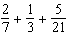. Express your answer in lowest terms.

15. Evaluate 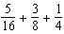 and express your answer in lowest terms.
16. What is the answer to 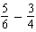, expressed in lowest terms?
17. Calculate 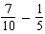, then express your answer in lowest terms.
18. Evaluate 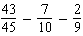. Express your answer in lowest terms.
19. What is the answer to 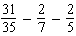? Express your answer in lowest terms.
20. Calculate the answer to 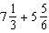.

Problems

21. Indira brought 3 tuna sandwiches to school for lunch. She cut each sandwich into 3 pieces. Indira met her friend, Amy, for lunch. Amy had 3 jelly sandwiches, each cut into 2 pieces. Indira traded 5 pieces of her tuna sandwiches for 3 pieces of Amy’s jelly sandwiches.

a) What is the fraction of tuna sandwiches Indira traded away?
b) What is the fraction of jelly sandwiches she got in return from Amy?
c) Write an expression to represent the fraction of sandwiches Indira started with, minus what she gave to Amy, and plus what she got in return. Evaluate the expression and express the answer in lowest terms.
d) Write an expression to represent the fraction of sandwiches Amy started with, minus what she gave to Indira, and plus what she got in return. Evaluate the expression and express the answer in lowest terms.

22. Warren’s father mowed of the lawn. Warren mowed of the lawn. Warren’s younger brother finished mowing the rest of the lawn.

A What is the fraction of the total lawn that Warren’s father did not mow?
b) What is the fraction of the total lawn that Warren’s brother mowed?.

23. Kristina brought a box of chocolates to school to share with her friends. The box had 36 pieces of chocolate. Kristina ate of the chocolates herself, gave of them to her friend June, and gave to her friend Ashley. She gave the remainder of the box to her teacher. What fraction of the chocolates did Kristina give to her teacher? Express your answer in lowest terms.

24. Jake and Billy are working together to weed a garden. Jake weeded of the garden, and Billy weeded .
a) How much of the garden have they weeded?
b) How much of the garden do they still have to weed?

25. Jamal was eating leftovers from a party. There was of a pizza left on a tray. He ate of a whole pizza. How much was left on the tray?

26. Write an expression to represent the addition of the shaded parts of the figures below and express the solution in lowest terms.
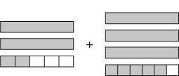

27. Write an expression to show the subtraction of the shaded parts of the figures on the right from the shaded parts of the figures on the left and express the solution in its lowest terms.
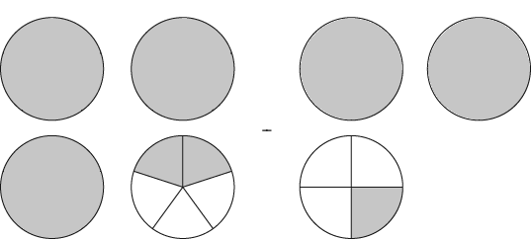

28. Yuri has barrels of water for his cattle. The cattle drink barrels. How much water does Yuri have left?

29. Brian does weight training for 2 h each school day. He does h of training each morning before school, and he does the rest after school. How many hours of training does he do after school?

30. Sara ran laps of the track during gym class. Bev ran laps during the same time. Who covered more distance, and by how much?

Integer Addition & Subtraction

B-1: Students will be able to add and subtract integers.

Multiple Choice
____ 1. (+5) + (–6) = –1 is an example of
a. | an addition statement | c. | a subtraction statement
b. | opposite integers | d. | a zero pair

____ 2. Opposite integers are any two integers
a. | where one can be divided by the other.
b. | with different numerals but the same signs.
c. | with opposite signs.
d. | with the same numerals but opposite signs.

____ 3. The sum of a positive integer and a negative integer
a. | can be greater than or less than zero.
b. | is always greater than zero.
c. | is always less than zero.
d. | is always zero.

____ 4. When a positive integer is subtracted from a negative integer, the difference is
a. | always a negative integer. | c. | either positive or negative.
b. | always a positive integer. | d. | zero.

____ 5. When a negative integer is subtracted from a positive integer, the difference is

a. | always a negative integer. | c. | either positive or negative.
b. | always a positive integer. | d. | zero.

____ 6. When a negative integer is subtracted from a negative integer, the difference

a. | could be zero. | c. | is always a negative integer.
b. | could not be zero. | d. | is always a positive integer.

____ 7. On a horizontal number line, +4 _____ +1.
a. | is closer to zero than
b. | is farther left than
c. | is farther right than
d. | is on a different number line than

____ 8. The integer sum shown by the arrows above the number line is
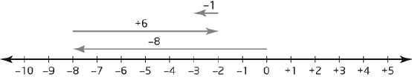
a. | –8 | b. | –3 | c. | –2 | d. | –1

____ 9. The integer sum shown by the arrows above the number line is

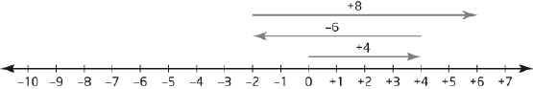
a. | –2. | b. | +4. | c. | +6. | d. | +8.

____ 10. The answer to (+5) – (+5) is
a. | +10 | b. | +5 | c. | 0 | d. | –5

Short Answer

11. Write the opposite integer for each of the following integers.

a) +12
b) +1
c) –100
d) –66

12. Write a pair of integers to represent each situation.

a) 15 min before and 45 min after
b) 5 m taller and 1 m shorter
c) ground level and 13 m underground
d) earning $10 and spending $5

13. Interpret each group of integer chips. Write and solve the addition statement for each.

a)

b)

c)

14. For each set of integer chips, subtract the group on the right from the group on the left. Write the subtraction statement, and then solve.
a)

b)

c)

15. Write an addition statement for each number line and solve.

a)
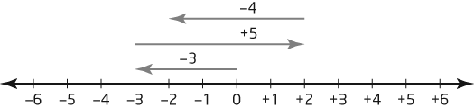

b)
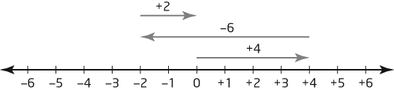

16. Draw a number line to show each addition statement. Identify each solution.

a) (–2) + (+1) + (–3)
b) (+3) + (–6) + (+5)

17. Solve each expression.

a) (–18) + (+56) + (–30)
b) (–10) – (–40) – (+52)
c) (–50) + (+35) + (+23) + (–20)

18. Calculate.

a) (–120) + (+120)
b) (+69) – (+17)
c) (–16) – (+82)
19. Calculate each sum.

a) (–5) + (–4) =
b) (+18) + (–8) =
c) 0 + (–9) =

20. Calculate each sum.

a) (–9) + (+13) + (–4) =
b) (+7) + (–6) + (–3) =
c) (–8) + (–1) + (+10) =

21. Solve each of the following.

a) (–2) – (–2) =
b) 0 – (–1) =
c) (+3) – (–6) =
d) (–3) – (+6) =

22. Solve each of the following.

a) (–3) – (+4) – (–3) =
b) (+7) – (–7) – (+1) =
c) (+5) – (–6) – (–8) =
d) (–9) – (–4) – (+2) =

Problems

23. Maria burned 400 calories jogging in the morning. At lunch she ate two slices of pizza, which provided 700 calories. Write and solve an addition statement to show her calorie balance.

24. Jeb received $35 on his birthday. He spent $14 on a new CD and $12 on a new shirt. Write and solve an addition statement to determine how much money Jeb has left.

25. Hilary filled her water bottle with 750 mL of water. She drank 425 mL during lunch and 225 mL during afternoon break. Write and solve an addition statement to determine how much water is left in Hilary’s bottle.

26. What addition statement does each diagram represent? Write and solve each statement.

a)
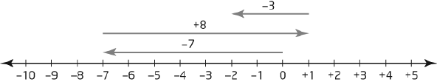

b)
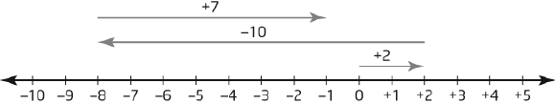

27. Ellen wants to go on a vacation with her family. She researches several cities and finds the following average temperatures for the upcoming week: Calgary –3ºC, Edmonton 1ºC, Vancouver 8ºC, and Victoria 7ºC.

a) What is the difference in temperatures between Victoria and Edmonton?
b) What is the difference in temperatures between Vancouver and Calgary?

28. One January day in Edmonton, a chinook raised the temperature from –16ºC to +12ºC. What was the change in temperature? Show your thinking.

29. Kate entered the lobby of a building and got on the elevator. She went up 16 floors to drop off a package for her father and then came down 6 floors to meet a friend for lunch. Develop and solve an addition statement to determine the floor where Kate met her friend.

30. When Warren started stamp collecting, his aunt gave him 135 stamps. Looking through the box, Warren found 52 doubles and sent them back to his aunt. His uncle then gave Warren 24 stamps; none of them were doubles. How many stamps does Warren have now? Show your thinking using what you know about integers.

31. The temperature in Williams Lake at lunch time was –6°C. That night the temperature dropped to –23°C. Determine the change in temperature between lunch time and later that night.

32. Juan earned $62 last week and spent $14. This week he earned $75 and spent $30. Next week, Juan expects to make $50 and spend nothing. How miuch money will Juan have at the end of next week.

The Coordinate Plane

C-1: Students will be able to identify and plot ordered pairs on a Cartesian plane.
C-2 Students will be able to reflect, translate and rotate two dimensional shapes on a Cartesian plane.

Multiple Choice

____ 1. Which transformation is a slide along a straight line?
a. | translation | c. | reflection
b. | rotation | d. | image

____ 2. Which transformation(s) might a skier use?
a. | translation only | c. | rotation only
b. | translation and rotation | d. | reflection and translation

____ 3. What type of transformation is a flip over a mirror line?
a. | translation | c. | reflection
b. | rotation | d. | image

____ 4. What are the signs of the coordinates in quadrant III?
a. | (–, –) | c. | (+, –)
b. | (–, +) | d. | (+, +)

____ 5. What are the coordinates of the vertices of quadrilateral ABCD?

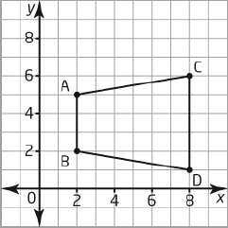

a. | A(5, 2), B(2, 2), C(6, 8), D(1, 8)
b. | A(2, 5), B(2, 2), C(8, 6), D(8, 1)
c. | A(2, –5), B(2, –2), C(8, –6), D(8, –1)
d. | A(–2, –5), B(–2, –2), C(–8, –6), D(–8, –1)

____ 6. What are the horizontal and vertical movements of point A to point C?
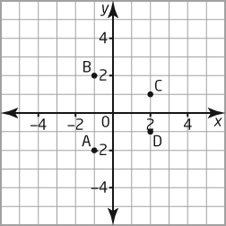

a. | 3 units right and 3 units up
b. | 3 units right and 3 units down
c. | 3 units left and 3 units up
d. | 3 units left and 3 units down
____ 7. In which quadrant is the point with coordinates (11, –6)?
a. | I | c. | III
b. | II | d. | IV

____ 8. In which quadrant is the point with coordinates (+3, +5)?
a. | I | c. | III
b. | II | d. | IV

____ 9. What are the coordinates of the vertices of quadrilateral ABCD?

a. | A(5, 2), B(2, 2), C(6, 8), D(1, 8)
b. | A(2, 5), B(2, 2), C(8, 6), D(8, 1)
c. | A(2, –5), B(2, –2), C(8, –6), D(8, –1)
d. | A(–2, –5), B(–2, –2), C(–8, –6), D(–8, –1)

____ 10.Which of the following most accurately describes a reflection?
a. | a mirror image | c. | a turn about a centre of rotation
b. | a slide along a straight line | d. | an enlargement or reduction

Short Answer

11. a) Plot the following points: (0, 6), (1, 5), (2, 4), (3, 3), (4, 2).

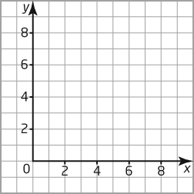

b) What pattern do the points create?

12. Use a 180º rotation to create an image of the arrow in the square provided.

13. Describe how a translation occurs. Give three everyday examples of items that move by translations.

14. ABC is translated 2 units left and 3 units down. Draw the translation image A'B'C'.

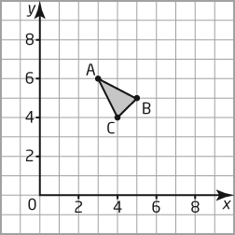

15. A figure has vertices at A(5, 2), B(5, 3), C(4, 3), D(4, 4) E(3, 4), F(3, 5), G( 2, 5), and H(2, 2). Draw the figure on the coordinate grid and join the points. Shade the figure and then identify it.
Draw a mirror line by joining the points (6, 6) and (6, 1). Draw the image of the figure after a reflection in the mirror line.

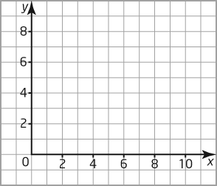

16. Plot the following points on a coordinate grid: (–3, –2), (–6, –3), (0, 3), (3, –2).

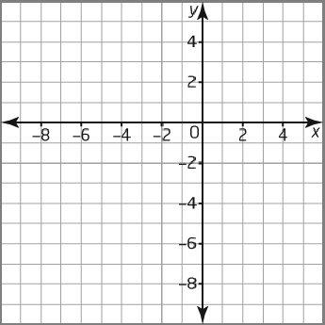

a) Which point seems out of place?
b) What shape do the other points create?

Problems
17. List five capital letters of the alphabet that have identical images after a reflection.

18. Plot the following coordinates on the grid provided. Join each set of points to create a figure, and then identify each figure.
Figure 1 has vertices at A (1, 1), B (1, 9), C (9, 9), and D (9, 1).
Figure 2 has vertices at E (1, 5), F (4, 6), G (5, 9), H (6, 6), I (9, 5), J (6, 4), K (5, 1), L (4, 4)

19. Use the following coordinate grid shown to do the following:
a) Rotate ABC 90º in a counterclockwise direction about centre of rotation C.
b) Translate A’B’C’ 3 units right and 3 units down.
c) What are the coordinates of B"?

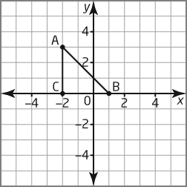

20. Use the coordinate grid shown to perform the following transformations:

a) Reflect ABC over the x-axis.
b) Translate A'B'C' 1 unit left and 4 units up.
c) What are the coordinates of the vertices of A"B"C"?

21. On the coordinate grid below, draw and label a triangle with vertices X (–6, 1), Y (–4, 5), and Z (–2, 1).

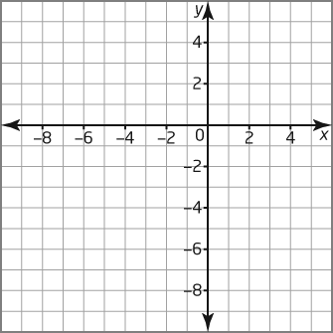

a) Draw X'Y'Z' after a reflection in the x-axis.

b) What are the coordinates of the vertices of X'Y'Z' ?
X'_____, Y'_____, Z'_____

c) Draw X"Y"Z" after a 180º clockwise rotation about Y'.

d) What are the coordinates of the vertices of X"Y"Z"?
X"_____, Y"_____, Z"___

Patterns & Expressions
D-1 Students will be able to continue and explain a pattern as a relation.
D-2 From a relation, students will be able to construct a table of values, then graph and analyze it.

Multiple Choice

____ 1. Ted is asked to look for a pattern in the numbers 17, 25, 33, 41, 49. Which mathematical operation does Ted have to use in order to determine the next number?
a. | addition | c. | multiplication
b. | division | d. | subtraction

____ 2. Start with the number 3, and add 9 repeatedly. What are the first five numbers in the pattern?
a. | 3, 12, 15, 18, 21 | c. | 3, 21, 54, 81, 102
b. | 3, 12, 21, 30, 39 | d. | 3, 27, 54, 81, 108

____ 3. What do you call a pattern formed by two sets of numbers?
a. | an expression
b. | a relationship
c. | a table of values
d. | a variable

____ 4. Which expression represents “a number increased by 12”?
a. | n + 12 | b. | n – 12 | c. | 12 + 2n | d. | 12 – 2n

____ 5. Which linear relation does this table of values represent?

x | y
2 | 2
3 | 3
4 | 4
5 | 5

a. | y = x | b. | y = x - 1 | c. | y = x + 1 | d. | y = 2x

____ 6. Which linear relation goes with this graph?

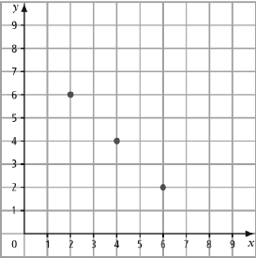

a. | y = 2x + 8 | b. | y = x + 8 | c. | y = x - 8 | d. | y = 8 – x

____ 7. Which linear relation goes with this table of values?

x | y
2 | 3
3 | 4
4 | 5
5 | 6

- y = x – 1 b. y = x + 1 c. y = x + 2 d. y = x - 2

_____ 8. Which graph represents the linear relation y = 2x + 1?

Graph A Graph B
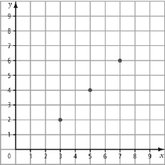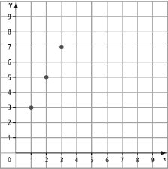
Graph C Graph D
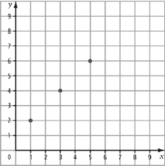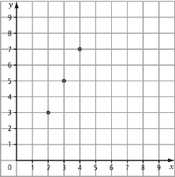

a. | Graph A | b. | Graph B | c. | Graph C | d. | Graph D

____ 9. Which table of values represents the linear relation y = 2x – 1

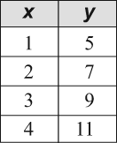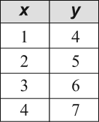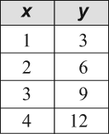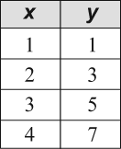

a. | Table A | b. | Table B | c. | Table C | d. | Table D
____ 10. Which graph represents the following table of values?

x | y
1 | 1
3 | 3
5 | 5
7 | 7

Graph A Graph C
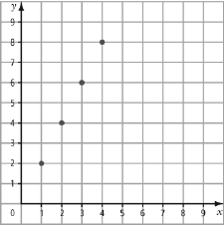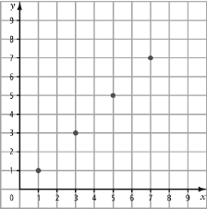

Graph B Graph D
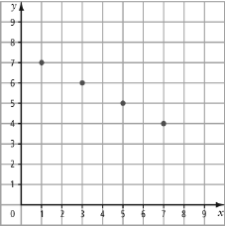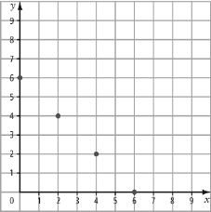

a. | Graph A | b. | Graph B | c. | Graph C | d. | Graph D

Short Answer

11. Identify the next term in each pattern.
a) 43, 47, 51, ...
b) 86, 79, 72, ...

12. a) Write a word description of this pattern.
4, 7, 10, 13, 16, ...

b) What is the next term in the pattern?

c) What expression would represent this pattern if the value of n started at 1?

13. Study the toothpick pattern. The first diagram is a square.

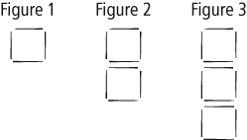
a) Copy and complete the table of values.

Figure | Number of Toothpicks | Perimeter
1 | 4 | 4
2 | 7 | 6
3 | 10 | 8
4 | 13 | 10
5 |  | 12
6 |  | 14

b) Describe the pattern.

14. A local zoo finds that when they add a new animal, more people come to the zoo. The following chart shows the increasing attendance as animals are added.

Number of Animals | Attendance
1 | 3
2 | 5
3 | 7
4 | 9
5

a) If this pattern continues, what will attendance be after the fifth animal is added?
b) If this pattern continues, what will attendance be after the eighth animal is added?

15. a) Plot and label the points given in the table of values.

x | y
0 | 6
1 | 5
2 | 4
3 | 3
4 | 2

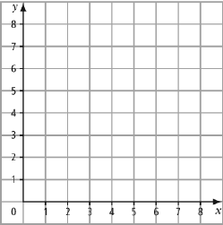

b) Describe the pattern of points.

16. a) Describe how to get the next term in this pattern: 6, 9, 12, 15, ... .
b) What are the next three numbers in the pattern?

17. If the cup represents an unknown number, write a variable expression modeled by the following diagram.

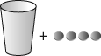

18. Write a word statement to describe the expression t + 5.

19. a) Complete the following table of values:

x | 2x – 4
2
3
4
5

b) Draw a graph using the values in the table.

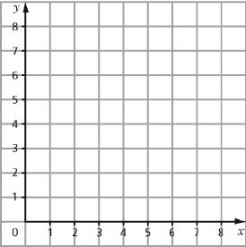

20. For each of the following statements, write an expression.
a) Jeans sell for $3 off the regular price.
b) The watermelons were shared equally among 6 families.
c) The number of people in a swimming pool triples.

Problem

21. a) Create a table of values for y = 2x.

x | y
1
2
3
4
5

b) Describe the pattern.

22. a) Complete the table of values.

x | y
2 | 1
4 | 5
6 | 9
8
10

b) Use a linear relation to describe the relationship between x and y.

23. a) Complete the following table.

Number of  Packages, p | Number of  Golf Balls, g
1 | 3
2 | 6
3 | 9

b) Use a linear relation to describe the relationship between golf balls, g, and packages, p.

c) Describe the pattern.

24. a) Complete the table using the expression y = 2x.

x | y
1
2
3
4

b) Draw a graph using the values in the table.

c) Describe the pattern on the graph.

25. a) Complete the table using the expression .

x | y
1
2
3
4

b) Draw a graph using the values in the table.

c) Describe the pattern on the graph.

26. A laser printer prints 20 pages per minute.
a) Write an expression for the number of pages the laser printer prints in q minutes.
b) How many pages can the laser printer print in 5 min?

27. a) Write an expression to describe Carly’s collection of cups and marbles.

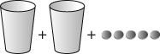

b) If Josh adds the following cups and marbles to Carly’s collection, what expression will represent the total?

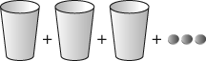

c) If each cup holds five marbles, how many marbles are there in total?
Solving Equations

E-1 Students will be able to explain the difference between an expression and an equation.
E-2 Students will be able to evaluate an expression when given the value of a variable.
F-1 Students will be able to demonstrate balance in an equation.
F-2 Students will be able to solve one-step equations.
F-3 Students will be able to solve two-step equations.

Multiple Choice

____ 1. The number of beans in a can is represented by the variable b. The expression that best represents the following diagram is

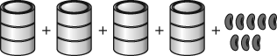
a. | 4b + 8 | b. | 4 + 8b | c. |  | d.

____ 2. The number of candies in a jar is represented by the variable j. The equation that best represents the following diagram is

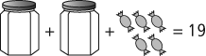
a. |  | b. |  | c. |  | d.

____ 3. Solve the equation .
a. |  | b. |  | c. |  | d.

____ 4. Solve the equation .
a. |  | b. |  | c. |  | d.

____ 5. Admission to the museum is reduced by $4 so that students pay only $7. If the original cost of admission is represented by the variable a, which equation describes this situation?
a. |  | b. |  | c. |  | d.

____ 6. Solve the equation 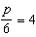.
a. |  | b. |  | c. |  | d.

____ 7. Solve for the value of x in the equation .
a. |  | b. |  | c. |  | d.

____ 8. What is the value of the variable in the equation ?
a. |  | b. |  | c. |  | d.

____ 9. Solve .
a. |  | b. |  | c. |  | d.

____ 10. Solve .
a. |  | b. |  | c. |  | d.

Short Answer

11. The number of pennies in a coin bank is represented by the letter p. Write the expression that best represents the model given below.

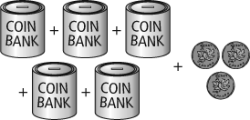

12. The number of pennies in a coin bank is represented by the letter p. Write the equation that best represents the model given below.

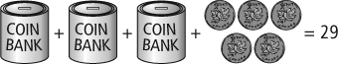

13. The number of marbles in a glass is represented by the letter m. Write the expression that best represents the model given below.

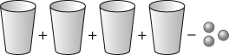

14. The number of marbles in a glass is represented by the letter m. Write the equation that best represents the model given below.

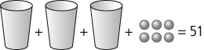

15. In a class of 32 students, 26 students completed their homework. Write an equation to determine the number of students, x, who did not complete their homework.

16. The school soccer team has played 17 games with no ties and 4 losses. Use the variable w to write an equation to represent the number of games won by the team.

17. Create a model and equation to represent 4 jars holding a total of 20 marbles. Assume that the marbles are divided equally among the jars.

18. Create a model and equation to represent 5 cups holding a total of 15 counters. Assume that the counters are divided equally among the cups.

19. Write the equation that represents the diagram shown below.

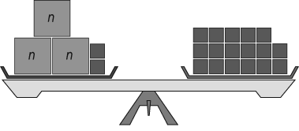

20. Write the equation that represents the diagram shown below.

Problems
21. A number is represented by the letter z. Write an equation for 4 times the number divided by 6 and increased by 5 to give a value of 11.

22. Brad has a bag of hamburger buns. His family eats seven hamburgers leaving five buns in the bag.
a) Model this situation using cups and counters.
b) Write and solve an equation to represent this model.

23. If Paige had $4 more in her pocket she could afford a dinner that will cost $17. If p represents the money in Paige’s pocket, write and solve an equation to model this situation.

24. A Vancouver Canucks jersey sells for $39. This is $6 less than the cost of a Calgary Flames jersey. If c represents the cost of a Flames jersey, write an equation and solve for the cost of a Flames jersey.

25. The equation modelling the total number of bald eagles in a valley is , where f represents the number of females, m represents the number of males, and 27 is the total number of eagles. If there are 13 male eagles, solve the equation to determine the number of female eagles.

26. Use the following model to write and solve an equation to determine the number of marbles that will divide equally into each cup.

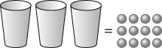
27. Sydney throws a stone off a cliff. The speed of the stone changes as it falls. The speed is modelled using the formula , where V represents the speed of the stone, in metres per second (m/s), and t represents the time for which the stone has been falling, in seconds.

a) What is the speed of the stone after falling for 1 s?
b) How many seconds will it take the stone to reach a speed of 55 m/s?

28. Bradon is saving for a mountain bike that costs $450. He knows that he needs to triple the money he has saved so far before he can afford his new bike. How much money has Bradon saved so far?

29. What value must the variable have to keep the scales balanced?

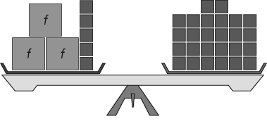

30. What value must the variable have to keep the scales balanced?

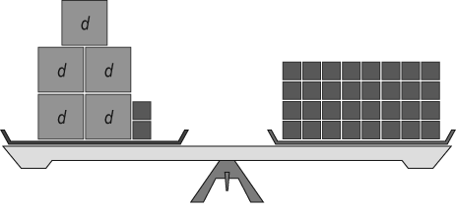

31. Solve the following equations, showing all your steps.

- $2+x=7$ b) $9=x+5$ c) $\frac{x}{4}=6$ d) $n-10=15$

e) $6c=18$ f) $24=\frac{m}{2}$ g) $32=4n$ h) $13=b+6$

i) $2x-5=35$ j) $7n+1=22$ k) $\frac{x}{5}+3=6$ l) $\frac{n}{4}-7=3$

m) $36=4x+4$ n) $12=\frac{c}{4}+5$ o) $8=\frac{n}{3}-1$ p) $11=5c-9$

32. Identify the variable, the numerical coefficient, constant in the following expressions:

a) $2m+5$ b) $4a-7$ c) $\frac{n}{5}+7$ d) $\frac{x}{2}-4$ e) $2m+3y-8$

Grade 7 Math Exam Review

Use the Chapter Reviews from Math Links 7 to prepare for each unit. Answers are provided at the back of the textbook to check your work.

Topic | Chapter Review | Answer pages
Divisibility & Fractions | Ch. 6 p. 222 - 223  Ch. 7 p. 260 - 261 | p. 479  p. 482 – 483
Decimal Operations & Conversions | Ch. 2 p. 74 - 75  Ch. 4 p. 146 - 147 | p. 468  p. 472
Integers | Ch. 9 p. 342 - 343 | p. 489
Expressions, Equations & Patterns | Ch. 10 p. 382 - 383  Ch. 11 p. 414 - 415 | p. 493 - 494  p. 495 – 496
Measurement | Ch. 3 p. 116 - 117  Ch. 8 p. 298 - 299 | p. 470 - 471  p. 485
Coordinate Geometry | Ch. 1 p. 36 - 37 | p. 465 – 466

For extra exam review you can complete the Chapter Test for Chapters 1,2,3,4,6,7,8,9,10 and 11 found after each chapter review. See your teacher for an answer sheet to the Chapter Tests.

