Divisibility Rules
1.

 | 2 | 3 | 4 | 5 | 6 | 8 | 9 | 10
314 | √
7323
624 | √ | √ | √ |  | √ | √
360 | √ | √ | √ | √ | √ | √ | √ | √

2. a)4
b) 1
c) 0,8
d) 8

3. James can make 3 rows because 6 + 8 + 1 = 15, and 15 is divisible by 3.
He cannot make 9 rows because the sum of the digits is 15 and 15 is not divisible by 9.

4. Yes he will because 126 is divisible by 2 and by 3, therefore it is divisible by 6.

5. 24, 48, 72

Operations on Decimal Numbers
Answer Section
MULTIPLE CHOICE
1. ANS: C

2. ANS: D

3. ANS: C

4. ANS: B

5. ANS: B

6. ANS: C

7. ANS: C

8. ANS: C

9. ANS: B

10. ANS: C
SHORT ANSWER
11. ANS:
123.54 – 87.9 = 35.64

12. ANS:
89.34 – 51.74 = 37.6

13. ANS:
794.85 – 521.36 = 273.49

14. ANS:
97.17 + 137.43 = 234.6

15. ANS:
8 x $0.76 = $6.08
$6.08 – $5.69 = $0.39

The box of 8 is cheaper by $0.39.

16. ANS:
(3.85 + 75) x 24 + 652.57 = 2544.97

The mass of a full box of bags of chips is 2544.97 g.

17. ANS:
$5.50 x 87 + $4.75 x 153
= $478.50 + $726.75
= $1205.25

$1205.25 was collected from the sale of dance tickets.

18. ANS:
80÷ ( 0.4 + 6 ) X 0.3 = 3.75

19. ANS:
80 ÷ 0.4 + 6 X 0.3 = 201.8 or ( 80 ÷ 0.4) +( 6 X 0.3) = 201.8

PROBLEM

21. ANS:
1105.7 + 360.4 + 247.8 – 201.6 = 1512.3

Kevin is 1512.3 km from Prince Rupert.

22. ANS:
36.7 + 32.4 + 28.9 + 29.6 + 31.5 + 1.24 = 160.34

The branch was 160.34 cm long.

23. ANS:
$50.00 – $9.85 – $21.67 = $18.48

Jen has $18.48 available for shopping.

24. ANS:

0.17 + 0.12 + 0.3 + 0.22 = 0.81

The bottle will contain 0.81 L of water.

25. ANS:
0.145 + 0.280 + 0.195 + 0.210 = 0.830

1.0 – 0.83 = 0.17

You must add 0.17 kg of snacks to total 1 kg of snacks.

26. ANS:
0.89 + 1.23 + 2.1 + 0.91 = 5.13
5.13 – 4.37 = 0.76
0.76 x 2 = 0.38

There will be 0.38 m of the walkway out of the mud on each side.

27. ANS:
ends = 2 x 3.81 = 7.62
crests = 5 x 7.62 = 38.1
spaces = 4 x 2.54 = 10.16

7.62 + 38.1 + 10.16 = 55.88

The display board must be 55.88 cm wide.

28. ANS:
20 ÷ 2.8 = 7.1428

The greatest number of holes possible will be 7.

29. ANS:
275 + 158 + 200 + 225 = 858

858 ÷ 71.5 = 12

Twelve party bags can be filled from the available candy.

30. ANS:
a) 2 x $10.16 + 2 x $14.68 + 4 x 2 x $20.33 + 4 x $7.88

b) 2 x $10.16 + 2 x $14.68 + 4 x 2 x $20.33 + 4 x $7.88
= $20.32 + $29.36 + $162.64 + $31.52
= $243.84

c) Sixteen CDs were purchased for a total of $243.84.
Average price of a CD = $243.84 ÷ 16
= $15.24

Fractions, Decimals, Percents
Answer Section
MULTIPLE CHOICE

1. ANS: C

2. ANS: A

3. ANS: B

4. ANS: D

5. ANS: D

6. ANS: C

7. ANS: D

8. ANS: D

9. ANS: C

SHORT ANSWER
10. ANS:
Responses will vary. Possible answers include (any three) , , , , .

11. ANS:
Responses will vary. Possible answers include (any three) , , , , .

12. ANS:
< < < <

Rationale:

= 0.6, = 0.75, = 0.5, = 0.41, = 0.

13. ANS:
Responses will vary. Possible answers include (any three) , , , , .

14. ANS:
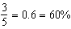

15. ANS:
Write each fraction as a decimal.
= 0.2, = 0.65, = , = , =
Since < 0.2 < < 0.65 < ,
< < < <

16. ANS:
a) 50%
b) 20%
c) 25%
d) 10%

17. ANS:
a) 66.7%
b) 26.7%
c) 44.4%
d) 46.7%

18. ANS:
a) 32% =
b) 55% =
c) 60% =
d) 80% =

19. ANS:
25% =
a) $20.00 ÷ 4 = $5.00
b) $60.00 ÷ 4 = $15.00
c) $50.00 ÷ 4 = $12.50
d) $10.00 ÷ 4 = $2.50

20. ANS:

a) 75% of $40.00 = $20.00 + $10.00 = $30.00 (or 0.75 x 40 = 30)

b) 75% of $80.00 = $40.00 + $20.00 = $60.00 ( or 0.75 x 80 = 60)

c) 75% of $60.00 = $30.00 + $15.00 = $45.00 (or 0.75 x 60 = 45)

d) 75% of $5.00 = $2.50 + $1.25 = $3.75 (or 0.75 x 5 = 3.75)

21. ANS:
a) 0.56
b) 0.125
c) 0.005
d) 0.3675

22. ANS:
a) = 0.07 = 7%
b) = 0.25 = 25%
c) = 0.6 = 60%
d) = 0.85 = 85%

23. ANS:
a) 55% of 200 g is 110 g.

b) 55% of 3 m is 1.65 m.

c) 55% of 50 mL is 27.5 mL.

d) 55% of 10 cm² is 5.5 cm².

24. ANS:
a) The total mass is 80 g.

b) The total mass is 121 g.

c) The total mass is 188 g.

d) The total mass is 1.6 g.

PROBLEM
25. ANS:
a) Kim: Paul: Anita:
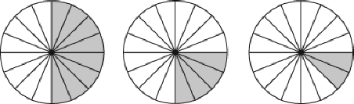

b) = 0.5, = 0.25, = 0.125

c) 0.5 = 50%, 0.25 = 25%, 0.125 = 12.5%

26. ANS:
10% of 60 = 6
White chocolate = 30% = 18 pieces
Milk chocolate = 60% = 36 pieces
Dark chocolate = 10% = 6 pieces

Number of pieces left:
White chocolate = 18 – 2 = 16 pieces
Milk chocolate = 36 – 2 = 34 pieces
Dark chocolate = 6 – 2 = 4 pieces
There are 16 pieces of white chocolate, 34 pieces of milk chocolate, and 4 pieces of dark chocolate left in the box.

27. ANS:
a) 12 + 6 + 3 + 9 = 30
There are 30 students in Carolyn’s class.

b) Pop: =
Rock: =
Jazz: =
Rap: =

c) = 0.4, = 0.2, = 0.1, = 0.3

d) 40% of the students like pop music, 20% like rock, 10% like jazz, and 30% like rap.

28. ANS:
a) 25% =
$40.00 ÷ 4 = $10.00
Eja will save $10.00 each month.

b) $120.00 ÷ $10.00 = 12
It will take Eja 12 months to save $120.00 for his bicycle.

c) The cost of the bicycle is $120.00. If Eja wants to have it after six months
$120.00 ÷ 6 = $20.00
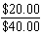 = 0.5 = 50%
Eja will need to save 50% of his allowance each month.
d) 25% = $10.00
75% = $30.00
$120.00 ÷ $30.00 = 4
It would take Eja four months to save $120.00 for his bicycle if he saved 75% of his allowance.

29. ANS:
Area of backyard = 30  30
= 900

The backyard is 900 m.

Area of tennis court = 20  15
= 300

The tennis court will be 300 m.

=
= 33.3%

33.3% of Greg’s backyard will be used for the tennis court.

30. ANS:
10% of park = 6 m²
5% of park = 3 m²
15% of park = 9 m²
The area of the flowered part of the park is 9 m².

31. ANS:
She gives away 95% of the chips, so she saves 5% for herself.
10% of 70 = 7
5% of 70 = 7 ÷ 2 = 3.5
She saves 3.5 g of chips for herself.
Fraction Introduction
Answer Section
MULTIPLE CHOICE

1. ANS: C

2. ANS: A

3. ANS: C

4. ANS: C

5. ANS: C

6. ANS: C

7. ANS: D

8. ANS: B

9. ANS: C

10. ANS: A

SHORT ANSWER

11. ANS:
a) 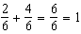
b) 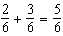
c) 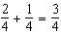

12. ANS:
a) 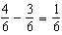
b) 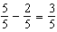
c) 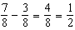

13. ANS:
a) =
b) =

14. ANS:
a) 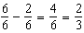
b) 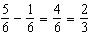

15. ANS:
a) 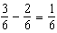
b)

16. ANS:
a) =
b) = =
c) =

17. ANS:
a) = 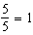
b) = 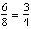
c) + = 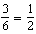

18. ANS:
a) 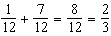
b)
c) 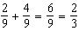

19. ANS:
a) 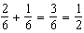
b) 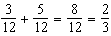
c) 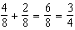
d) 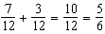

20. ANS:
a) 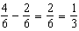  
b)
c)

PROBLEMS

21. ANS:
a) 15 + 35 + 10 + 5 = 65
The total cost is $65.00.
b) brushes: = ; canvas boards: = ; sketchpads: = ; pencils: =

22. ANS:
a) There are 35 bicycles on sale.
b) blue: ; red: 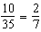; green: ; orange: 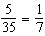; black: ; silver:

23. ANS:
a) 6 + 3 + 7 + 2 = 18
There are 18 pets in total.

b) dogs: ; rabbits: ; cats: ; hamsters:

c) Fraction of animals picked up: 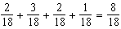

Fraction left: 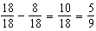

of the pets remained on Sunday evening.

24. ANS:
a) 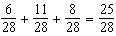

of the box has been taken.

b) 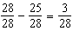

There are 3 candy bars left in the box.

25. ANS:
a) =
b) =
c) =
d) =

26. ANS:
Red pens: =
Blue pens: =
Melanie took of the pack of red pens and of the pack of blue pens.

27. ANS:
Chocolate chip cookies: =
Oatmeal cookies: =
Kevin took of the bag of chocolate chip cookies and of the bag of oatmeal cookies.

28. ANS:
a) 10 4 = 40

Audrey made 40 pieces.

b) 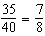

of the sandwiches were taken in the first hour.

c) 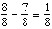

of the sandwiches were left in the tray after the first hour.

Fraction Addition & Subtraction
Answer Section

MULTIPLE CHOICE

1. ANS: C
2. ANS: C

3. ANS: D

4. ANS: B

5. ANS: B

6. ANS: C

7. ANS: C

8. ANS: A

9. ANS: B

10. ANS: B

SHORT ANSWER

11. ANS:
Answers will vary. Examples include:
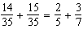
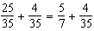
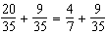

12. ANS:
Answers will vary. Examples include:
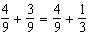
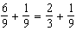

13. ANS:
Answers will vary. Examples include:
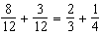
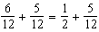

14. ANS:
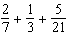 = =

15. ANS:
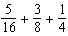 =

16. ANS:
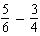 =

17. ANS:
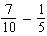 =
=

18. ANS:
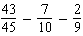 =
=

19. ANS:
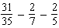 =
=

20. ANS:
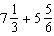 =
PROBLEMS

21. ANS:
a)
b)
c) 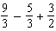 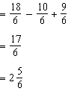
d) 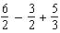 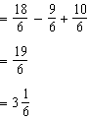

22. ANS:
a) 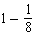 =
Warren’s father did not mow of the lawn.
b) 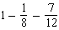 =
Warren’s brother mowed of the lawn.

23. ANS:
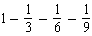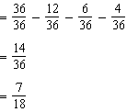
Kristina gave her teacher of the box of chocolates.

24. ANS:
a) 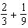 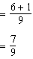
Jake and Billy have weeded of the garden.
b) 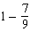
They still have to weed of the garden.

25. ANS:
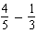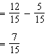
There was of a pizza left on the tray.

26. ANS:
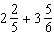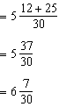

27. ANS:
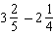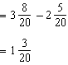

28. ANS:
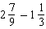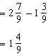
Yuri has barrels of water left.

29. ANS:
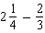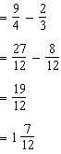
Brian does h of training after school.

30. ANS:
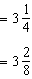
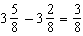
Sara ran of a lap more than Bev did.

Integer Addition & Subtraction
Answer Section

MULTIPLE CHOICE

1. ANS: A

2. ANS: D
3. ANS: A

4. ANS: A

5. ANS: B

6. ANS: A

7. ANS: C

8. ANS: B

9. ANS: C

10. ANS: C

SHORT ANSWER

11. ANS:
a) –12
b) –1
c) +100
d) +66

12. ANS:
a) –15, +45
b) +5, –1
c) 0, –13
d) +10, –5

13. ANS:
a) (+5) + (–3) = +2
b) (+1) + (–4) = –3
c) (+3) + (–3) = 0

14. ANS:
a) (+3) – (–5) = +8
b) (+4) – (+3) = +1
c) (–3) – (–5) = +2

15. ANS:
a) (–3) + (+5) + (–4) = –2
b) (+4) + (–6) + (+2) = 0

16. ANS:
a)
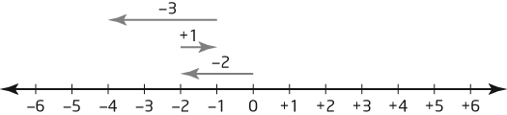

(–2) + (+1) + (–3) = –4

b)
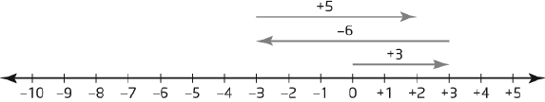

(+3) + (–6) + (+5) = +2

17. ANS:
a) +8
b) –22
c) –12

18. ANS:
a) 0
b) +52
c) –98

19. ANS:
a) –9
b) +10
c) –9

20. ANS:
a) 0
b) –2
c) +1

21. ANS:
a) 0
b) +1
c) +9
d) –9

22. ANS:
a) –4
b) +13
c) +19
d) –7

PROBLEM
23. ANS:
(–400) + (+700) = +300
Maria gained 300 calories.

24. ANS:
(+$35) + (–$14) + (–$12) = +$9
Jeb has $9 left.

25. ANS:
(+750) + (–425) + (–225) = +100
There is 100 mL of water left in Hilary’s bottle.

26. ANS:
a) (–7) + (+8) + (–3) = –2
b) (+2) + (–10) + (+7) = –1

27. ANS:
a) (+7) – (–1) = +8 or (–1) – (+7) = –8
The difference in temperatures is 8ºC.

b) (+8) – (–3) = +11 or (–3) – (+8) = –11
The difference in temperatures is 11ºC.

28. ANS:
(+12) – (–16) = 28 or (–16) – (+12) = –28
The change in temperature was 28ºC.

29. ANS:
(+16) + (–6) = (+10)
Kate met her friend on the 10th floor.

30. ANS:
(+135) + (–52) + (+24) = +107
Warren now has 107 stamps.

31. ANS:
(–6) – (–23) = 17 or (–23) – (–6) = –17
The temperature change was 17°C.

32. ANS:
(+$62) + (–$14) + (+$75) + (–$30) + (+$50) + ($0) = +$143
Juan will have $143 at the end of next week.

The Co-ordinate Plane
Answer Section
MULTIPLE CHOICE
1. ANS: A

2. ANS: B

3. ANS: C

4. ANS: A

5. ANS: B

6. ANS: A

7. ANS: D

8. ANS: A

9. ANS: B

10. ANS: A

SHORT ANSWER

11. ANS:
a)
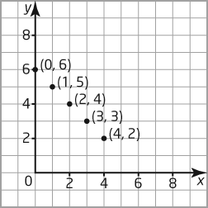

b) The points form a line that goes down and to the right.

12. ANS:

13. ANS:
A translation occurs when an object moves to a new position in a straight line.
Examples will vary. For example:
• elevators,
• ski lifts, etc.

14. ANS:
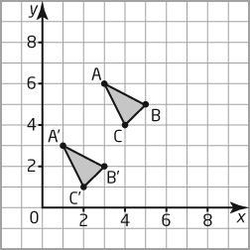

15. ANS:
The figure is in the shape of a set of stairs.

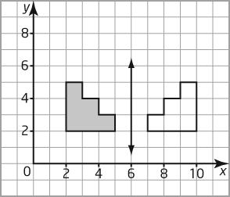

16. ANS:
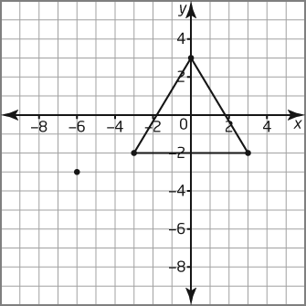

a) (–6, –3)
b) a triangle

PROBLEM

17. ANS:
Answers will vary. For example:
A, H, I, M, O, T, U, V, W, X, Y (Reflection in a vertical mirror line)
B, C, D, E, H, I, K, O, X (Reflection in a horizontal mirror line)

18. ANS:

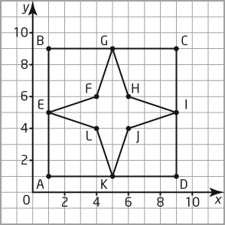

Figure 1 is a square and Figure 2 is a star.

19. ANS:
a) & b)
\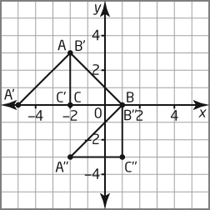

c) B" will have coordinates (1, 0).

20. ANS:
a) & b)
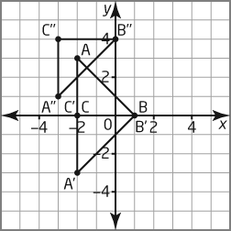

c) Coordinates of the vertices of A"B"C" are
A"(–3, 1), B"(0, 4), C"(–3, 4).

21. ANS:
a) and c)
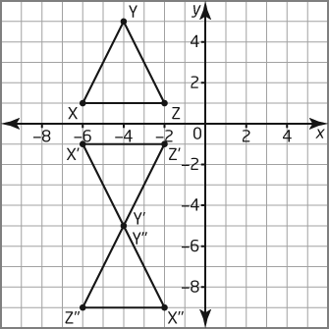
b) X'(–6, 1), Y'(–4, –5), Z'(–2, –1)

d) X"(–2, –9), Y"(–4, –5), Z"(–6, –9)

Patterns & Expressions
Answer Section

MULTIPLE CHOICE

1. ANS: A

2. ANS: B

3. ANS: B

4. ANS: A

5. ANS: A

6. ANS: D

7. ANS: B

8. ANS: B

9. ANS: D

10. ANS: C

SHORT ANSWER

11. ANS:
a) 55
b) 65

12. ANS:
a) In this pattern, add 3 to get to the next term.

b) The next term is 19.

c) The expression representing this pattern would be n + 3.

13. ANS:
a)
Figure | Number of Toothpicks
1 | 4
2 | 7
3 | 10
4 | 13
5 | 16
6 | 19

b) The figure number is multiplied by 3, then increased by 1. The algebraic expression is $3n+1$

14. ANS:
a) Attendance will be 11.
b) Attendance will be 17.

15. ANS:
a)
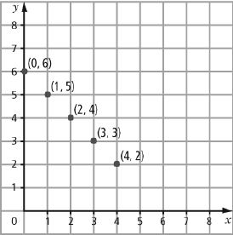

b) The points form a line that goes down to the right.

16. ANS:
a) The next term in the pattern is generated by adding 3 to the previous term.
b) The next three numbers in the pattern are 18, 21, 24.

17. ANS:
c + 4

18. ANS:
The expression represents a number increased by 5.

19. ANS:
a)
x | 2x – 4
2 | 0
3 | 2
4 | 4
5 | 6

b)
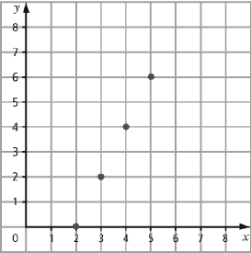

20. ANS:
a)
b)
c)
PROBLEM
21. ANS:
a)
x | y
1 | 2
2 | 4
3 | 6
4 | 8
5 | 10

b) The value of y is twice the value of x.

22. ANS:
a)
x | y
2 | 1
4 | 5
6 | 9
8 | 13
10 | 17

b) y = 2x – 3

23. ANS:
a)
Number of  Packages, p | Number of  Golf Balls, g
1 | 3
2 | 6
3 | 9
4 | 12
5 | 15

b) The relationship can be described as g = 3p (or 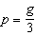.)

c) As the number of packages increases by 1, the number of golf balls increases by 3. (or the number of packages multiplied by three equals the number of golf balls)

24. ANS:
a)
x | y
1 | 2
2 | 4
3 | 6
4 | 8

b)
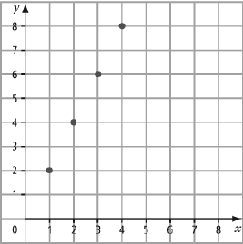

c) The graph presents a diagonal line going upward.

25. ANS:
a)
x | y
1 | 5
2 | 4
3 | 3
4 | 2

b)
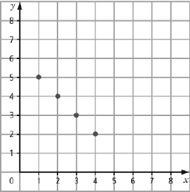

c) The graph presents a diagonal line going downward.

26. ANS:
a) 20q

b) q = 5
20  5 = 100
The laser printer can print 100 pages in 5 min.

27. ANS:
a) 2c + 5

b) 5c + 8

c) 5c + 8 = 5(5) + 8
= 25 + 8
= 33

There are 33 marbles in total.

Solving Equations
Answer Section

MULTIPLE CHOICE

1. ANS: A

2. ANS: C

3. ANS: A

4. ANS: B

5. ANS: B

6. ANS: D

7. ANS: B

8. ANS: A

9. ANS: B

10. ANS: C

SHORT ANSWER

11. ANS:

12. ANS:

13. ANS:

14. ANS:

15. ANS:
or

16. ANS:

17. ANS:
Answers may vary. Example:

18. ANS:
Answers may vary. Example:

19. ANS:

20. ANS:

PROBLEMS

21. ANS:
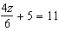

22. ANS:

a)

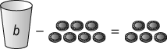
b)
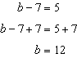

There were 12 hamburger buns in the bag.

23. ANS:
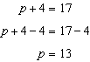

Paige has $13 in her pocket.

24. ANS:
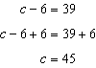

A Calgary Flames jersey costs $45.

25. ANS:
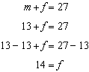

There are 14 female eagles in the valley.

26. ANS:
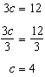

Four marbles will go into each cup.

27. ANS:
a) 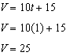

After 1 s, the stone is falling at a speed of 25 m/s.

b) 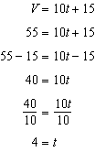

The stone will reach a speed of 55 m/s after falling for 4 s.

28. ANS:
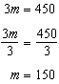

Bradon has saved $150 so far.

29. ANS:
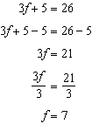

The variable must equal 7.

30. ANS:
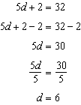
The variable must equal 6.

31 .

a) $2+x=7$
$2-2+x=7-2$
$x=5$

b) $9=x+5$
$9-5=x+5-5$
$4=x$

c) $\frac{x}{4}=6$
$\frac{4x}{4}=6\left(4\right)$
$x=24$

d) $n-10=15$
$n-10+10=15+10$
$n=25$

e) $6c=18$
$\frac{6c}{6}=\frac{18}{6}$
$c=3$

f) $24=\frac{m}{2}$
$24 \left(2\right)=\frac{2m}{2}$
$48=m$

g) $32=4n$
$\frac{32}{4}=\frac{4n}{4}$
$8=n$

h) $13=b+6$
$13-6=b+6-6$
$7=b$

i) $2x-5=35$
$2x-5+5=35+5$
$2x=40$
$\frac{2x}{2}=\frac{40}{2}$
$x=20$

j) $7n+1=22$
$7n+1-1=22-1$
$7n=21$
$\frac{7n}{7}=\frac{21}{7}$
$n=3$

k) $\frac{x}{5}+ 3=6$
$\frac{x}{5}+3-3=6-3$
$\frac{x}{5}=3$
$\frac{5x}{5}=3 \left(5\right)$
$x=$ $15$

l)
$\frac{n}{4}-7=3$
$\frac{n}{4}- 7+7=3+7$
$\frac{n}{4}= 10$
$\frac{4n}{4}=10 \left(4\right)$
$n=40$

m) $36=4x+4$
$36-4=4x+4-4$
$32=4x$
$\frac{32}{4}=\frac{4x}{x}$
$8=x$

n) $12=\frac{c}{4}+ 5$
$12-5=\frac{c}{4}+ 5-5$
$7=\frac{c}{4}$
$7\left(4\right)=\frac{4c}{4}$
$28=c$

o) $8=\frac{n}{3}- 1$
$8+1=\frac{n}{3}-1+1$
$9=\frac{n}{3}$
$$9\left(3\right)=\frac{3n}{3}$$
$27=n$

p) $11=5c-9$
$11+9=5c-9+9$
$20=5c$
$\frac{20}{5}=\frac{5c}{5}$
$4=c$

32.
expression | Variable | Numerical coefficient | constant
$$2m+5$$ | $$m$$ | $$2$$ | $$5$$
$$4a-7$$ | $$a$$ | $$4$$ | $$-7$$
$$\frac{n}{5}+7$$ | $$n$$ | $$\frac{1}{5}$$ | $$7$$
$$\frac{x}{2}-4$$ | $$x$$ | $$\frac{1}{2}$$ | $$-4$$
$$2m+3y-8$$ | $$m,y$$ | $$2,3$$ | $$-8$$

