Extra Practice 1

Target B-1

|  |
| --- |
| Lesson 3.1: Using Models to Multiply Fractions and Whole Numbers  **1.** Write each repeated addition as a multiplication statement in two ways.  **a)**  +  +  +  +   **b)**  +  +  +   **c)**  +  +  +  +  +  +  +  **2.** Multiply. Draw a picture to show each answer.  **a)** 7 ×  **b)**  × 4 **c)** 8 ×  **d)**  × 6  **3.** Ella baby-sits for  h before school each morning.  **a)** How many hours does she baby-sit in a 5-day work week? \_\_\_\_\_\_\_\_\_\_\_\_\_\_\_\_\_\_\_\_\_   1. How many hours does she baby-sit in 4 weeks? \_\_\_\_\_\_\_\_\_\_\_\_\_\_\_\_\_\_\_\_\_\_\_\_\_\_\_\_\_\_   **4.** Multiply. Draw a picture to show each answer. Explain any patterns you see.  **a)** 6 ×  **b)** 9 ×  **c)** 6 ×  **d)** 9 ×    **5.** Ian’s monthly allowance is $21. In January he starts saving for a  birthday gift in June. Each month he saves  of his allowance.  The gift he wants to buy costs $110. Will Ian have enough money? Explain. |

**Extra Practice 1 Answers**

**1. a)** × 5 or 5 × **b)**  × 4 or 4 ×

**c)**  × 8 or 8 ×

**2. a)** = 4 **b)** = 2 = 2

**c)** = 10 **d)** =

**3. a)** h = 3 h **b)** h = 15 h

**4.** All the answers are = 4 as a mixed number.   
The fractions in parts a and c are equivalent. In parts b and c, the whole number and numerator are interchanged. The fractions in parts b and d are equivalent. The pictures show that all the questions have the same product.

5. In the six months from January to June, Ian will save of $21 = $14.   
 $14 × 6 = $84  
 Ian needs $110 − $84 = $26 Extra Practice 2

|  |
| --- |
| Lesson 3.2: Using Models to Multiply Fractions  Target B-1  **1.** Use the rectangle to find each product.  **a)**  ×  **b)**  ×  **c)**  ×    **2.** Draw a rectangle on grid paper to find each product.  **a)**  ×  **b)**  ×  **c)**  ×  **d)**  ×  **e)**  ×  **f)**  ×  **g)**  ×  **h)**  ×  **3.** One-third of the students in Mrs. Hayko’s class walk to school.  Of the students who do not walk, four-fifths take the bus.  **a)** Use counters to illustrate the product.  **b)** What fraction of the students in Mrs. Hayko’s class take the bus to school? \_\_\_\_\_\_\_\_\_  **c)** How many students might there be in her class?    **4.** Which of the following statements are equivalent? Draw area models to explain your answers.  **a)**  of  **b)**  of  **c)**  of  **d)**  of  **e)**  of  **f)**  of |

**Extra Practice 2 Answers**

**1. a)**  **b)**  **c)** 

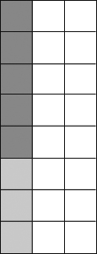**2. a)**  **b)** 

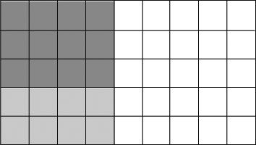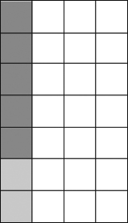 **c)**  **d)** 



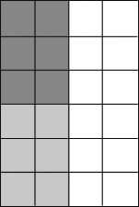 **e)**  **f)** 

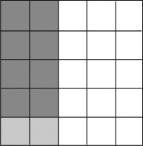 **g)**  **h)** 

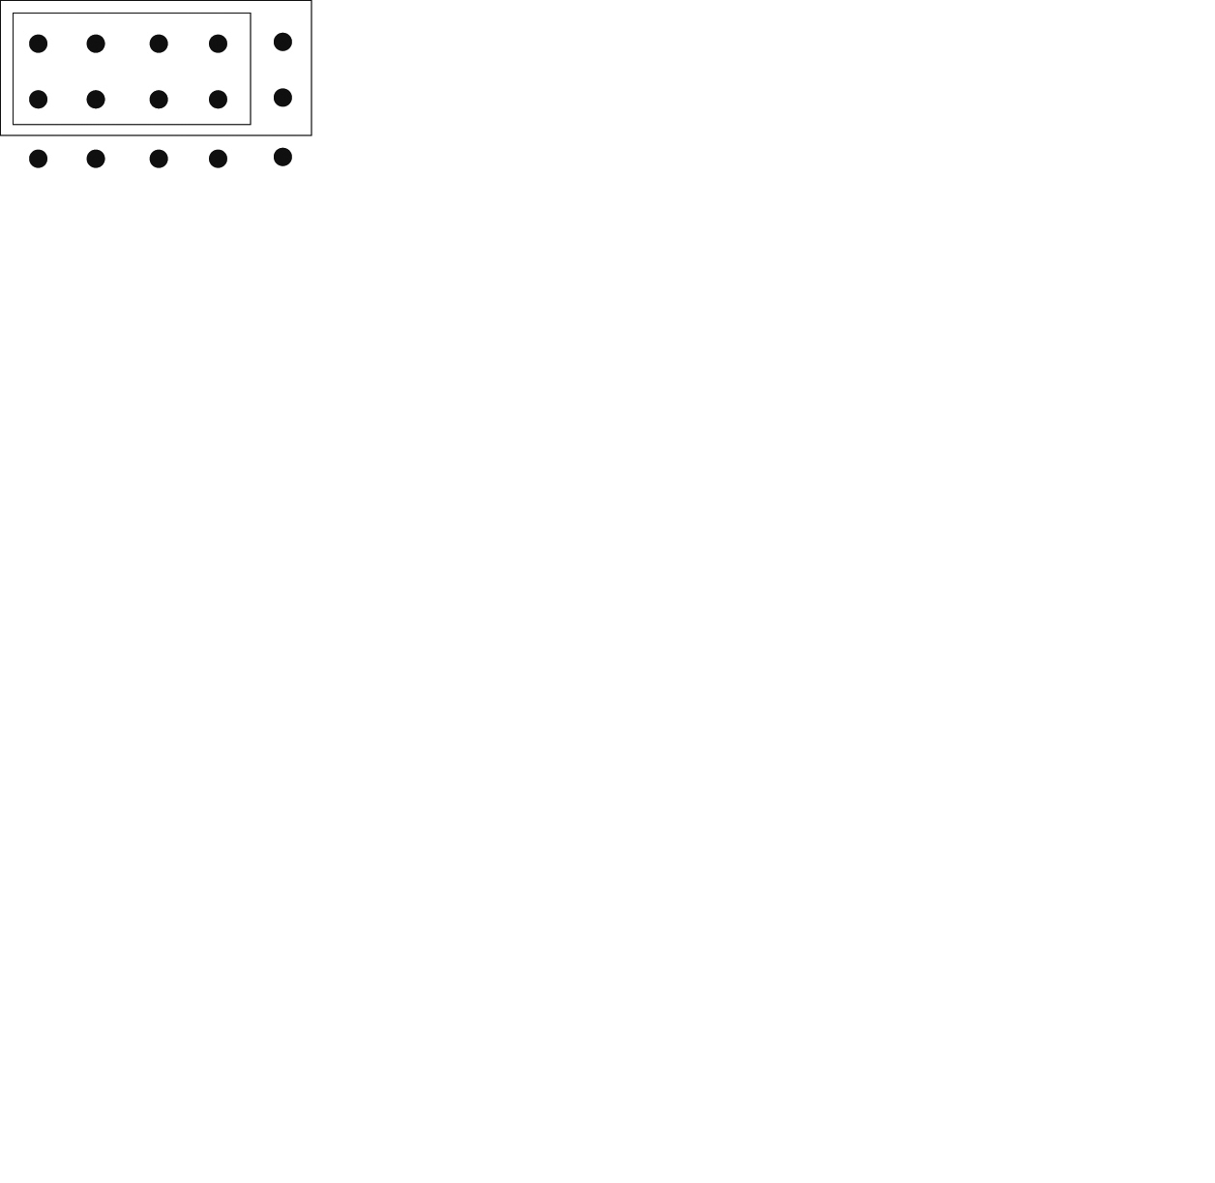**3. a)**

**b)** 

**c)**For example, 15 or 30 students

**4.** a and c both equal ; b and d both equal ;   
 e and f both equal 

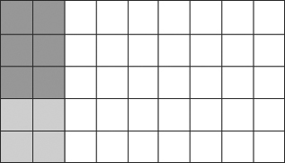 **a)**

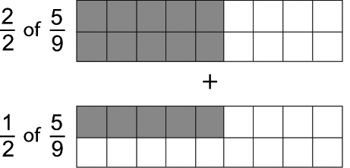 **b)**

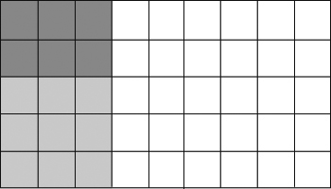 **c)**

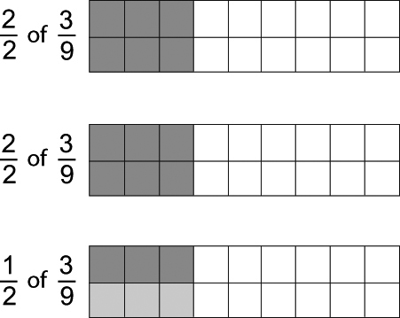 **d)**

**e)** 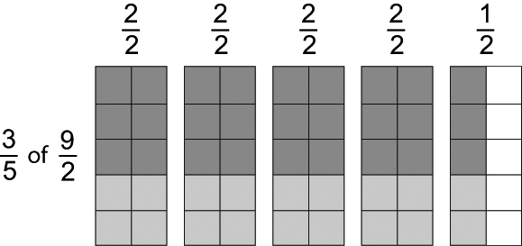

**f)**

**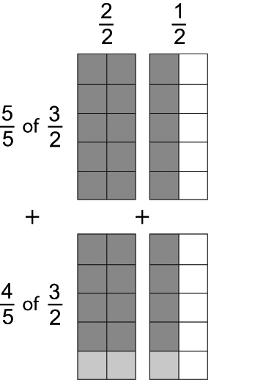**

Extra Practice 3

|  |
| --- |
| Lesson 3.3: Multiplying Fractions  Target B-1  **1.** Multiply. Estimate to check.  **a)**  ×  **b)**  ×  **c)**  ×  **d)**  ×  **e)**  ×  **f)**  ×  **g)**  ×  **h)**  ×  **2.** Daphne replaced light bulbs in her mother’s store. She had of a box of light bulbs. She used of the bulbs.  **a)** What fraction of the box of light bulbs was left?    **b)** How many light bulbs might be in a full box? Explain.    **3.** Estimate each product.  **a)** × **b)**  × **c)**  ×  **4.** The product of two fractions is . One fraction is .  What is the other fraction?      **5.** Multiply. Simplify before multiplying if possible.  **a)**  × **b)**  × **c)**  × **d)**  × |

**Extra Practice 3 Answers**

**1. a)**  **b)**  **c)**  **d)** 

**e)** 2 **f)**  **g)**  **h)** 2

**2. a)**  of the box of light bulbs was left.

**b)** A dozen, or any multiple of 12, because  and  have a common denominator of 12.

**3. a)** is 3 and is around 1, the product should be about 3.

**b)** is close to 1, 1 ×  = ; the product should be about .

**c)** is close to 6 and is between 1 and 2, closer to 2, so the product should be about 12.

**4.**  

**5. a)**  **b)**  **c)**  **d)** 

Extra Practice 4

|  |
| --- |
| Lesson 3.4: Multiplying Mixed Numbers  Target B-1  **1.** Write the mixed number and improper fraction represented by each picture.  **a)**  **b)**  mmswncptg_08_03-BLM-22a mmswncptg_08_03-BLM-22b  **c)**  mmswncptg_08_03-BLM-22c  **2.** Use estimation. Which suggested estimate is closer to the given product?  **a)** 3 × 1 3 or 8 **b)** 2 × 4 8 or 15 **c)** 2 × 3 or 6  **3.** Multiply. Estimate to check.  **a)** 2 × 1 **b)** 4 × 3 **c)** 5 × 2 **d)**  × 3  **4.** Amber made 5 pitchers of iced tea for her friends.   They drank of the iced tea.   How many pitchers of iced tea did they drink?  **5.** Carlos has 1 cups of flour.  He uses  of the flour to make pizzas for the school fundraiser.  How much flour does Carlos use? |

**Extra Practice 4 Answers**

**1. a)**  or  **b)**  or  **c) or **

**2. a)** 8 **b)** 8 **c)** 3

**3. a)**  **b)**  **c) ** **d) **

**4.** 

**5. **

Extra Practice 5

Target B-1

|  |
| --- |
| Lesson 3.5: Dividing Whole Numbers and Fractions  **1.** Use a number line to find each quotient.  **a) i)** 4 ÷  **ii)** 4 ÷  mmswncptg_08_03-BLM-23a  **b) i)**   ÷ 2 **ii)**  ÷ 4  mmswncptg_08_03-BLM-23b  **2.** Find each quotient. Use fraction circles to illustrate the answers.  **a)** 2 ÷  **b)** 3 ÷  **c)** 4 ÷  **d)** 5 ÷  **3.** Use a number line to find each quotient.  **a)**  ÷ 3 **b)**  ÷ 3 **c)**  ÷ 4 **d)**  ÷ 4  **4.** Samuel uses  of a roll of ribbon to tie one balloon for the school dance. He has 12 rolls of ribbon. How many balloons can he tie?  **5.** A student knows that  × 4 is the same as 4 × .  The student assumes that 4 ÷  is the same as  ÷ 4.   Is the student correct?  Use number lines to prove or disprove this assumption. |

**Extra Practice 5 Answers**

**1. a) i)** 12 **ii)** 6 **b) i)**  **ii)** 

**2. a)** 6 **b)** 4 **c)** 6 **d)** 25

**3. a)**  **b)**  **c)**  **d)** 

**4.** 18 balloons

**5.** No, 4 ÷  = 5 and  ÷ 4 = 

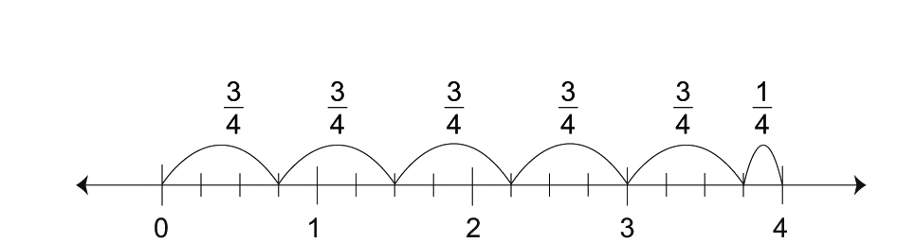

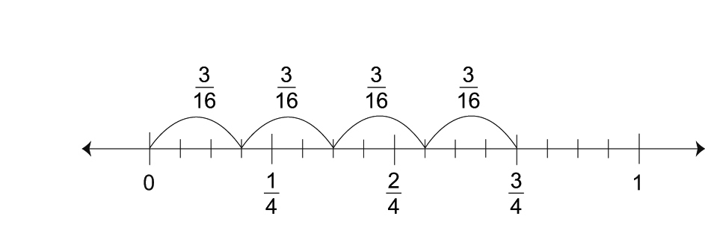

Extra Practice 6

|  |
| --- |
| Lesson 3.6: Dividing Fractions  Target B-1  **1.** Write the reciprocal of each fraction.  **a)**  **b)**  **c)**  **d)**  **2.** Use a copy of each number line to illustrate each quotient.  mmswncptg_08_03-BLM-24a **a)**  ÷  mmswncptg_08_03-BLM-24b **b)**  ÷  mmswncptg_08_03-BLM-24c **c)**  ÷  mmswncptg_08_03-BLM-24d **d)**  ÷  **3.** Use multiplication to find each quotient.  **a)**  ÷  **b)**  ÷  **c)**  ÷  **d)**  ÷  **4.** Use common denominators to find each quotient.  **a)**  ÷  **b)**  ÷  **c)**  ÷  **d)**  ÷  **5.** Write three division questions that have  as their quotient. |

**Extra Practice 6 Answers**

**1. a)**  **b)**  **c)**  **d)** 

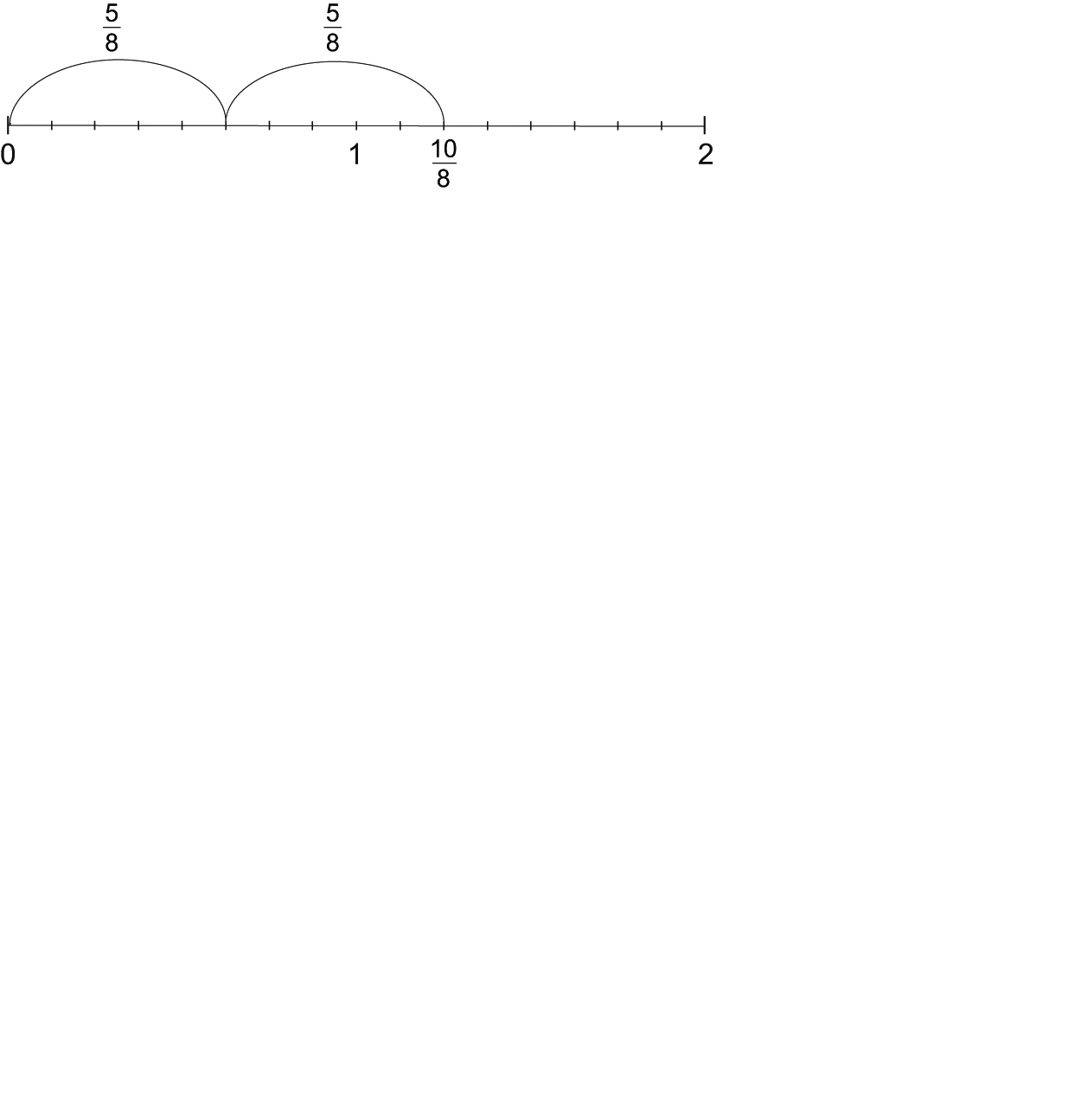**2. a)** 2

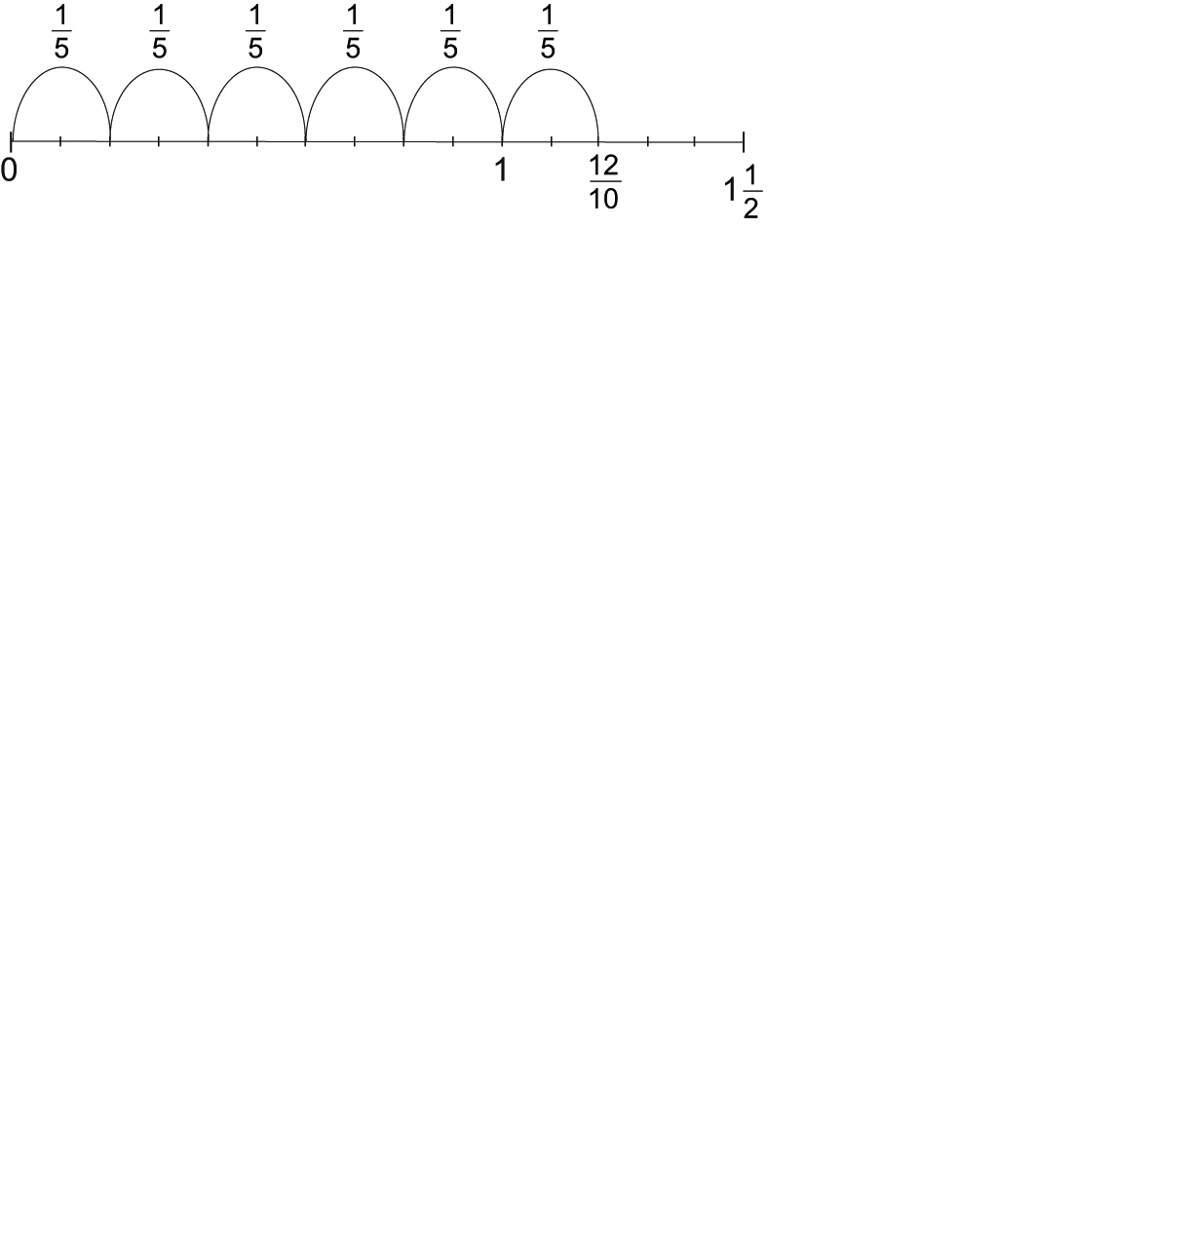

**b)** 6

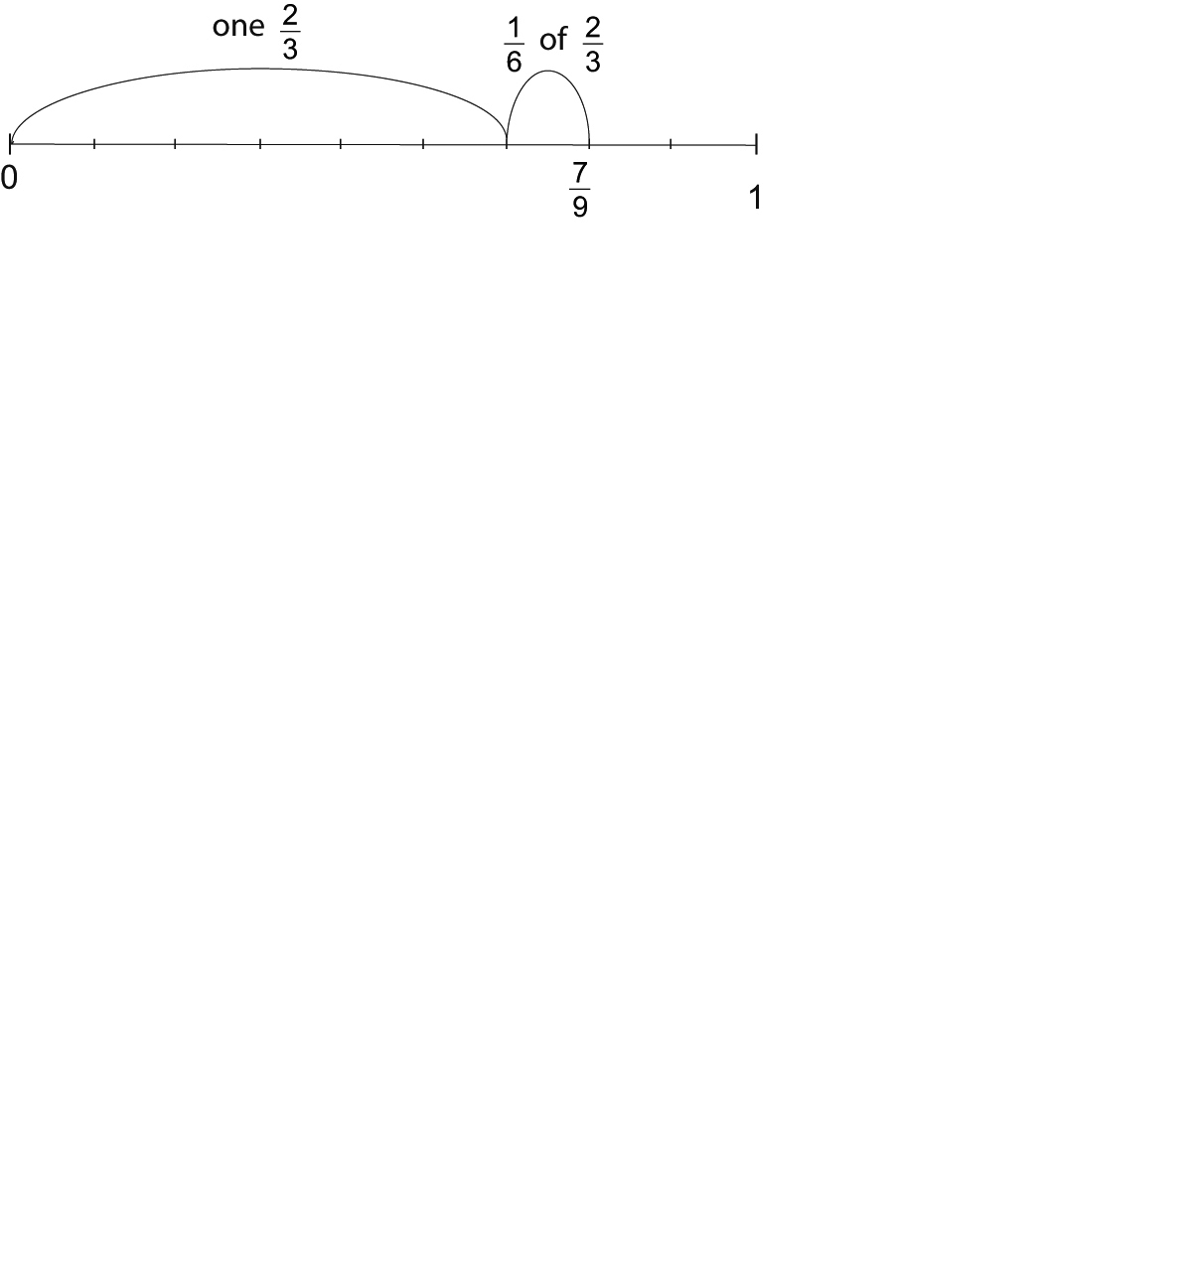

**c)** 

**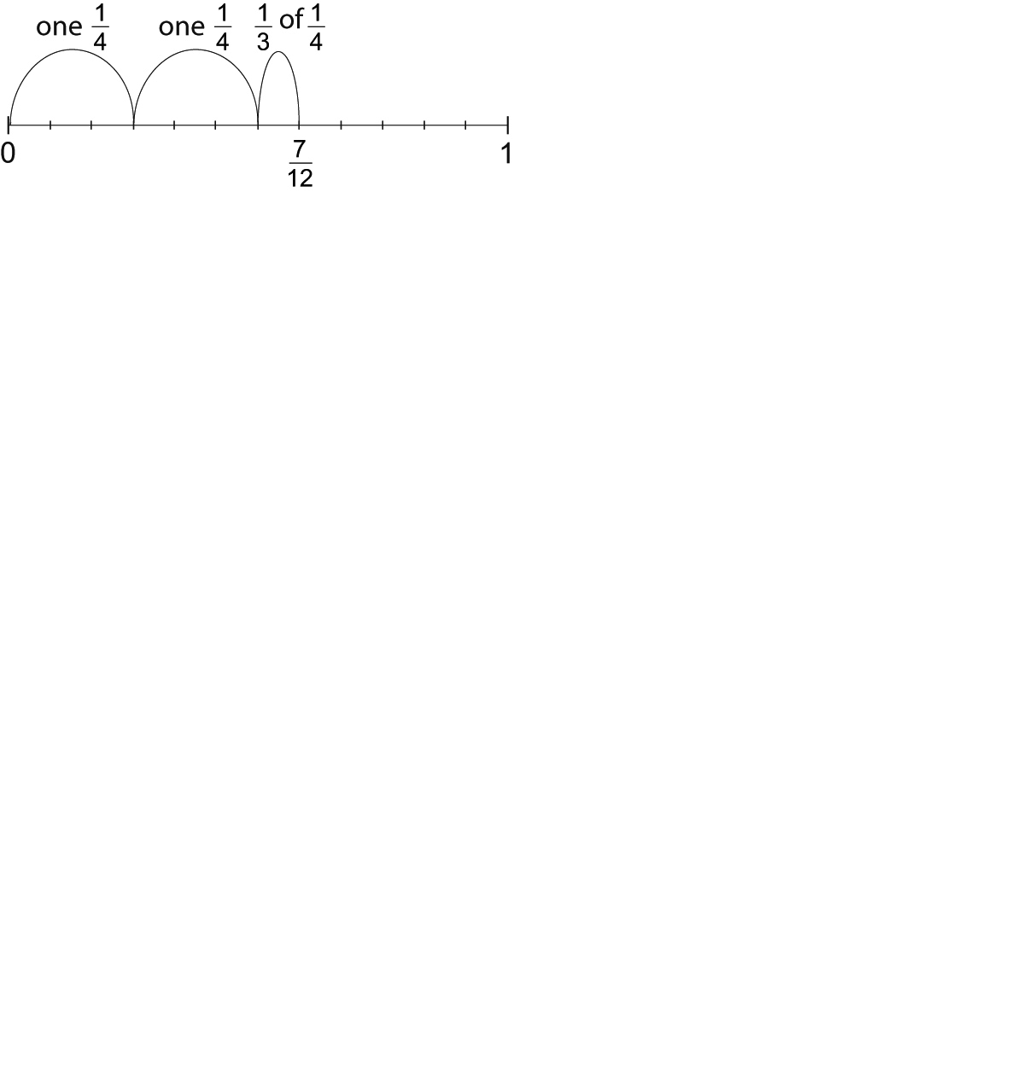 d)** 

**3. a)**  **b)**  **c)**  **d)** 

**4.**  **a)**  **b)**  **c)**  **d)** 

**5.** **a)**  **b)**  **c)** 

Extra Practice 7

|  |
| --- |
| Lesson 3.7: Dividing Mixed Numbers  Target B-1  **1.** Write each mixed number as an improper fraction.  **a)** 2 **b)** 1 **c)** 3 **d)** 7  **2.** Use common denominators to find each quotient.  **a)** 1 ÷ **b)** 2 ÷ 1 **c)** 4 ÷ 1 **d)** 5 ÷  **3.** Use multiplication to find each quotient.  **a)** 3 ÷ 1 **b)** 6 ÷ 2 **c)** 5 ÷ 2 **d)** 6 ÷ 7  **4.** Divide. Estimate to check.  **a)** 2 ÷ 1 **b)** 3 ÷ 2 **c)** 1 ÷ 2 **d)** 3 ÷ 2  **5.** Which statement has the greatest value? How do you know?  **a)** 2 ÷  **b)** 2 +  **c)** 2 ×  **d)** 2 –  **e)** 2 ÷  **f)** 2 + |

**Extra Practice 7 Answers**

**1. a)**  **b)**  **c)**  **d)** 

**2. a)** 12 **b)**  **c)**  **d)** 

**3. a)**  **b)**  **c)**  **d)** 

**4. a)** 2 **b)** 1 **c)**  **d)** 1

**5**. 2 ÷  = 8; dividing a number by  will give a greater answer than adding  to the number, multiplying the number by , subtracting  from the number, or dividing the number by 3; adding  to the number will give a lesser answer than dividing by .

Extra Practice 8

|  |
| --- |
| Lesson 3.8: Solving Problems with Fractions  Target B-1  Solve the following problems.  Estimate to check the reasonableness of your solutions.  **1.** During a one-hour phone-in talk show, 8 callers made calls that took 3 min each.  **a)** How many minutes were used by the 8 callers?  **b)** What fraction of the hour was used by these callers?  **c)** How many minutes were left for other callers?  **d)** What fraction of the hour was left in the talk show for other callers?  **2.** Ms. Lecky ordered pizza for a party. 1 of the vegetarian pizza and   of the ham and pineapple pizza were not eaten. How much pizza was left?  **3.** A dressmaker needs 3 m of fabric to sew one dress.  How many dresses can the dressmaker make with 28 m of fabric?  **4.** A dock is 7 m high. The portion of the dock above water one day was measured at 2 m high.  How much of the dock structure was above water that day? |

**Extra Practice 8 Answers**

**1. a)** 26 min **b)**  **c)** 34 **d)** 

**2. **

**3.** 8 withleft over

**4.** 