Grade 8 – Science

Exam Review
Answer Key 2014

Name: ___________________

Class: _____

UNIT BY UNIT – BIG TOPICS (REFERENCE TEXTBOOK PAGES)

UNIT 1: CELLS AND SYSTEMS
- Parts of the microscope (page 12 to 14)
- How to use a microscope (page 12 to 14)
- Calculating total magnification and what happens when magnification is increased (page 13,15)
- Who’s credited with inventing the 1st simple microscope (page 7)
- Organelles and their functions (page 27)
- Differences between plant and animal cells (page 28,29)
- The cell theory – 4 parts (page 20)
- Diffusion and Osmosis (page 40 – 43)
- Why cells specialize (page 60)
- Chemical equation for photosynthesis and cellular respiration (page 48)
- How cells, tissues, organs, and organ systems are organized - order and examples of each (page 68)
- Major organs of the circulatory and respiratory systems (Page 79 and/or your notes)
- Similarities, differences, characteristics of arteries, veins, and capillaries (page 81)
- Structure and function of the heart (page 80 and/or your notes)
- Pathway of a red blood cell (notes, page 90,91)
- Parts of the blood, their functions (Page 88)
- How the circulatory system and respiratory system work together to provide oxygen for all cells (Page 81,82, and/or your notes)
- What’s blood pressure and how’s it measured with the sphygmomanometer (Page 92)
- How organ systems work together to maintain homeostasis (Page 84)
- How the immune system fights disease and how technology helps it (notes)
UNIT 2: FANTASTIC FLUIDS
- What fluids are (page 110)
- What viscosity is and how it relates to flow rate and temperature (Page 117 to 120)
- How internal friction and particle size relate to viscosity and flow rate (Page 123,124)
- How matter changes from state-to-state and the name of the changes (Page 115)
- How to calculate the density of a solid or liquid – regular/irregular (Page 138,139,141 and/or notes)
- How to use density to identify a substance (Page 143 #4)
- What pressure is and how it is calculated (Page 164)
- The difference between flow and static pressure (Page 170)
- How pressure relates to surface area and temperature (Page 174), depth (Page 170) or altitude.
- What hydraulics and pneumatics are and how they work (Page 175 to 179, 188)
- The heart as a pump in a hydraulic system (Page 180,181)
- What is a hydrometer (Page 153 to 155), and barometer (Page 185) and what do they do?
UNIT 3: LIGHT
- What is light? Types of light sources. Two basic properties of light (and evidence) (Page 204 to 213)
- Differences between fluorescent and incandescent sources and bulbs (Page 208,209)
- Energy pathway for fluorescent and incandescent light bulbs (Page 208)
- Transparent, translucent, opaque (notes)
- Laws of reflection, Laws of refraction (Page 217, 230) label reflection ray diagram
- Label a wave diagram (page 282,283)
- Difference between mirrors reflecting and lenses refracting (Page 240,245)
- The attitude (upright and inverted) and types of images formed by concave mirrors, convex mirrors (Pages 203,239,240,238,240 and/or notes)
- Which lenses converge or diverge light (Page 245)
- Comparing the eye to the camera: structures and functions (Page 247)*
- Why a person is near or far-sighted and how to correct it? (Page 247)
- The 3 additive primary colors (Page 273)
- The nature of color and white light and how we see it (Page 268-270, 274)
- The types of electromagnetic radiation and technologies that use them (Page 293 – 298)
UNIT 4: WATER SYSTEMS
- The distribution and relative amounts of fresh and salt water (Page 334,335)
- The water cycle and the vocabulary related to it (Page 324 – 331)
- Drainage and watersheds and environmental impact on the watersheds (Not in textbook)
- Pollution and watersheds (Page 320 to 323)
- Air pollution and water systems/acid rain (Page 336 – 338)
- Water treatment and human use of treated water (Page 394)
- Pollution of the seas and how we are not being responsible environmental citizens (Page 400 – 403)
- Floods cause, prevention and how to clean up after floods (Page 313,319)

Cells & Cell Systems Learning Outcomes:
Use appropriate vocabulary related to their investigations of cells and systems.
Include: cell theory, osmosis, diffusion, selective permeability, unicellular, multicellular, specialized cells and tissues, organs, systems, arteries, veins, capillaries, terms related to cell structure, heart structure, components of blood, and primary and secondary defense systems
Identify characteristics of living things, and describe how different living things exhibit these characteristics.
Include: composed of cells; reproduce; grow; repair themselves; require energy; respond to the environment; have a lifespan; produce wastes
Describe cell theory.
Include: all living things are composed of one or more cells; cells are the basic unit of structure and function of any organism; all cells come from pre-existing cells; the activity of an organism as a whole depends on the total activity of all its cells
Identify major events and technological innovations that have enabled scientists to increase our understanding of cell biology.
Examples: invention of the light and electron microscope, works of Robert Hooke, Anton van Leeuwenhoek, Matthias Schleiden and Theodor Schwann
Identify and compare major structures in plants and animal cells, and explain their function.
Include: cell membrane, cytoplasm, mitochondria, nucleus, vacuoles, cell wall, chloroplasts
Demonstrate proper use and care of the microscope to observe the general structure of plant and animal cells.
Include: preparing wet mounts beginning with the least powerful lens; focussing; drawing specimens; indicating magnification
Describe the movement of nutrients and wastes across cell membranes and explain its importance.
Include: osmosis, diffusion, selective permeability
Differentiate between unicellular and multicellular organisms.
Describe why cells and tissues are specialized in multicellular organisms, and observe examples.
Include: specialization is needed because all cells in a complex organism do not have access to the external environment
Describe structural and functional relationship among cells, tissues, organs, and systems.
Describe the structure and function of the heart and the path of blood to and from the heart through its four chambers.
Include: atria, ventricles, septum, valves, aorta, pulmonary artery, pulmonary veins, superior vena cava, inferior vena cava
Compare and contrast the structure and function of arteries, veins, and capillaries.
Identify components of blood and describe the function of each.
Include: red blood cells carry oxygen; white blood cells fight infection; platelets clot blood; plasma is the liquid part of blood that transports blood cells, dissolved material, nutrients, and waste products
Describe, using examples, how individual systems in the human body function interdependently.
Compare heart rate and respiratory rate before, during, and after various physical activities; explain the observed variations; and discuss implications for overall health.
Identify components of the primary and secondary defense systems of the body and describe their roles.
Include: primary defense system - skin, tears, ear wax, saliva, gastric juices, cilia hairs; secondary defense system - white blood cells, antibodies
Identify medical advances that enhance the human body's defense mechanisms and describe their effects on society.
Examples: vaccines, antibiotics
Research and describe disorders/diseases that affect body systems, and identify possible preventative measures.
Examples: liver disease, diabetes, multiple sclerosis, heart attack, stroke, high/low blood pressure, leukemia, anemia, high cholesterol
Describe functional similarities and differences of comparable structures and systems in different groups of living things.
Examples: movement, food intake, and digestion of a unicellular organism, an invertebrate, and a vertebrate; gas exchange in plants versus animals

Chapter 1:
- Which of the following is not a correct procedure for handling a microscope?
- Carry the microscope by its arm and its base
- Leave the high-power objective lens in place when not in use
- Use lens paper to clean the light source
- Use the stage clips to secure the slide

- Which of the following statements about the cell theory is not true?
- All living things are made up of only one cell
- The cell is the basic unit of structure in an organism
- All cells come from previously existing cells
- The cell is the basic unit of function in an organism

- Which of the following organisms has more than one cell?
- Euglena
- Spider
- Paramecium
- Amoeba

- When you increase the power of an objective lens on a microscope…
- You see more of the specimen
- You see less of the specimen
- The magnification decreases
- The field of view increases

- Function of cell organelles.
A | B
C i. Fluid-filled storage area | a. chloroplast
A ii. Contains the green pigment “chlorophyll” | b. nucleus
B iii. Controls all of the cell’s activities | c. vacuole
E iv. Surrounds the cell and controls flow of substances | d. mitochondrion
D v. Transforms energy for the cell | e. cell membrane

- Plant or animal cell organelles.
A | B
C i. nucleus | a. plant cells only
A ii. chloroplast | b. animal cells only
C iii. mitochondrion | c. both plant and animal cells
C iv. cell membrane
A v. cell wall

- Parts of the microscope.
A | B
B i. Holds the eyepiece and objective lenses at the proper working distance from each other | a. stage  b. tube
C ii. Controls the amount of light that reaches the object being viewed | c. diaphragm  d. fine-adjustment knob
D iii. Used with medium- and high-power objective lenses to bring the object into sharper focus. | e. ocular lens
A iv. Supports the slide.
E v. Look through this part, which usually magnifies the object by 10x.

- Calculate the magnification.
A | B
A i. Ocular lens of 10x and objective lens of 4x | a. 40x
C ii. Ocular lens of 5x and objective lens of 20x | b. 400x
E iii. Ocular lens of 2x and objective lens of 5x | c. 100x
B iv. Ocular lens of 10x and objective lens of 40x | d. 1000x
D v. Ocular lens of 10x and objective lens of 100x | e. 10x

- Scientists and their contribution to the cell theory.
A | B
E i. Conducted experiments that led to the final abandonment of spontaneous generation theories. | a. Leeuwenhoek  b. Schleiden
B ii. Botanist who proved all plants are composed of cells | c. Schwann
D iii. Conducted experiments that showed that maggots can from tiny eggs laid by flies (on rotten meat) | d. Redi  e. Pasteur
C iv. Zoologist who proved all animals are composed of cells
A v. Made instruments called microscopes that he used to examine “animalcules” that lived in pond water

- Sometimes creative people talk about fire as though it were a living thing. List and explain ways that fire is similar to living organisms.
A.W.V. but fire can move, reproduce (spread), exchange gases (burns O₂),
grow, excrete (give off smoke) and take in nutrients (wood etc.) but it is not
made of cells. MR. C. Green or Mr. Green or Characteristics of Living Things
- In what ways do you think a school building could be compared to a cell?
A.W.V. but each room has a task like an organelle. The office is like the
nucleus, gym is like the mitochondrion, etc.
- Are elephant cells the same size as mouse cells? Explain your answer.
Yes, but an elephant has many more cells.

Chapter 2:
- Identify the cell membrane that does not allow any particles to pass through it.
- Selectively permeable
- Permeable
- Impermeable
- Not really a cell membrane

- What kind of membrane lets every particle pass through it?
- Selectively permeable
- Permeable
- Impermeable
- Not really a cell membrane

- Which term best describes the movement of water from an area of high concentration to an area of low concentration?
- Flow
- Active transport
- Osmosis
- An energy reaction

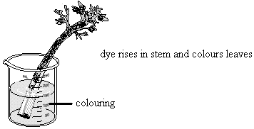
- What is the name of the process that is illustrated in the diagram?

- Flow
- Active transport
- Osmosis
- An energy reaction

- Which of the following is not an example of diffusion?
- Perfume is sprayed from a bottle and soon fills the room with fragrance
- Food colouring is dropped into a glass of water and eventually the water turns pink
- Boiling water causes rice grains to float to the top of the pot
- Chlorine is poured into a swimming pool, and eventually the whole pool has an equal chlorine distribution

- Which one of the following cells would you expect to have the shortest life span?
- Skin on a hand
- Muscle in an arm
- Blood in a heart
- Nerve in a toe

- Which of the following cells is thin and disk-shaped in order to have a large surface area?
- Neurons
- Red blood cells
- Muscle cells
- Skin cells

- In which organelle does cellular respiration occur?
- Nucleus
- Mitochondrion
- Chloroplast
- Vacuole

- In which organelle does photosynthesis occur?
- Nucleus
- Mitochondrion
- Chloroplast
- Vacuole

- Specialized cells.
A | B
B i. 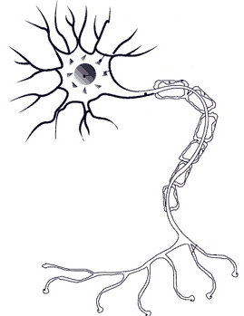 D ii. 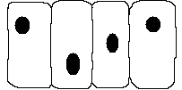 | a. muscle cell  b. nerve cell  c. red blood cell  d. skin cell
C iii. A iv.

- Substances involved in cellular respiration.
A | B
A i. carbon dioxide | a. product
B ii. oxygen | b. reactant
A iii. energy
A iv. water
B v. sugar

- Substances involved in photosynthesis.
A | B
B i. carbon dioxide | a. product
A ii. oxygen | b. reactant
B iii. energy
B iv. water
A v. sugar

- Impermeability, permeability, and selectively permeability.
A | B
C i. open window | a. impermeable
B ii. towel | b. selectively permeable
A iii. plastic sheet | c. permeable
A iv. closed window
B v. window with a screen

- Grocers spray fresh vegetables with water to keep the vegetables crisp. What process are they making use of?Osmosis…as the veggies lose water to the air (less concentrated) the water is sprayed on to replenish them.
- Why is it advisable to protect yourself from the Sun by wearing a hat, long sleeves, and using sunscreen? Explain your answer on a cellular level.
Harmful UV rays from the sun damage your cells.
- A nicotine patch is used to help smokers get over their addiction to nicotine.
- What is the process that helps this to happen? Diffusion
- Explain. Nicotine diffuses into the blood stream where it is less concentrated than in the patch.
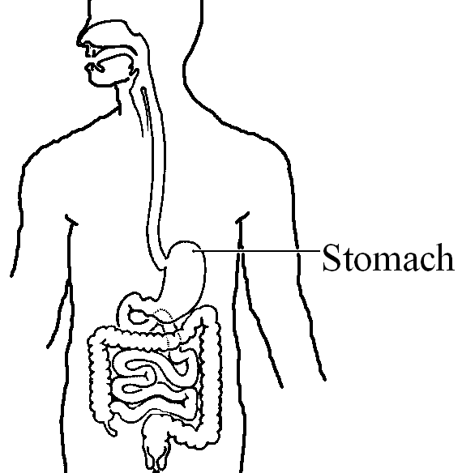
Chapter 3:
- What term could you use to describe the stomach?

- Tissue
- Organ
- Organ system
- Organism

- Which system transports food AND oxygen to all body cells?
- Digestive system
- Respiratory system
- Circulatory system
- Nervous system

- Jenka has a cold. Which system is fighting this cold virus?
- Digestive system
- Respiratory system
- Circulatory system
- Immune system
- Which one of the following is not a component of the blood?
- Plasma
- Vitreous humor(hemoglobin)
- White blood cells
- Platelets

- Which component of blood defends the body against infection and disease?
- Plasma
- Red blood cells
- White blood cells
- Platelets

- The respiratory system.
A | B
C i. Millions of tiny air sacs found in the lungs | a. trachea
E ii. Where air enters the body | b. larynx
D iii. The windpipe divides into a right and left one | c. alveoli
A iv. Also known as the windpipe | d. bronchus
F v. Thousands of smaller branchings found in a bronchus | e. nose
 | f. bronchioles

- The circulatory system.
A | B
B i. Are thinner-walled vessels that have valves so that blood does not flow backward | a. arteries  b. veins
F ii. Chambers in the heart that receive blood from veins | c. capillaries
A iii. Thick, muscular vessels that carry blood under high pressure | d. heart  e. ventricles
E iv. Chambers in the heart that pump out blood | f. atria
C v. The smallest blood vessels

- When people listen to your heartbeat, they may hear a “lub-dub” sound.
  - Why do you think they hear this sound? It is the sound of the valves closing. The “lub” is the valves for the atria and the “dub” is the valves for the ventricles.
  - What is the device that they use to listen to your heart? Stethoscope

- Blood pressure is the pressure that the blood exerts on the wall of a blood vessel. Why does your pulse feel stronger in your neck and weaker in your wrist? Because it is closer to your heart…i.e. closer to the pumping station so it is under greater pressure still.

- List and explain two factors that may cause blood pressure to increase.
Excitement, exercise, stress, diet (food) etc.

- a) Group the words below that relate to the circulatory system by putting a circle around them.
b) Group the words below that relate to the respiratory system by underlining them.
c) Label the following two diagrams, using the words provided (each word will be used once):

left atrium | Trachea | Left ventricle | Pulmonary artery
Aorta | Bronchi | Septum | Right ventricle
Lungs | Mouth | Superior vena cava | Right atrium
Alveoli | Diaphragm | Nose | Inferior vena cava
Bronchioles | Pulmonary artery | Pulmonary vein

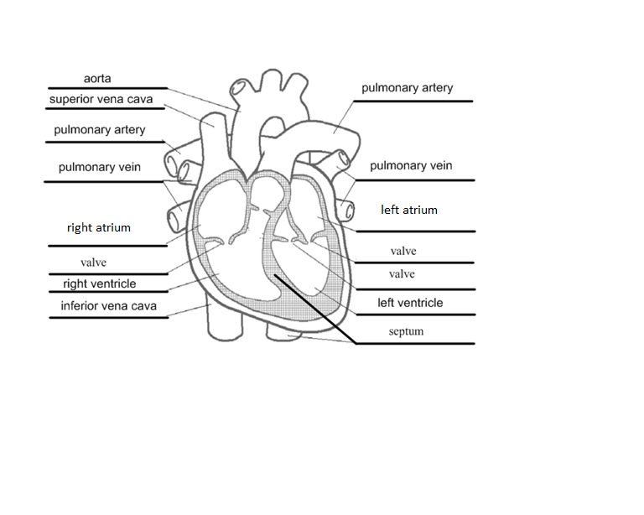

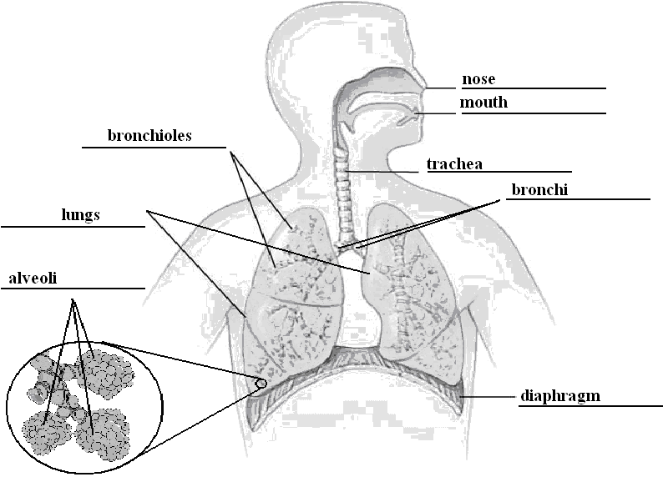

- a) Label the parts of the microscope.

Base | Light Source | Body tube | Condenser lens
Stage | Arm | Diaphragm | Stage clips
Ocular lens/  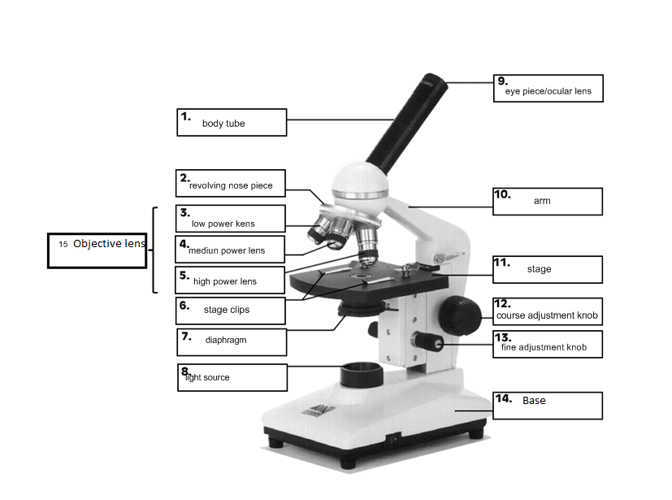  Eye piece | Coarse Adjustment knob | Revolving Nose  Piece | Fine Adjustment  Knob
Low Power Lens | Medium Power Lens | Objective lens | High Power Lens

b) Pick five parts of the microscope and state their function.

Microscope Part | Function
Eyepiece | AKA Ocular lens – the part you look through. It has a lens that magnifies the object, usually by 10 times (10x).
Tube | Holds the eyepiece and the objective lenses at the proper working distance from each other.
Revolving nosepiece | Rotating disk that holds two or more objective lenses. Turn it to change lenses. Each lens click into place.
Objective lens | Magnify the object. Each lens has a different power of magnification, such as 10x, 40x, and 100x.
Fine-adjustment knob | Use with medium- and high-power magnification to bring the object into sharper focus.
Coarse-adjustment knob | Moves the tube or stage up and down to bring the object into focus. Use it only with the low-power objective lens.
Stage | Supports the microscope slide or specimen. Clips hold the slide in position. A hole in the centre of the stage allows the light from the light source to pass through the slide.
Condenser lens | Directs light to the object being viewed.
Diaphragm | Use this to control the amount of light reaching the object being viewed. It is a disk with different sized holes in it that rotates.
Light source | Shining a light through the object being viewed makes it easier to see the details. Some have a mirror instead of a light.

- a) Label the plant cell diagram and state the functions of the organelles.

Cell Wall | Mitochondria | Cell Membrane | Nucleus
Cytoplasm | Vacuole | Chloroplasts
Endoplasmic reticulum
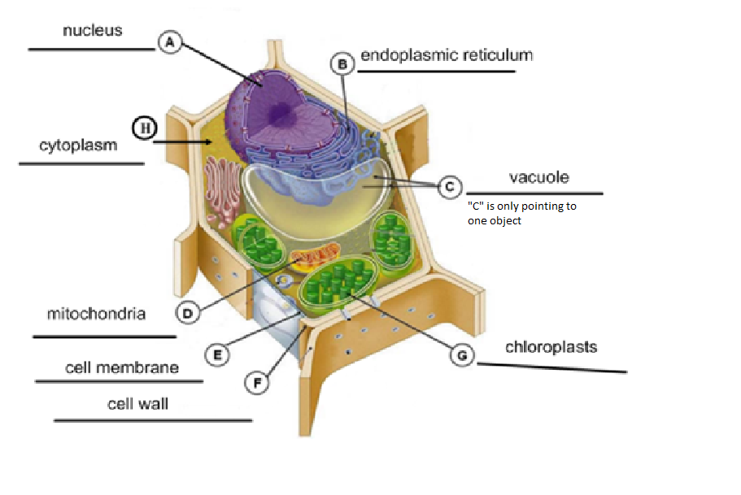

- Pick five parts of the plant cell and state their function.
Organelle | Function | Animal/Plant/Both
cell membrane | Surrounds the cell and protects the cell contents – regulates materials that enter and exit the cell | Both
cytoplasm | Distributes materials like oxygen and food to different parts of the cell – also helps support parts inside cell | Both
nucleus | Controls the cell’s activities and contains chromosomes | Both
vacuole | Storage places for surplus food, wastes, and other substances that the cell cannot use right away | Both (bigger in plants)
endoplasmic reticulum | Transports materials to different parts of the cells or to the outside of the cell | Both
mitochondria | Break down food particles to release their chemical energy for the cell’s activities, makes energy for the cell. | Both
cell wall | Provide support for the cell | Plant
chloroplasts | Location of photosynthesis to convert energy from the sun into sugar (carbohydrates) | Plant
chromosomes | Structures in the nucleus made of genetic material that directs the cell’s growth and reproduction | Both
Unit 2: Fantastic Fluids
Use appropriate vocabulary related to their investigations of fluids.
Include: fluid, viscosity, flow, density, particle theory of matter, buoyant force, pressure, compressibility, hydraulic, pneumatic
Distinguish between fluids and non-fluids.
Explore and compare the viscosity of various liquids.
Examples: time the fall of a steel ball through various liquids; time the flow rate of different liquids on an incline
Identify products in which viscosity is an important property, and evaluate different brands of the same product, using the design process.
Examples: sauces, lubricating oil, paint, hand lotion
Plan and conduct experiments to determine factors that affect flow within a given system.
Examples: temperature, pressure, tube diameter
Measure, calculate, and compare densities of solids, and liquids, and gases.
Include: different amounts of the same substance, regularly and irregularly shaped objects
Illustrate, using the particle theory of matter, the effects of temperature change on the density of solids, liquids, and gases.
Compare fluids of different densities to determine how they alter the buoyant force on an object.
Recognize that pressure is the relationship between force and area, and describe situations in which pressure can be increased or decreased by altering surface area.
Examples: wearing snowshoes instead of boots to decrease pressure, increase surface area, and stay on top of snow
Explain, using the particle theory of matter, the relationships among pressure, volume, and temperature of liquid and gaseous fluids.
Compare the relative compressibility of water and air, and relate this property to their ability to transmit force in hydraulic and pneumatic devices.
Identify a variety of natural and constructed hydraulic and pneumatic systems and describe how they function.
Examples: heart, lungs, eyedropper, misting bottle, fuel pump, hydraulic lift
Compare hydraulic and pneumatic systems, and identify advantages and disadvantages of each.
Use the design process to construct a prototype that uses a pneumatic or hydraulic system to perform a given task.
Examples: a prototype that can lift a load a specified distance

Chapter 4:
- A substance with a flow rate of 0.0 cm/s at room temperature is…
- A gas
- A liquid
- A solid
- A plasma

- Which flow rate indicates the lowest viscosity?
- 2.0 cm/s
- 13.0 cm/s
- 0.0 cm/s
- 5.0 cm/s

- Name the change of state that is demonstrated when snow disappears without a
trace on a sunny day.
- Melting
- Freezing
- Evaporation
- Sublimation

Use the following to answer questions 45, 46, & 47:

Flow Rate of Liquids
Liquid | Flow Rate (cm/s)
Water | 0.66
Molasses | 0.05
Cooking oil | 0.4
Honey | 0.055

- Which order ranks the substances by flow rate, from highest to lowest?
- Water, cooking oil, honey, molasses
- Water, cooking oil, molasses, honey
- Molasses, honey, cooking oil, water
- Honey, molasses, cooking oil, water

- Which order ranks the substances by viscosity, from highest to lowest?
  - Water, cooking oil, honey, molasses
  - Water, cooking oil, molasses, honey
  - Molasses, honey, cooking oil, water
  - Honey, molasses, cooking oil, water

- In which substance would it be most difficult to blow bubbles?
- Water
- Molasses
- Cooking oil
- Honey

- Why is oil more viscous than water?
- It comes out of the ground.
- It’s density is greater than water.
- It is made up of less bulkier particles.
- It is made up of more bulkier particles.

- States of matter
A | B
B i. Indefinite shape and definite volume | a. solid
D ii. Very hot gas in an ionized state | b. liquid
A iii. Definite shape and definite volume | c. gas
E iv. Definite shape and indefinite volume | d. plasma
C v. Indefinite shape and indefinite volume | e. no such state
- Changes of state
A | B
D i. Drops of water form on a lawn early in the morning | a. sublimation
C ii. Water changes to ice | b. melting
E iii. A pond becomes shallower as a dry spell continues | c. freezing
A iv. Ice cubes shrink when left in the freezer for a long time | d. condensation
B v. Chocolate chips become chocolate sauce in a microwave oven | e. vaporization

- Key terms related to change of state
A | B
C i. Slow vaporization | a. fusion
A ii. Another term for melting | b. vapour
D iii. Rapid vaporization | c. evaporation
E iv. Liquid wax becoming hard | d. boiling
B v. A gas that normally exists as a liquid at room temperature | e. solidification

- Particle theory of matter
A | B
C i. All matter is made up of very small ones | a. different
D ii. All particles of a pure substance | b. space
B iii. What is found between particles | c. particles
E iv. What particles are always doing | d. identical
C v. Move faster as they gain energy | e. moving

- Changing viscosity
A | B
C i. Thinning oil paint with turpentine | a. heating
A ii. Microwaving honey that has gone hard | b. cooling
D iii. Creating a wall paint that does not drip down the brush handle | c. diluting  d. concentrating
B iv. Stiffening soft ice cream
D v. Producing a fabric softener that can be stored in a smaller container and diluted when ready to use

- Key terms related to viscosity
A | B
B i. A fluid’s resistance to flow | a. flow rate
C ii. Can cause a solid to flow | b. viscosity
D iii. The action between the particles of a fluid that cause viscosity | c. melting  d. internal friction
A iv. Used to estimate the viscosity of a fluid | e. chilling
E v. Used to increase the viscosity of a fluid

- Compare and contrast the terms “fluid” and “liquid”.
A “fluid” is anything that flows (liquid or gas) but a “liquid” is a state of matter.
- Make three comparisons between traffic moving on a busy highway and
viscosity in fluids. A.W.V.

- Paint is manufactured to give optimum performance on a specific viscosity.
Once the paint has been opened, its viscosity begins to change. List three
things that a painter can do to keep the paint in its original viscosity for as long
as possible. Heat, stir, paint thinner, put lid back on it etc.

Chapter 5:
- What instrument measures liquid density?
- Barometer
- Thermometer
- Hygrometer
- Hydrometer

- If the gravitational pull on an object suspended in a fluid is greater than the buoyant force, what will happen to the object?
    - It will float
    - It will rise
    - It will sink
    - It will become less dense

- According to the diagram, which liquid has the highest density?
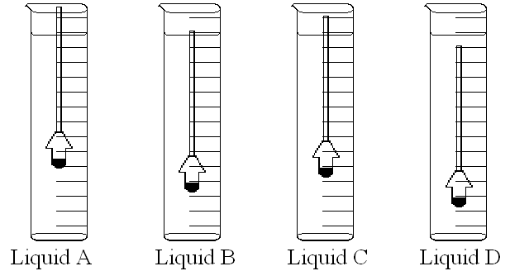
- Liquid A
- Liquid B
- Liquid C
- Liquid D

- What do you do to make a Cartesian diver sink in the bottle?
- Fill the bottle with water
- Release the sides of the bottle
- Increase the average density of the Cartesian diver
- Decrease the average density of the Cartesian diver

- Ivan performs an investigation into the density of a liquid. After recording his results in a data table, he calculates the density. What is his answer?
Volume (mL) | Mass of beaker (g) | Mass of beaker and substance (g)
100 | 185 | 385
200 | 185 | 587
300 | 185 | 784

- 185g
- 200g/mL
- 2.0g/mL
- 2.0mL

- According to the density tower shown, list the substances in order from most to least dense.
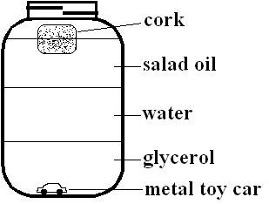
- Cork, salad oil, water, glycerol, metal toy car
- Metal toy car, glycerol, water, salad oil, cork
- Salad oil, water, glycerol
- Glycerol, water salad oil

- A riverboat loaded with gravel comes to a bridge that is 5 cm too low for the
boat to pass beneath it. What is the best way to solve the problem?
- Unload some of the gravel
- Turn the barge around and find another route
- Have some of the crew members wait on the riverbank
- Add more gravel to the load

- Aisha wants to find out the density of the milkshake she is drinking. What equipment will she need?
- Graduated cylinder, spring scale
- Graduated cylinder, balance
- Large container, spring scale
- Large container, balance

- Key terms related to density and buoyancy.
A | B
D i. Total mass divided by total volume | a. buoyant force
A ii. Opposes the force of gravity | b. hydrometer
B iii. Used to measure liquid density | c. barometer
C iv. Measures air pressure | d. average density

- Calculating density.
A | B
E i. Amount of fluid a container will hold | a. mass
C ii. Amount of space occupied by a substance | b. weight
A iii. Amount of matter in a substance | c. volume
B iv. Force of gravity exerted on an object | d. mass : volume
D v. Ratio used to find density | e. capacity
 | f. buoyancy
- Forces in action.
A | B
D i. Ability of a fluid to support an object in or on the fluid | a. flying
C ii. Occurs when an object’s weight is greater than its buoyancy | b. floating
B iii. Occurs when an object remains suspended in a fluid | c. sinking
E iv. Pulls down, toward the centre of Earth | d. buoyancy
 | e. gravity
- Units of measure.
A | B
B i. Density of a solid | a. mL
A ii. Volume of a liquid | b. g/cm³
D iii. Density of a liquid | c. lb
E iv. Mass | d. g/mL
 | e. g

- Terms related to buoyancy.
A | B
C i. Can be lowered by wearing a life jacket | a. periscope
D ii. Part of the depth-control structure of a submarine | b. neutral buoyancy
 | c. average density
F iv. Organ containing a mixture of air and water | d. ballast tank  e. swim bladder
B v. When force of gravity and buoyant force are equal

- The students in your class are having a contest to see who can design the aluminum foil boat that holds the most pennies without sinking. Your boat sinks after 20 pennies have been loaded onto it. Several of the boats are able to float more than 100 pennies on board. The teacher agrees to a rematch. List three elements you should consider when designing your second boat, and explain why each is important. A.W.V. Large surface area, high sides, no leaks, etc…should show understanding of average density.

- Jesse buys and old statue of a horse at a garage sale. It is about 20 cm tall and very tarnished. She cannot tell what metal it is made out of, but she thinks it may be copper. How can she find out for sure? Outline a procedure she could follow using step-by-step instructions. Find density. Steps should explain water displacement and using a balance.
- Marcel has a plastic statue of a frog that he wants to use as a focal point for his underwater garden. Every time he tries to put the frog in place, however, it floats back up to the surface. Use your knowledge of buoyancy and density to suggest two ways of making the hollow statue stay at the bottom. A.W.V. fill it with something more dense, tie it down, etc.

- You have been challenged to find the density of a styrofoam packaging “peanut”.
a) Describe how you would accomplish this task. Water displacement and a balance to find density.
b) List two difficulties that you might expect to encounter and how you would overcome them. It may float…various ways to overcome this etc.

Chapter 6:
- In what direction does a fluid at rest exert pressure?
- Up and down
- Sideways
- At right angles to the container or perpendicular to the container
- In all directions

- Which is the most common device for measuring air pressure?
- Hydrometer
- Barometer
- Sphygmomanometer
- Radar
- Four students are asked to use straws of various lengths to drink some juice.
The straws are 20 cm, 40 cm, 60cm, and 1 m in length. The longest straw is
the hardest to drink with. What factor is responsible?
- The number of juice particles in the glass
- Pressure on the surface of the juice in the glass
- Pressure on the outside wall of the straw
- The air pressure on the air in the straw

- Why are gases compressible?
- Their particles are extremely far apart
- They are invisible
- Their particles are large
- Their particles are not complex

- Why will a balloon left inside a car on a hot day become larger?
- The air particles inside the balloon collide with the balloon walls more frequently
- The material of the balloon softens and becomes less stretchable
- The air pressure inside the car increases
- The density of the air inside the car increases

- An engineer is applying a certain amount of force to an object in a test lab. The engineer’s assistant suggests spreading the same amount of force over double the area. What will happen?
- The pressure on the object will be doubled
- The pressure on the object will be halved
- The pressure on the object will not be affected
- The force will decrease
- You are using a vacuum cleaner to suck up some wood shavings in the workshop. Which of the following is true about the air pressure inside the machine when it is running?
- It is greater than the air pressure outside the machine
- It is equal to the air pressure outside the machine
- It is less than the air pressure outside the machine
- It will vary depending on the amount of wood shavings

- Ramiro heats a pop can and then immerses it in ice to cool it quickly. The pop
can implodes. What might he infer from this result?
- Air pressure inside the can decreased
- Air pressure inside the can increased
- A vacuum was created outside the can
- There was no change in air pressure inside the can

- What could you do to your garden hose to make the water that flows from it travel farther?
- Make a bigger hole at the end of the hose for the water to get out
- Keep the hose coiled up as much as possible
- Use the hose when it is cold outside
- Make the hole at the end of the hose smaller

- Which of the following experiences indicates that pressure changes with depth and altitude?
- Your sister feels pain in her hears when she dives to the bottom of a lake
- Mountain climber ascending the Himalayas gets a crushing headache
- Your ears pop when you take a fast elevator to the top of the CN Tower
- All of the above

- Key terms related to compression.
A | B
D i. Force per unit area (Newton per cm²) | a. compressibility
A ii. The ability to be squeezed into a smaller volume | b. compressor
E iii. Unable to move much closer together | c. decompress
B iv. Key mechanical part of a pneumatic system | d. pressure
C v. Release pressure and allow particles to move freely | e. incompressible
- Hydraulics at work.
A | B
D i. Transmits applied force through a liquid | a. Jaws of LifeTM  b. pumping station
A ii. Used to free people from vehicles involved in an accident | c. internal friction  d. hydraulic system
C iii. Can affect fluid pressure
B iv. Restores pressure on long routes

- Pressure in fluids.
A | B
B i. Changes with altitude | a. water pressure
D ii. The study of pressure in liquids | b. air pressure
F iii. Have the ability to flow | c. pneumatics
A iv. Changes with depth | d. hydraulics
C v. The study of pressure in gases | e. particle theory
 | f. fluid particles

- Pneumatics at work.
A | B
C i. Protects driver from full force of impact | a. air pressure
A ii. Builds up in compressors | b. pneumatic brakes
B iii. Used by heavy trucks to stop quickly and safely | c. air bag

- Explain why it would be impossible to drink a glass of milk through a 10m long straw. Gravity acting on the air and milk in the straw would be too strong to counteract the sucking on the straw.

- This is a diagram of a “Cartesian diver.” Using the ideas of buoyancy, pressures, and average density, explain how it works.

The eye dropper is initially floating because the buoyant force is greater than the gravity pulling on it. It is less dense than the water. Squeezing the bottle compresses the air at the top of the eye dropper. This increases the average density of the eye dropper which then descends into the water. When the bottle is let go, the air re-expands and the average density decreases. The eye dropper then rises to the top of the water again.
Optics
Use appropriate vocabulary related to their investigations of optics.
Include: spectrum; additive theory; subtractive theory; frequency; wavelength; refraction; concave and convex mirrors and lenses; terms related to types of light sources, types of electromagnetic radiation, and the law of reflection
Differentiate between incandescent and luminescent sources of light.
Include: fluorescent, phosphorescent, chemiluscent, bioluminescent
Demonstrate that light is a form of energy, that light travels in a straight line, and can be separated into the visible light spectrum.
Explain, using the additive theory, how colours are produced, and identify applications of this theory in daily life.
Explain how the human eye detects colour, and how the ability to perceive colour may vary from person to person.
Demonstrate, using the subtractive theory, how colours are produced, and identify applications of this theory in daily life.
Compare and contrast various types of electromagnetic radiation, with respect to relative energy, frequency, wavelength, and human perception.
Include: radio waves, microwaves, infrared radiation, visible light, ultra-violet radiation, x-rays, gamma rays.
Provide examples of technologies that use electromagnetic radiation, and describe potential postive and negative impacts of their uses.
Examples: satellite dish, x-ray machine, light telescopes, motion sensors, microwave ovens
Conduct experiments to determine the law of reflection, and provide examples of the use of reflection in daily life..
Include: the angle of reflection is the same as the angle of incidence; the incident beam, the normal and the reflected beam are all on the same plane
Conduct experiments to compare the refraction of light through substances of different densities.
Explain how reflection and refraction produce natural phenomena.
Examples: sun dogs, rainbows, blue sky
Investigate to determine how light interacts with concave and convex mirrors and lenses, and provide examples of their use in various optical instruments and systems.
Demonstrate the formation of images using a double convex lens, and predict the effects of changes in lens position on the size and location of the image.
Examples: magnify or reduce an image by altering the placement of one or more lenses
Compare the functional operation of the human eye to that of a camera in focusing an image.

Chapter 7:
- Which term describes light bouncing off a surface?
- Luminous
- Non-luminous
- Reflection
- Refraction

- Each of the following lie on the same plane, except the …
- Normal
- Incident ray
- Reflected ray
- Reflecting surface

- According to the first law of reflection, the angle of incidence is equal to the …
- Normal
- Reflected ray
- Angle of reflection
- Reflecting surface
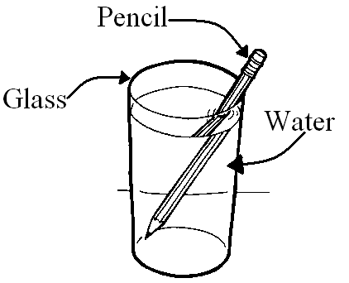
- Martha wishes to become a magician. She claims she can break a pencil in half without physically breaking. When you see her trick (shown below), you explain that it is an optical illusion based on …

- Reflection
- Refraction
- Luminosity
- Normal

- On a smooth plane mirror, if the angle of incidence is 30º then the angle of reflection is …
- 30º
- 60º
- 90º
- None of these are correct

- Which of the following statements is not true about the reflected image of an object in a plane mirror?
- The image is the same height as the reflected object
- The image is the same distance away from the object as the reflected image
- The image is the same size as the reflected object
- The image is upside down and the reflected object is right side up

- Refraction …
- Can be transformed into chemical energy, electrical energy, or thermal energy
- Is the bending of light as it passes from one medium to another
- Allows no light to pass through it
- Occurs when light bounces off a surface

- Reflection …
- Can be transformed into chemical energy, electrical energy, or thermal energy
- Is the bending of light as it passes from one medium to another
- Allows no light to pass through it
- Occurs when light bounces off a surface

- Types of light energy
A | B
D i. Special type of light produced in living creatures | a. incandescence
A ii. Emission of visible light by a hot object | b. fluorescence
E iii. Chemical reactions produce particles that give off visible light energy | c. phosphorescence  d. bioluminescence
C iv. Persistent emission of light following exposure to and removal of a source of radiation (“glowing in the dark”) | e. chemiluminescence
B v. Glow caused when ultraviolet light is absorbed by mercury particles and emitted as energy

- Luminous and non-luminous objects
A | B
A i. A light bulb | a. luminous
A ii. Stars | b. non-luminous
B iii. Planets
B iv. Books
A v. Glow-worms

- Types of reflection
A | B
B i. Light is shone on a plane mirror | a. diffuse reflection
A ii. Light is shone on a stucco ceiling (bumpy ceiling) | b. regular reflection
B iii. Light is shone on a smooth piece of aluminum foil
A iv. Light is shone on a crumpled piece of aluminum foil
B v. Light is shone on a calm lake at night

- What happens when light strikes a reflecting surface?
A | B
C i. normal  B ii. angle of incidence  D iii. angle of reflection  A iv. incident ray  E v. reflected ray | 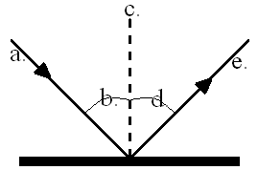

- Light terms
A | B
C i. Can be transformed into thermal, electrical, or chemical energy | a. image  b. luminous
B ii. Objects that produce their own light | c. light
D iii. Emits both light and heat | d. incandescent bulb
A iv. What you see in a mirror

- Draw a diagram of a tray that contains oil. What would happen to a beam of
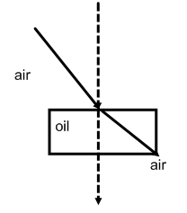
light as it travels through the tray? Knowing that oil is more dense than
water, how does the angle of incidence in air compare to the angle of
refraction in oil? Diagram should show light bending towards the
normal. The angle of incidence is greater than the angle of refraction
when the light strikes the dish.

Chapter 8:
- Name the black opening of your eye through which light enters.
- Retina
- Optic nerve
- Pupil
- Iris

- What is the coloured part of your eye called?
- Retina
- Optic nerve
- Pupil
- Iris

- Name one instrument to which the human eye is often compared.
- Telescope
- Pair of binoculars
- Camera
- Microscope

- Which descriptor below is not a characteristic of an image? *
  - Size
  - Attitude
  - Location
  - Concave

- The eyeball is filled with fluids called …
- Corneas
- Humours
- Retinas
- Lenses

- What do we call the natural adjustment in the size of the pupils?*
- Accommodation
- Optic nerve
- Blind spot
- Iris reflex

- Which of the following is not a characteristic of a concave lens?
  - Thinner in the middle, thicker edges
  - Flatter in the middle
  - Thicker in the middle, thinner edges
  - Causes light to spread out

- Which of the following is not a characteristic of a convex lens?
- Thinner in the middle, thicker edges
- Causes light to converge
- Thicker in the middle, thinner edges
- Forms image upside down

- Judy is in her late 40s. She has trouble seeing things that are close up. Her
eye condition is described in this diagram. What name describes this
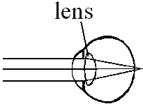
condition?
- Near-sightedness
- Far-sightedness
- Focussing
- Accommodation

- Jerome is a 12-year-old grade 8 student. He has trouble seeing things that
are far away. His eye condition is described in this diagram. What name
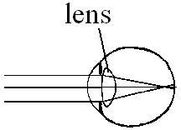
describes this condition?
- Near-sightedness
- Far-sightedness
- Lighting
- Accommodation

- Mandy wants to powder her nose. The powder comes in a small compact
with a mirror. When Mandy opens the mirror she notices that when she is
close to the mirror, her nose appears a bit larger than normal. From her
studies in optics, she knows that the mirror is…
- Concave
- Convex
- Compact
- Plane

- Definitions
A | B
D i. Path from the retina to the brain | a. virtual image*
B ii. Curves inward | b. concave mirror
A iii. An image from which no light comes | c. convex mirror
C iv. Bulges outward | d. optic nerve
E v. Controls the size of the pupil | e. iris

- Matching parts of the human eye to with camera parts.
A | 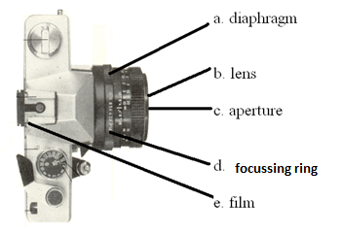B
e i. retina
a ii. iris
d iii. ciliary muscles
b iv. lens
c v. pupil

- How would you use a curved mirror to start a fire if you were hiking in the
woods and became lost? Name three safety precautions you would take
when starting the fire. Concave mirror. A.W.V.

- Draw and label a diagram showing how to use a mirror to start a fire.
Diagram should show light rays converging where fire is to be started.

- What kind of lens might a flashlight have? Explain why. Convex lens to
magnify light.

- Describe how the headlight of a car can be an application of reflection using
curved lenses. Spreads light out to illuminate a larger area.

- Jane works in a store and has been asked to put a convex mirror on the wall.
Jane has two mirrors to choose from; one that is curved inward and one that
is curved outwards. Which one is the correct choice? Why does her boss
want her to use this kind of mirror in the store? She should use a mirror
that is curved outwards because it gathers the light rays so she can see a
larger area.

Chapter 9:
- Which of the following is not an additive secondary colour of light?
- Magenta
- Cyan
- Blue
- Yellow

- What is name for the height of a crest or the depth of a trough from the rest
position?
- Wavelength
- Frequency
- Hertz
- Amplitude
- Which combination will result in cyan?
- Red + yellow
- Red + blue
- Green + yellow
- Green + blue

- Which of the following has the shortest wavelength?
- X-rays
- Gamma rays
- Infrared rays
- Ultraviolet rays

- Which of the following lists the colours in order of increasing wavelength?
(Shortest to longest)
- Red, yellow, orange, blue, green, violet
- Red, orange, yellow, green, blue, violet
- Violet, green, blue, orange, yellow, red
- Violet, blue, green, yellow, orange, red

- Amy has read that looking directly into the Sun can cause damage to a
person’s eyes. She decides to invest in a pair of protective sunglasses. What
kind of rays will be filtered out by her sunglasses?
- Microwaves
- Ultraviolet rays
- X-rays
- Infrared rays

- Doctor Ross is convinced that Jacob has a cancerous tumour and that
radiation is the best plan to prevent it from spreading. What type of
radiation therapy will be used?
- Gamma radiation
- Ultraviolet radiation
- X-ray
- Infrared radiation

- Mario knows that for a robot to detect motion, it determines if the object is
warmer than its surroundings. What type of rays does the motion detectors
sense?
- Gamma rays
- Ultraviolet rays
- X-rays
- Infrared rays

- Marcy and Breanna were fooling around and Marcy fell down the stairs.
She might have a broken bone in her leg. What type of radiation will the
doctor use to determine if the bone is broken?
- Gamma rays
- Ultraviolet rays
- X-rays
- Infrared rays

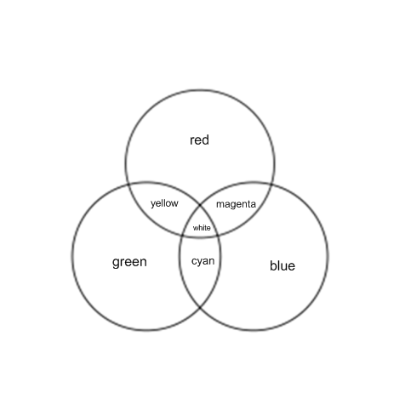
- Label the Venn diagram below using the additive colour theory. If necessary, refer to
page 273 from your textbook.

- Producing white light and secondary colours

A | B
B i. Red and blue | a. yellow
C ii. Green and blue | b. magenta
D iii. Cyan and red | c. cyan
A iv. Red and green | d. white
D v. Magenta and green

- Colour definitions
A | B
B i. The colours red, green, and blue | a. solar spectrum
D ii. Visible light energy and all the invisible forms of radiant energy | b. additive primary colours  c. laser
A iii. The colours red, orange, yellow, green, blue, indigo, and violet | d. electromagnetic spectrum  e. secondary colours
C iv. Light amplification by the stimulated emission of radiation
E v. The colours yellow, cyan, and magenta

- Looking at waves
A B
D i. The high part of the wave a. wavelength
C ii. How many waves pass a single point in a certain amount of time b. amplitude
E iii. The low part of the wave c. frequency
A iv. The distance from crest to crest, or from trough to trough d. crest
B v. The height of the crest, or depth of the trough from rest position e. trough

- Frequencies and wavelengths of light
 | A | B
E i. Have the shortest frequency and highest energy of all the radiant waves; are useful in destroying cancerous cells |  |  | a. microwaves  b. X-rays  c. ultraviolet radiation
C ii. Can result in tanning; can damage the cornea of the eye |  |  | d. infrared radiation  e. gamma rays
D iii. Heat radiation; useful in motion sensors and burglar alarms
B iv. Are penetrating and energetic waves that can easily pass through skin and muscle but are absorbed by hard bone
A v. Are absorbed by water particles in food, vibrate faster, and become hot

- Match the letter to the corresponding Roman numeral on the diagram below.
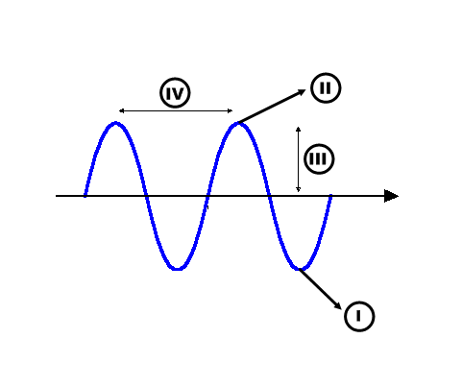
              - trough i
              - wavelength iv
              - crest ii
              - amplitude iii

- a) Describe one way in which light behaves like a wave instead of a particle.*
It doesn’t displace items it strikes.
b) Why do scientists prefer to talk about a wave model of light instead of saying that light is a wave?
Explains how light behaves but the waves would be too small to see to
confirm that they are there.

- Detail the effects of ultraviolet radiation on Earth if the ozone layer did not
exist. The ozone layer protects us from the UV rays that would burn our
skin. The earth would be too hot.

- What is the relationship between wavelength and frequency in light rays?
As frequency increases, wavelength decreases and vice versa.

- Label the eye using the words provided
ciliary muscles | cornea | optic nerve
sclera | lens | vitreous humour
iris | pupil | retina

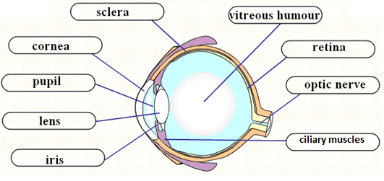

Water Systems on Earth
Use appropriate vocabulary related to their investigations of water systems.
Include: heat capacity, fresh water, salt water, convection, Coriolis effect, global water cycle, drainage system, watershed, continental divide, erosion, deposition, flow rate, tides, terms related to water treatment
Demonstrate that water, as compared to other substances, has a high heat capacity and is able to dissolve a wide variety of solutes.
Compare and contrast characteristics and properties of fresh water and salt water.
Examples: freezing point, density, dissolved materials, global distribution, relative amounts, biologically diverse components of each
Identify factors that can work individually or in combination to affect ocean currents.
Include: convection, Coriolis effect, prevailing winds, position of continents
Describe how the heat capacity of large bodies of water and the movement of ocean currents influence regional climates.
Examples: Gulf Stream effects, El Nino, lake affect
Describe the components of the global water cycle and explain how it works.
Describe features of the North American drainage system.
Include: local and regional watersheds, direction of water flow, continental divide
Describe how erosion and deposition are influenced by the flow rate of a stream or river, and contrast the related characteristics of young and mature streams.
Examples: meanders, oxbows, alluvial deposits, sandbars, flood plains, deltas
Describe how wave action and ice movement in large bodies of water cause erosion and deposition.
Explain how tides are caused and describe their effects on shorelines.
Describe examples of human interventions to prevent riverbank or coastal erosion.
Examples: vegetation, reinforcement (concrete, boulders), piers, breakwaters
Identify factors that can cause flooding either individually or in combination.
Examples: heavy snow pack, quick thaw, rain in spring, lack of vegetation to remove water through transpiration, frozen ground preventing absorption, agricultural drainage systems, dams, diversions
Provide examples of the way in which technology is used to contain or prevent damage due to flooding, and discuss related positive and negative impacts.
Examples: floodway, diversion, dike, levee
Identify sources of drinking water and describe methods for obtaining water in areas where supply is limited.
Examples: desalination, melting of ice, condensation
Explain how and why water may need to be treated for use by humans.
Include: filtration, settling, chlorination, fluoridation
Compare the waste-water disposal system within their communities to one used elsewhere.
Include: process involved, environmental impact cost
Identify substances that may pollute water, related environmental and societal impacts of pollution, and ways to reduce or eliminate effects of pollution.
Identify environmental, social, and economic factors that should be considered in the management of water resources.
Examples: ecosystem preservation, employment, recreation, industrial growth, water quality
Use the design process to develop a system to solve a water-related problem.

- Label the following diagram with the different aspects of the hydrological/water cycle. Be sure to include the different changes of state and arrows to show the direction in which the water is moving. Then explain the hydrological cycle including the different changes of state that occur within it.
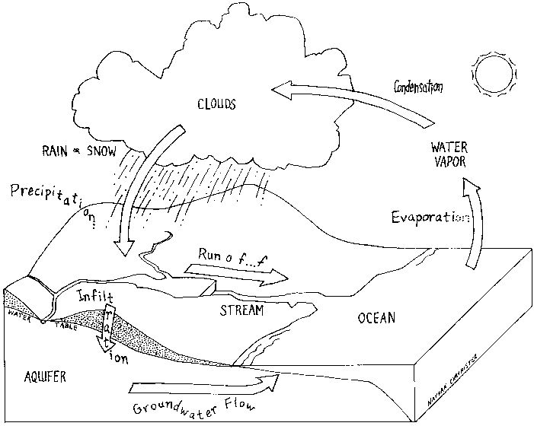

- a). What could you do personally to reduce your water usage?
Don’t leave tap on when brushing, switch to low flow shower head, leave a cold
jug of water in fridge, etc.
b). How can you prevent water contamination?
Don’t put medicines down the toilet, use phosphate free soaps, don’t use
pesticides, etc.

- Southern Manitoba is prone to flooding. There are a number of different
factors that can help contribute to a flood. List and explain as many as you
can. A high amount of precipitation the previous summer can saturate
the ground so that the snow melt cannot infiltrate into the ground
causing overland flooding. A high amount of snow can cause excess
water in the spring. A non-porous ground surface can cause excess run-
off because the water has nowhere else to go. ETC.

- Even though most of the surface of our planet is covered in water, only a
small percentage of that water is considered drinkable. Using the following
diagram, explain how much of the earth’s water is actually available for
drinking. Of this available water, some of it is still unsafe (dirty etc.). How
would you go about treating the water so that it would be safe to drink?

Only about 0.65% of the earth’s water is available for drinking. Purifying the water for drinking can be done by filtration, distillation, adding chemicals, etc.

SamPLE Long Answer Questions

Write out answers to the following questions.

- Compare the cellular structures of plant and animal cells.
- Compare the different forms of nutrient transfer into and out of cells (diffusion, osmosis and active transport).
- Review the contributions of all Scientists to the cellular biology.
- Describe the travel and adventures of a red blood cell as it makes one cycle through the body (ie the pathway of blood through the heart).
- Describe how to determine the density of regular and irregular objects. Make sure to use the correct name of instruments.
- Discuss the differences of Hydraulics and Pneumatics. Makes sure to point out advantages and disadvantages of each.
- Explain Archimedes’ Principle.
- Explain how a submarine is like a fish and how it is able to stay under water at a given depth.
- Compare regular and diffuse reflection. Use correct terms.
- Compare convex and concaves mirrors.
- Compare convex and concave lenses.
- Explain what a Laser is.
- Why is it important to be a good global citizen?
- Describe the water cycle. Use a diagram to support your work.
- Describe how rain in the mountains reaches the ocean. What can happen on a journey to the ocean?
- Describe how flooding can occur? What caused the flood of 1997?
- What do you have to do to protect our fresh water?

