WEBQUEST: Heart & Circulatory System
Name: ________________________

- Go to kidshealth.org & click the KIDS link or go to http://kidshealth.org/kid/ .
- Click HOW THE BODY WORKS on the left side menu or go directly to http://kidshealth.org/kid/htbw/htbw_main_page.html . Watch the pictures going across the screen and click on the HEART when you see it. It is below ears and beside lungs
- Once you click on the HEART, below it you will see:
MOVIE
ARTICLES
QUIZ
WORD FIND
ACTIVITIES
- Watch the movie. It MAY pop up in another window. DO NOT CLOSE the original window! You’ll need it later.
- Now click on ARTICLES – Your heart and circulatory system.
- Answer the following WEBQUEST questions on this sheet.

WHEN YOU ARE DONE THE WEBQUEST QUESTIONS…….

7) Go back to http://kidshealth.org/kid/htbw/htbw_main_page.html where you selected THE HEART, and then click on the third option down, QUIZ. Mark down what you get as a score OUT OF 10 ON THE BOTTOM OF THE WEBQUEST SHEET.

WHEN YOU ARE DONE…..

- Try the word find
- Try the activity (heart-labelling) if you have time.

If you do not have time, you will get a copy of a detailed heart that is labelled.

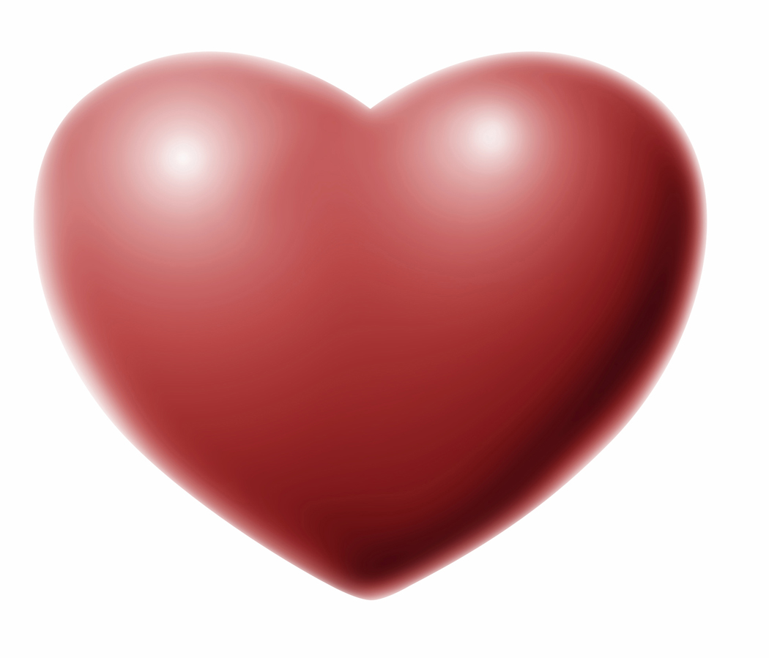WEBQUEST QUESTIONS

a) Is the shape of the heart inside of you the same as this? YES / NO

b) Read the section: Working That Muscle
Your heart is really a m_______________. It is about the size of your f_________ . The heart sends b__________________ around your body. The b______________ gives your body the o________________ and n________________ it needs and it carries away w_____________________ .
Your heart is a p_____________! The r_____________ side of your heart receives blood from the body and pumps it to the l_____________.

The l___________ side of the heart does the exact opposite: It receives blood from the lungs and pumps it out to the b____________.

- Read the section: We Got the Beat
Your heart f________ with blood and squeezes or c________________.

- Read the section: Heart Parts
The heart is made up of f______ areas that fill with blood. These are called c________________s. The two c______________s on top are called a__________, that is plural for 2 of them. A___________ means only one of them. You have a left and a right one. They fill with blood returning to the heart form the body and the lungs.

The two c_____________s on the BOTTOM are called the v_______________s. You have a left and a right one. Their function is to squirt out blood to the body and the lungs. You have a thick wall of muscle separating the 2 sides of your heart called the s_________________ . It keeps the blood from either side of the heart from mixing.

Your blood knows which way to go by special doors that let blood in and close the door so it can’t flow backwards. These “doors” are called v________________s.

- Read the section: It’s Great to Circulate
Blood doesn’t just float around our bodies. It moves through tubes called a__________________ and v___________________ and tiny vessels called c______________________________ (this last word isn’t on the website, check your textbook!).
A_____________________move blood away from the heart (A-A-Arteries Away!) and v______________ carry blood back to the heart (Veins have Valves, VV!)

The movement of the blood through the heart and around the body is called c___________________________!

The left side of your heart sends out o__________________________ blood out to the

body. Once your living cells do MR. C. GREEN and use up the oxygen and put in

wastes like carbon dioxide, the blood travels back to the heart! The returning blood enters the r_________________ side of the heart. This blood is full of wastes like carbon dioxide and needs a little freshening up with oxygen, so your heart pumps it back to the l_____________s!

- Read the section: Listen to the Lub-Dub& Pretty Cool — It's My Pulse!

What tool does a doctor use to listen to your heart? S___________________________

- Read the section: Keep Your Heart Happy

Summarize the 5 things you can do to keep your heart happy IN YOUR OWN WORDS!

1)

2)

3)

4)

5)

WEBQUEST ON THE ARTICLE IS DONE! GO BACK TO THE DIRECTIONS
(STEP 6)

RECORD YOUR MARK OUT OF 10 HERE ______________ /10

