**Science Test Review - Answers**

**Name of Structure Function**

A nose -warms, filters and moisturizes the incoming air

B mouth -warms & moisturizes the incoming air

C trachea -provides a path for the air to the lungs

D bronchi -provides a path for the air to the bronchioles (smaller branches of the

bronchi

E alveoli -allows oxygen from the air to diffuse into the capillaries that are

wrapped around it

F lungs -expand to hold air when inhaling and contract to exhale air

G diaphragm - muscle that contracts down to pull air into lungs and relaxes (moves

upward) to exhale air.

1. The respiratory system is responsible for bringing oxygen into the lungs during inhalation and getting rid of waste carbon dioxide during exhaling.
2. The path of the air from the mouth to the lungs is nose & mouth 🡪 trachea 🡪 bronchi 🡪 bronchioles 🡪 alveoli
3. See diagram above. 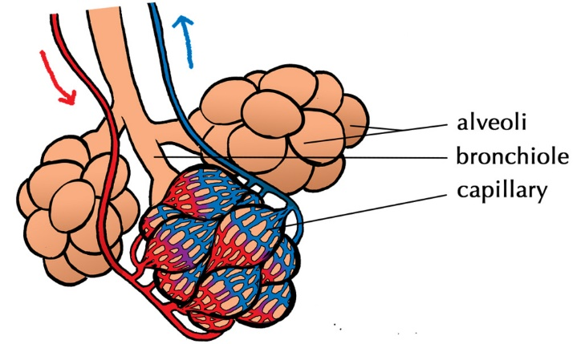



Carbon dioxide moves into the alveoli FROM the blood in the capillaries

Oxygen moves OUT OF the alveoli into the blood in the capillaries.

1. When we inhale, the ribs move out & the diaphragm moves down. This makes more space (volume) in the chest cavity and thus, air gets pulled into the body.

During exhalation, the ribs move in, the diaphragm relaxes, (moving up) and this makes less space (volume) in the chest. There is not enough space for the air so it moves out of the body.

1. 1. E 2. J 3. C 4. G 5. D 6. B (plural), I (singular) 7. D (away from the heart is always an artery 8. H 9. F 10. F OR E (C is ok but too general for these grade 8 experts) 11. I 12. A



CIRCULATORY SYSTEM

1. The main function of the circulatory system is to CIRCULATE blood from the heart to the lungs and from the heart to the body and back to the heart.

Heart Diagram



1. The heart is a double pump because the the two sides of the heart are two separate pumps that pump blood to different places.

The right side pumps blood FROM the body TO the lungs and back to the left side of the heart.

The left side pumps blood FROM the lungs TO the body.

1. The septum divides the heart into two sections. This is important because there are two separate pumps in the heart. The blood never travels directly from one side of the heart to the other.
2. The heart has 4 chambers: left atrium, left ventricle, right atrium, right ventricle
3. a) The RIGHT side receives deoxygenated blood. The LEFT side receives oxygenated blood.

b) The left side of the heart pumps blood to the body. The right side pumps blood to the lungs.

c) The main blood vessel that transports deoxygenated blood from the heart to the lungs

is the pulmonary ARTERY.

Remember artery 🡪 away!

Deoxygenated 🡪 colored blue -🡪 right side

d) The main blood vessel that transports oxygenated blood from the lungs back TO the heart is the pulmonary VEIN.

Remember vein 🡪 back TO the heart

Oxygenated 🡪 colored red -🡪 left side

e) The main blood vessel transporting blood TO the heart from the upper/lower body is the VENA CAVA

**3 Types of Blood Vessels**

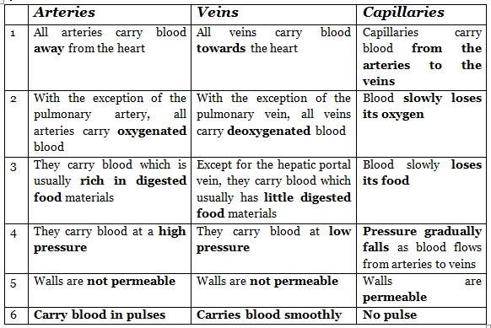

6 a) Three main differences between arteries and veins are caused because arteries move blood AWAY from the heart while veins move blood back to the heart.

Because of this

*veins need valves (to prevent backwashing of blood). They are pushing blood against gravity. Arteries have no valves.

*arteries need to be thicker (ie more muscular) as arteries push blood under higher

pressure

*arteries carry blood AWAY from the heart

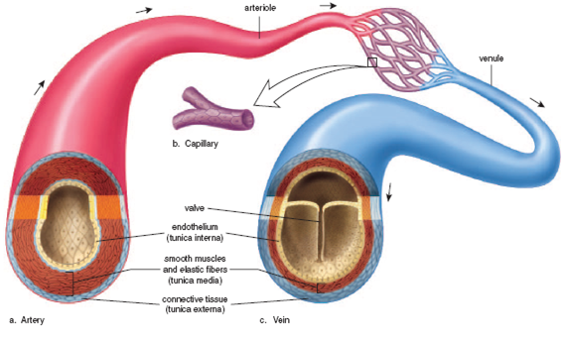

b) The main role of the capillaries are gas exchange. The two gases that are being exchanged (traded) are oxygen and carbon dioxide.

c) The MEMBRANES of the capillaries are so small because diffusion has to happen across the membrane of the capillaries. Oxygen diffuses from high to low. Carbon dioxide diffuses from high to low.



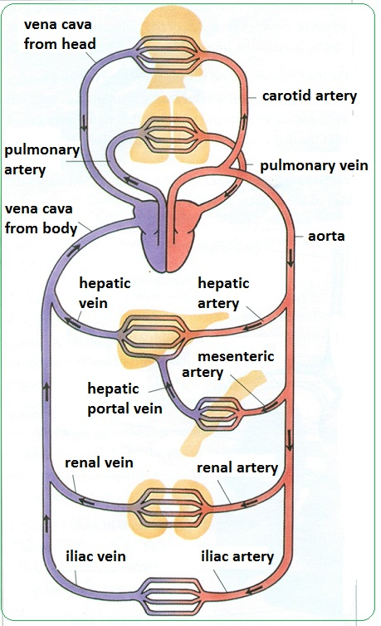



6 d) The function of the valves (in VEINS only) is to prevent backwashing of blood.

e) The veins have valves. The arteries have blood that is under high pressure so they do not have the problem of backwashing blood.

**4 Parts of Blood**

White blood cells – fight infection

Red blood cells – carry oxygen

Platelets – clot the blood (make scabs, blood clots)



Plasma – liquid for all other cells to move in, even antibodies are transported in the plasma when they are made.



The plasma makes up 55% of your blood. (The plasma itself is 92% water!)

1, 8,2,10,11,4,3,9,2,5,7,6

9a) Blood pressure is the FORCE (strength) of yoru blood pushing on the walls of your vessels.

**5 factors that can affect blood pressure.**

* + The volume of blood.
  + Heart rate
  + Artery size
  + Artery elastically
  + Blood viscosity

c) Sphygmomanometer gives the “lub-dub” measurement (ie systolic/diastolic pressure) of the blood being pushed from atria to ventricles

(stethoscope measures heart rate so it provides some information on blood pressure too)

d) To reduce blood pressure:

* Do not smoke

*Exercise regularly

*Eat healthy foods

*Do not eat foods with:

* + - High salt content
    - Fatty foods
    - Cholesterol (HDLD = good cholesterol and LDLD = bad cholesterol)

e) The difference between

* **Systolic pressure** – the pressure found in the arteries while the heart muscles are tightening and squeezing blood out of the heart
* **Diastolic pressure** – the pressure of blood as it continues to flow through the arteries between heart beats.

Immune System

1. The immune system is responsible for ensuring that pathogens (bacteria, viruses) do not enter the body (primary defense system) and if they do, that they are fought (using secondary defense system).
2. Saliva, skin, tears, earwax, cilia, gastric juices
3. Leukocytes (white blood cells) – attack and destroy

Antibodies – flag (identify) pathogens for destruction

1. A vaccine is a mild form of a virus that is injected (or swallowed into) into your body. It causes your immune system produces antibodies to the virus. If you do get exposed to that virus later, you already have antibodies that can identify (flag) them as dangerous and then your white blood cells can destroy them!

**PRACTICING APPLICATIONS & PROBLEM SOLVING**

**Circulatory system of a Fish**

1. The fish atrium must contain deoxygenated blood because it has come from the body and has not yet passed through the gills where the capillaries are for gas exchange. I know this not because we studied it but because I read the passage and I applied what I knew about human hearts to the fish heart.
2. The muscular walls of the ventricle suggest that it has a longer distance to push the blood, OR that the blood is under higher pressure here.
3. Humans exchange their gases through their capillaries wrapped around their alveoli
4. Yes, gases like oxygen need to move by diffusion no matter what organism because the concentration of oxygen will be high wherever oxygen is brought into the body. Oxygen will then diffuse naturally (ie it is a form of passive transport) from where it is high in concentration to where we need it (where it is low in concentration). Carbon dioxide is also a poisonous gas to organisms. We want it to diffuse from where it is in high concentration (in our cells after our cells have used the oxygen) to the outside of our body. It may have to be carried out of our body by our blood in larger organisms.

In some organisms, this diffusion happens right through the skin!!

**BLOOD VESSELS**

1. Vessel A has the structure needed to do the job of an artery.
2. Vessel A has strong, muscular walls that can handle the high blood pressure when the blood is leaving the heart form the strong ventricles.
3. THIS QUESTION SHOULD HAVE READ VESSEL B!! (APOLOGIES, candy for everyone!)

Vessel B has valves to prevent the blood from backwashing backward. For example, if we have weak veins, our blood might “pool” in our legs.

1. Vessel C has a thin membrane so that gases (carbon dioxide, oxygen) can diffuse through it easily.

**Connections between the Respiratory & Circulatory Systems**

The respiratory system gets oxygen into our alveoli. Our circulatory system has blood vessels with thin walls surrounding the alveoli so that the diffusion of that oxygen can happen and provide oxygen to our cells. The blood is the carrier of that oxygen. An analogy might be that the respiratory system brings the packages to the mail center and the circulatory system distributes eh packages to the correct homes. The respiratory system cannot distribute the oxygen tot eh body cells!

The cells of our body allow carbon dioxide to diffuse out of their membranes and into the bloodstream (via the capillaries). The blood stream carries the carbon dioxide waste to the respiratory system, where it can diffuse into alveoli to be exhaled from the body. The circulatory system could not exhale this waste gas!

In both cases, it is the exchange of gases that connects the respiratory and the circulatory systems.