Mental Maths
(A-5 and B-1 are the review targets for the next test)
- Express 1.236363636... in bar notation

- Write decimals for these fractions below:
$\frac{7}{11}$, $\frac{12}{20}$, $\frac{5}{15}$

- Find the following differences:
(+7) - (- 2) = (-4) – (+4) =

(+9) - (+3) = (-2) - (-5) =

4) Write decimals for each of the following:
a. 33.3% b. 71%
c. $\frac{71}{1000}$ d. $\frac{71}{100}$

Summary of C-1
Parts of the Cartesian plane
*x-axis *y-axis *origin
*quadrant *ordered pair
How to plot points and ordered pairs on the Cartesian plane
*when given an ordered pair in the form of
(x,y)
Ex: Plot the ordered pair (2,-2)
*when given a point on the Cartesian plane
Ex: Plot the coordinate (-3,4). Which
quadrant is it in?
How to label geometric shapes on the Cartesian plane
How to TRANSFORM shapes on the Cartesian plane
*translations (SLIDE)
*reflection (MIRROR) *line of reflection
*rotation (SPIN) *centre of rotation
Summary of C-1 Concepts
Locations on the Cartesian plane are described by ordered pairs.
An ordered pair tells us a location on the Cartesian plane, starting from the ORIGIN of the Cartesian plane. See your labelled Cartesian plane if you forget where the origin is. It is located at (O,O).
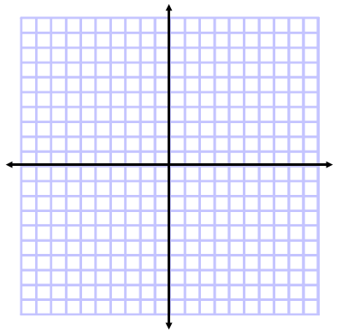
Example: M (4, 7) N (-4, 6) P (-5,-5) Q (6 -5)
When we put a dot to show the location of the ordered
pair, we say we are PLOTTING the ordered pair on the
Cartesian plane.

Complete p,9 #1-5
Complete p.15 #3,4,9
We can draw shapes on the Cartesian plane by joining dots together with lines. and when we do, we make shapes or GEOMETRIC FIGURES on the Cartesian plane. Join the dots you drew above to draw a geometric figure. We call this particular geometric figure a quadrilateral (because it has 4 sides) and its name is quadrilateral MNPQ.
TRANSFORMATIONS
There are 3 ways we can move or TRANSFORM shapes on the Cartesian plane.
We can now move the shape by sliding (translation), spinning (rotation), or reflecting it in a “imaginary mirror” (reflection). When we move the quadrilateral its new name is M’N’P’Q’ and we say “prime” for those small apostrophe marks.
Complete groupwork (p.18 & 19 #1-9) and be ready to present your TRANSLATION, REFLECTION or ROTATION on Tuesday March 11, 2013

