Scientists (2-02)

Match the model(s) with the sentence description of the update from the previous model for each of the following scientists

- ____Democritus, the Greek a) the position of an electron in the electron cloud can be predicted
mathematically
- ____Dalton b) added a positive nucleus to the model due to the bouncing back of
particles from the gold foil
- ____Thomson c) called tiny indivisible particles “atomos” meaning ‘can’t be cut’
- ____Rutherford d) had positive charges but not in a nucleus yet; had negative charges in
his model but not it energy levels yet
- ____Bohr e) similar to Rutherfords model but had the electrons in energy levels
instead of just AROUND the positive nucleus
- ____Quantum Model f) 4 main ideas:
- All matter is made of particles called atoms
- Atoms can’t be made, destroyed, or divided (ie individsible)
- Atoms of the SAME element are the SAME in mass + size; atoms of DIFFERENT elements are DIFFERENT in mass + size
- Compounds are made when atoms of different elements link together in specific ratios (ie water always has 2 hydrogen and 1 oxygen)

- Draw the models of the scientists in the order given above.

- Make a memory strategy to remember the 4 main points of Dalton’s theory.

Grade 9 Science
Chemistry Test Review

Date of test: Given: copy of the periodic table (yellow version)

What to Bring: pencil, calculator, snack for Sandro

You should have already completed a 3-point approach on all vocabulary from the vocabulary list!

Atoms, Elements, and the Periodic Table (2-03)

Write the first 20 elements names and chemical symbols.

What is the definition of atomic number? _____________________________________________________

What other information does it give you about an atom? _________________________________________

What are the units for atomic mass? _________________________________________________________

Why are the atomic masses decimal numbers? _________________________________________________

Bohr Models (2-02, 2-04)

- Complete the chart summarizing information about the subatomic particles.
Here is a word bank to use. Words may be used once, twice, or not at all.
positive, nucleus, 1 atomic mass unit, neutral, atomic number, atomic mass
1/1837th of 1 atomic mass unit, negative, energy level/electron cloud

Subatomic particle | Mass | Charge | Location | How do you find how many of this particle in an atom?
proton
neutron
electron

- True or False
- _______ Atomic mass is a combination of that element’s protons, neutrons and electrons masses.
- _______ An element’s atomic number tells the number of neutrons in atoms of that element.
- _______ Overall, the nucleus of an atom is positive but overall, an atom is neutral.
- _______ Electrons are neutral.
- _______ Neutrons have as much mass as protons.
- _______ Electrons and neutrons are opposite in charge.
- _______ Atomic masses are decimal numbers because not all of the atoms of that element have
the same number of neutrons.
- _______ The atomic number should be subtracted FROM the atomic mass to find the number of
neutrons in an atom.

You should have found 3 false statements above. Rewrite them here correctly.

________________________________________________________________________________________

________________________________________________________________________________________

________________________________________________________________________________________

- Give the maximum number of electrons in each energy level:
1st energy level ________ 2nd energy level ________ 3rd energy level ________________

- Draw Bohr models (without looking at your already-drawn Bohr models) for each element:
sodium chlorine hydrogen argon

5) Choose an element from the periodic table that is between atomic number 1-20. Ensure it is from the alkali metals family. Draw a Bohr diagram of 1 atom of this element. Label the number of all subatomic particles, the chemical symbol, and state the number of valence (outer shell) electrons in the blanks below.

Draw your Bohr Model here:
Protons: ________

Neutrons: ________

Electrons: ________

Valence (outer shell) electrons:________

Symbol: ________

Period:_______

Group:_______

Family Name:________

Physical & Chemical Properties & Changes (2-11, 2-12)

- What is a property of an element?

- What is the difference between a physical property and a chemical property?

- What is the difference between a qualitative physical property and a quantitative physical property?

- List 3 physical properties of playdough. ________________ __________________ ____________________

- List 2 chemical properties of wood _____________________ ________________________________

- Describe the chemical changes you see in the on-line video “Reactions of Lithium, Sodium & Potassium
http://www.youtube.com/watch?v=ZM_qOtV9Iew

- Describe 5 indicators or signs that a chemical change has taken place.

- Each description below involves physical or chemical properties. Use the following word list to fill in the blanks with the number from the list that describes the property in the description.

Before you begin, circle the words that describe chemical properties.

- brittle 2) malleable 3) ductile 4) dense 5) lustrous 6) flammable
- combustible 8) reactive with oxygen when water is present 9) conductive of electricity
10) nonconductive of electricity 11) good heat conductor 12) purple-black in color
13) magnetic

- I twisted a piece of this substance and it broke. _________________________
- I stretched this substance into a long thin wire. __________________________
- The paper caught on fire quite easily __________________________
- When she brought the match close to the barbeque,
the propane that was leaking out of the barbeque
immediately burst into flames _________________________
- The buckle of the belt was very shiny _________________________
- The metal bridge was rusty _________________________
- Sulfur is a yellow nonmetal that cannot light a bulb in a _________________________
circuit
- Iodine is a nonmetal that sublimes directly to a gas from _________________________
solid state
- The fridge magnet sticks to the fridge _________________________

- Identify the following examples as physical or chemical properties, and write the word “chemical” or “physical” in the blank.

_________________1. Lead is a relatively soft metal.

_________________2. Copper wires are good conductors of electricity.

_________________3. An iron nail will rust.

_________________4. Milk of Magnesia neutralizes excess stomach acid.

_________________5. The density of gold is greater than that of silver.

- Identify the following examples as physical or chemical changes, and write the word “chemical” or “physical” in the blank. One of them is not a change but it is a property. Leave it blank.

_________________1. Frying bacon 6. _________________ Dissolving juice crystals in water.

_________________2. Brewing coffee 7. _________________ Density of water is 1 g/cm³

_________________3. Boiling water 8. _________________ Corrosion or rusting

_________________4. Mixing salt and pepper 9. ________________

_________________5. Burning paper

- Each of the following in Column B lists a chemical change. Match the chemical change to the most obvious sign that a chemical reaction has occurred.

Column A Column B

A) _________A new color 1) Rusting of iron to iron oxide
B) ________Heat energy or light energy given off or used 2) Cooking an egg
C) ________Bubbling 3) A yellow precipitate
D) _______ Two liquids are mixed and a solid appears 4) Burning a candle
at the bottom of the test tube
E) _______ Irreversible reaction 5) Vinegar and baking soda

Mendeleev & the Periodic Table (2-06)
- On the following blank periodic table, label the following:
- Alkali metals B) nitrogen family C) alkaline earth metals
D) noble gas family E) Oxygen family (called chalcogens)
F) halogens G) numbers of the periods H) numbers of the groups (1 – 18)

Color or outline or mark the following according to the directions:
metalloids (there are officially 7 in total) PINK
outline of the location of the metals in BLUE
place a * above the family/group that has the most reactive non-metals
place a $ above the family/group that has the most reactive metals
Answer the following:
Which are there more of: metals or non-metals? ______________
Which are there more of: solids, liquids, gases? ______________
(at room temperature)
Which family has elements with 2 valence electrons? ______________
Which group number are the halogens? ______________
Which element would have more energy levels – sodium or lithium? _____________
Where would we find malleable, ductile elements with high electrical
and heat conductivity: the left side or the right side
of the periodic table? ______________
On what property(ies) did Mendeleev organize the periodic table? _____________________
Which property is the table organized with today? ______________

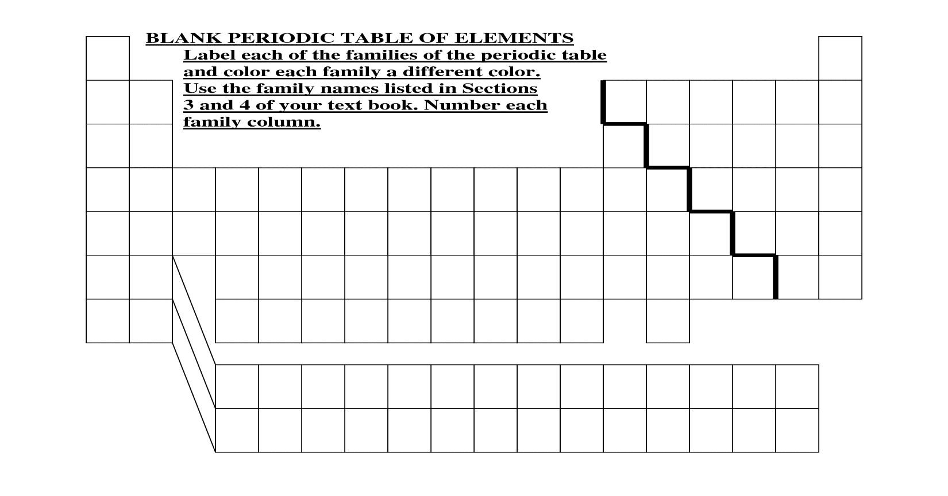

- Summarize 3 patterns in the Bohr models going vertically down a group (family) of the periodic table.

- Summarize 3 patterns in the Bohr models going horizontally across (left to right) a period (row) of the periodic table.

- Find the following information from the periodic table that you will get on the test and exam day:

- atomic mass of nitrogen ________ f) number of neutrons in lithium ______
- number of protons in oxygen ______ g) number of electrons in the third energy level of
argon ______
- atomic number of sodium _______ h) number of total electrons in argon ______
- number of electrons in the first energy i) The number of atomic mass units (amu)
level of argon ______ for sulfur ______
- number of electrons in the second energy j) number of protons in carbon ______
level of argon _____ k) number of electrons in fluorine ______
l) chemical symbol for sodium ______

- The hypothetical element Okenium has 14 protons and 17 neutrons

What is the atomic number of Okenium? ________
What is the atomic mass of Okenium? ________
How many electrons does Okenium have? ________
How many energy levels does Okenium have? ________

