**Grade 9 Science**

**Chemistry Test Review**

Date of test: Given: copy of the periodic table (yellow version)

What to Bring: pencil, calculator, snack for Sandro

You should have already completed a 3-point approach on all vocabulary from the vocabulary list!

**Atoms, Elements, and the Periodic Table** (2-03)

Write the first 20 elements names and chemical symbols.

Please refer to the periodic table for these.

What is the definition of atomic number?

The number of protons in the nucleus of an atom

What other information does it give you about an atom?

It provides you with the number of protons AND since the atom is electrically neutral overall, it also tells you the number of electrons.

What are the units for atomic mass?

The units for atomic mass are a.m.u. (atomic mass units)

Why are the atomic masses decimal numbers?

Atomic mass is the sum of the mass of all subatomic particles in an atom.

(Since the electrons are so small in mass, they can be ignored for the purpose of grade 9 Science)

However, since an element may have more than one ISOTOPE, the masses of all of the isotopes – based on which ones are most common – are averaged and the final result is the value placed on the periodic table.

**Bohr Models** (2-02, 2-04)

1. Complete the chart summarizing information about the subatomic particles.

Here is a word bank to use. Words may be used once, twice, or not at all.

positive, nucleus, 1 atomic mass unit, neutral, atomic number, atomic mass

1/1837th of 1 atomic mass unit, negative, energy level/electron cloudp

|  |  |  |  |  |
| --- | --- | --- | --- | --- |
| Subatomic particle | Mass | Charge | Location | How do you find how many of this particle in an atom? |
| proton | 1 a.m.u. | + | nucleus | Atomic number |
| neutron | 1 a.m.u. | neutral | nucleus | Atomic mass-atomic number |
| electron | 1/1837th a.m.u. | _ | Energy levels | Equal to protons in an atom |

1. True or False
2. TRUE - the electrons do not add much mass but they aren’t excluded in the mass. We can still safely sum protons & neutrons to equal mass.

Atomic mass is a combination of that element’s protons, neutrons and electrons masses.

1. FALSE – it tells us the number if protons

An element’s atomic number tells the number of neutrons in atoms of that element.

1. TRUE Overall, the nucleus of an atom is positive but overall, an atom is neutral.
2. FALSE – electrons are negative

Electrons are neutral.

1. TRUE – both have mass of 1 a.m.u.

Neutrons have as much mass as protons.

1. FALSE – Electrons and Protons are opposite in charge

Electrons and neutrons are opposite in charge.

1. TRUE – Atoms of the same element that have different numbers of neutrons are called ISOTOPES of eachother. The number you see on the periodic table is average atomic mass.It takes into consideration that certain isotopes are more common than the other.

Atomic masses are decimal numbers because not all of the atoms of that element have

the same number of neutrons.

1. TRUE atomic masss- atomic number = number of neutrons in the atom

The atomic number should be subtracted FROM the atomic mass to find the number of

neutrons in an atom.

You should have found 3 false statements above. Rewrite them here correctly.

See above

1. Give the maximum number of electrons in each energy level:

1st energy level 2 electrons

2nd energy level 8 electrons

3rd energy level 18 electrons

1. Draw Bohr models (without looking at your already-drawn Bohr models) for each element:

sodium chlorine hydrogen argon



5) Choose an element from the periodic table that is between atomic number 1-20. Ensure it is from the alkali metals family. Draw a Bohr diagram of 1 atom of this element. Label the number of all subatomic particles, the chemical symbol, and state the number of valence (outer shell) electrons in the blanks below.



**Alkali metals that have atomic numbers between 1-20 are lithium, sodium and potassium**

Draw your Bohr Model here:

Protons: ________



Neutrons: ________



Electrons: ________



Valence (outer shell) electrons:________



Symbol: ________



Period:_______



Group:_______



Family Name:________



**Physical & Chemical Properties & Changes** (2-11, 2-12)

1. What is a **property** of an element?

A property is a physical or chemical description of an element

1. What is the difference between a physical property and a chemical property?

Physical properties are observed without changing the substance into some new substance.

Chemical properties are observed by changing the substance into some new substance.

1. What is the difference between a qualitative physical property and a quantitative physical property?

Qualitative physical properties are measured without numbers

Quantitative physical properties are measured with numbers

1. List 3 physical properties of playdough. malleable, green,
2. List 2 chemical properties of wood burns in oxygen at high enough temperatures,
3. **Describe** the chemical changes you see in the on-line video “Reactions of Lithium, Sodium & Potassium

http://www.youtube.com/watch?v=ZM_qOtV9Iew

Lithium + water 🡪 lithium oxide + hydrogen gas

Li + H2O 🡪 LiO + H2

2 Li + 2 HOH 🡪 2 LiO + H2

Lithium Observations

1. The lithium moves around the surface of the water
2. Steam arises from the sodium.

Conclusion: This is from the heat that is made during the reaction. We can’t feel it from the video

Sodium Observations

1. The sodium moves around the surface of the water
2. The sodium lights on fire

Conclusion: This is because the heat that is made during the reaction ignites the hydrogen gas

1. Describe 5 indicators or signs that a chemical change has taken place.
2. Heat, sound, or light is given off
3. A color change is seen
4. The change is not easily reversed
5. Each description below involves physical or chemical properties. Use the following word list to fill in the blanks with the number from the list that describes the property in the description.

Before you begin, circle the words that describe chemical properties.

1. brittle 2) malleable 3) ductile 4) dense 5) lustrous 6) flammable
2. combustible 8) reactive with oxygen when water is present 9) conductive of electricity

10) nonconductive of electricity 11) good heat conductor 12) purple-black in color

13) magnetic

1. I twisted a piece of this substance and it broke. 1) brittle
2. I stretched this substance into a long thin wire. 3) ductile
3. The paper caught on fire quite easily 7) combustible
4. When she brought the match close to the barbeque,

the propane that was leaking out of the barbeque

immediately burst into flames 6) flammable

1. The buckle of the belt was very shiny 5) lustrous
2. The metal bridge was rusty 8) reactive with oxygen when water is present
3. Sulfur is a yellow nonmetal that cannot light a bulb in a 10) nonconductive of electricity

circuit

1. Iodine is a nonmetal that sublimes directly to a gas from 11) purple-black in color

solid state

1. The fridge magnet sticks to the fridge 13) magnetic
2. Identify the following examples as **physical or chemical properties,** and write the word “chemical” or “physical” in the blank.

Physical 1. Lead is a relatively soft metal.

Physical 2. Copper wires are good conductors of electricity.

Chemical 3. An iron nail will rust.

Chemical 4. Milk of Magnesia neutralizes excess stomach acid.

Physical 5. The density of gold is greater than that of silver.

1. Identify the following examples as **physical or chemical changes,** and write the word “chemical” or “physical” in the blank. One of them is not a change but it is a property. Leave it blank.

Chemical 1. Frying bacon 6. Physical Dissolving juice crystals in water.

Physical 2. Brewing coffee 7. Physical Density of water is 1 g/cm3

Physical 3. Boiling water 8. Chemical Corrosion or rusting

Physical 4. Mixing salt and pepper

Chemical 5. Burning paper

1. Each of the following in Column B lists a chemical change. Match the chemical change to the most obvious sign that a chemical reaction has occurred.

Column A Column B

A) 1 A new color 1) Rusting of iron to iron oxide

B) 4 Heat energy or light energy given off or used 2) Cooking an egg

C) 5 Bubbling 3) A yellow precipitate

D) 3 Two liquids are mixed and a solid appears 4) Burning a candle

at the bottom of the test tube

E) 2 Irreversible reaction 5) Vinegar and baking soda

**Mendeleev & the Periodic Table** (2-06)

1. On the following blank periodic table, label the following:
2. Alkali metals B) nitrogen family C) alkaline earth metals

D) noble gas family E) Oxygen family (called chalcogens)

F) halogens G) numbers of the periods H) numbers of the groups (1 – 18)

Color or outline or mark the following according to the directions:

metalloids (there are officially 7 in total) PINK

outline of the location of the metals in BLUE

place a * above the family/group that has the most reactive non-metals

place a $ above the family/group that has the most reactive metals

Answer the following:

Which are there more of: metals or non-metals? metals

Which are there more of: solids, liquids, gases? solids

(at room temperature)

Which family has elements with 2 valence electrons? Alkaline earth metals

Which group number are the halogens? Group 17

Which element would have more energy levels – sodium or lithium? sodium

Where would we find malleable, ductile elements with high electrical

and heat conductivity: the left side or the right side

of the periodic table? Left side

On what property(ies) did Mendeleev organize the periodic table? Atomic mass and

atomic number

Which property is the table organized with today? Atomic number

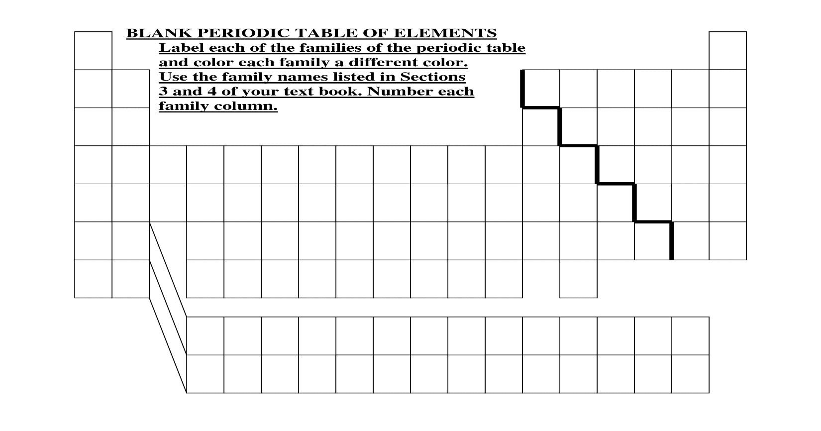

1. Summarize 3 patterns in the Bohr models going vertically down a group (family) of the periodic table.
2. Summarize 3 patterns in the Bohr models going horizontally across (left to right) a period (row) of the periodic table.
3. Find the following information from the periodic table that you will get on the test and exam day:
4. atomic mass of nitrogen ________ f) number of neutrons in lithium ______
5. number of protons in oxygen ______ g) number of electrons in the third energy level of

argon ______

1. atomic number of sodium _______ h) number of total electrons in argon ______
2. number of electrons in the first energy i) The number of atomic mass units (amu)

level of argon ______ for sulfur ______

1. number of electrons in the second energy j) number of protons in carbon ______

level of argon _____ k) number of electrons in fluorine ______

l) chemical symbol for sodium ______

1. The hypothetical element Okenium has 14 protons and 17 neutrons

What is the **atomic number** of Okenium? 14

What is the **atomic mass** of Okenium? 31 a.m.u.

How many **electrons** does Okenium have? 14

How many **energy levels** does Okenium have? 3 energy levels (2,8,4)