Grade 8 Science
Review for Test: Cell Structure, Function & Movement Across the Cell Membrane
Ask questions while you review!!!
Name: Date of test: Thurs Nov 24 for 8-7, Mon Nov 28 for 8-3
What to Bring: pencil, eraser

Topics on the Test:
8 01 Vocabulary - see vocabulary sheet
8 02 Life Functions – MR C GREEN (How do We Know Something is Alive?)
NOTE: C is for CELLS (not circulation). To be alive you must be made of cells. Some small organisms do not have circulation systems so it is not a life function.
8 03, 8 04 Cell Theory
8 05 Cell Structure & Function -animal cell organelles (structures and their functions)
-plant cell organelles (structures and their functions)
-difference between plant and animal cells organelles
8 06 Microscope – name of microscope parts
- total magnification
- field of view
- wet mounts
8 07 3 Types of Movement Across the Cell Membrane
-Diffusion
-Osmosis
-Active Transport
8 09 Specialized Cells (ie nerve cell is shaped like 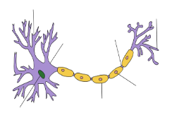so that it can do its function
8 10 Organization of Multicellular Organisms (Cells Tissues Organs Organ Systems)
8 08 Unicellular/Multicellular, 8 20 Similarities and Differences in Living Things
8 14 Respiratory System - Organ Systems Depend on Eachother (respiratory & circulatory)

INQUIRY
*3 types of variables
- controlled
-independent (change on purpose)
-dependent (see the effects of what you changed on purpose)
*how to read and record data in tables
*calculate % change (see labs)

Not as important
8 02 Life Functions 8 03 Cell Theory - 4 ideas 8 04 Cell Theory Development
Format of the Test:
Part A: Knowledge - knowing facts, labelling diagrams, remembering details
Part : Application & Problem Solving - joining ideas together in ways we did not do in class,
thinking “outside the box”

Part C: Scientific Method (how we do Science) & Inquiry
-knowing how we do Science
(hypothesis, designing experiments, measurement using tools like a microscope, calculations,
graphing, analysis, conclusions)

Practice Questions for the Test
These questions do not cover everything we studied. They are only example questions to give you an idea of what questions might be like on the test. You must still study all notes, quizzes, lab reports, calculations, etc. ANYTHING IN THE YELLOW BOOKLET IS ALSO TESTABLE.
Vocabulary (8 01)

Choose the most correct word from the word list below.

unicellular organ multicellular cell tissue

organ system

A group of cells that have the same structure and function __________________

Organisms that are one cell big ________________________

Smallest unit of an organism that can do all of the life functions _________________

Organisms that need specialized cells because they are so big and complex __________________

A group of tissues that work together to perform a certain function ____________________

A group of organs that work together to perform a major function (ie respiratory system)

______________________

Cell Structure & Function (8 05)

- Describe 3 differences and 1 similarity between plant & animal cells by drawing a Venn Diagram below.

- Describe two differences between a cell membrane and a cell wall.

Unicellular/Multicellular (Specialized Cells & Organization) (8 08, 8 09, 8 10)

- List the following in order from smallest to largest and give an example of each: organ, tissue, cell,
organ system

Note: there are only 4 types of tissue: connective, epithelial (skin), nervous, muscular

Smallest Largest

________________ ____________________ _______________ _______________

________________ ____________________ ________________ ______________

- Multicellular organisms are much more complex than unicellular organisms. Their cells need to be specialized.

Give an example of a specialized cell. ______________________________

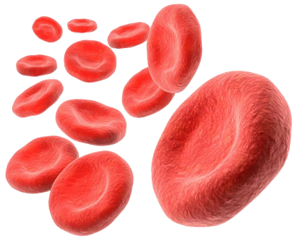
- Different cells have different functions and THEREFORE their structure is different.
Identify the cell illustrated to the right:
a) muscle cells
b) red blood cells
c) nerve cells
d) bone cells

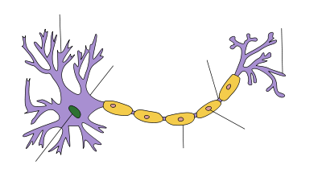
- Refer to the diagram below, which functions below matches its structure?
a) can contract which makes the fibres shorter and causes bones to move.
b) collects calcium from food and allows for growth and repair for bones.
c) protects cells inside and reduces water loss.
d) carries electrical signals to make body parts move.

- A unicellular paramecium might need a semipermeable membrane because

- it might need to bring food inside of itself
- it might need to pump water out of itself
- both of the above

- Which is FALSE? A unicellular paramecium

- has to use any energy to let food diffuse into it
- has to use energy to let water move into it by osmosis
- needs to use energy to move food into it by active transport

- The organism that would be at higher risk of drying out if it had no water in its external environment is a) a multicellular organism
b) a grade 8 bottle flipper
c) a unicellular organism

- Compared to a multicellular organism, a unicellular organism
- has an easier time diffusing oxygen in and out of its internal environment.
- has a more difficult time diffusing oxygen into its cells.
Respiratory System (8 14)
Write the letter of the word in Column 2 on the blank beside its function in Column 1.
Column 1 | Column 2
____ 1. Small air sacs at the tips of bronchiole tubes  which exchange CO₂ and O₂ | - trachea
____ 2. The tube(s) that carries air from your nose/mouth  to your lungs | - bronchi  - lungs
____ 3. Spongy, pink-colored organs of the respiratory system | - esophagus
____ 4. The tube(s) that carry (ies) your food from your  mouth to your stomach  ____ 5. The tube(s) that carry(ies) oxygen and carbon dioxide  from the end of your trachea to your lungs  ____ 6. Small blood vessels that surround your alveoli and help  exchange CO₂ and O₂ | - alveoli  - capillaries
INQUIRY

The table below shows the results of an experiment to find the effect of osmosis on potato cells.
- One cube of a potato was massed and placed in 500 mL of distilled water.
- One cube of a potato was massed and placed in 500 mL of water with 100 mL of salt added to the solution.
- One cube of a potato was weighed and placed in 500 mL of water with 300 mL of salt added to the solution.
Time (minutes) | Beaker 1  Distilled Water | Beaker 2  (500 mL & 100 mL) | Beaker 3  (500 mL & 300 mL)
0 | 52 grams | 59 grams | 60 grams
15 | 52 grams | 58 grams | 58 grams
30 | 53 grams | 54 grams | 55 grams
45 | 54 grams | 53 grams | 51 grams
60 | 55 grams | 50 grams | 49 grams

- What are the independent, dependent and controlled variables in this experiment?
i. Independent variable ____________________________________________
ii. Dependent variable _____________________________________________
iii. Controlled variable ______________________________________________
- What has happened to the mass of the potato in water? _____________________________
(use proper vocabulary)

Why? ______________________________________________________________________

What has happened to the mass of the potato in salt solution? ________________________
(use proper vocabulary)

Why? ________________________________________________________________________
Variables
For each of the following, identify
*2 controlled variables (to keep the experiment fair)
*independent variable
*dependent variable
Cell Parts and Their Functions (Jobs) (8 05)
- Is the diagram below a plant cell or animal cell? __________________________

- What is an organelle? (do not just give an example of one. Give a definition when asked to describe what something is) _______________________________________________________________________

- Why does a plant cell need a chloroplast with chlorophyll in it? Be specific and use proper vocabulary.

- Write the letter of the organelle in Column 2 on the blank beside its function in Column 1.

Column 1 | Column 2
____ 1. Makes energy in the cell. | - cell membrane
____ 2. Responsible for directing all the cell’s activities | - cell wall
____ 3. Breaks down food and old cell parts. | - chloroplast
____ 4. Sac-like structure; stores water, nutrients, and wastes | - cytoplasm
____ 5. Photosynthesis occurs in this green plant organelle | - endoplasmic reticulum
____ 6. Jellylike substance that surrounds all the organelles | - golgi body
____ 7. A selectively permeable covering for the cell which  holds the cell contents and allows nutrients and  wastes to flow in or out of the cell | - lysosome
____ 8. Packaging center for the cell | - mitochondria
____ 9. Made of cellulose and helps provide rigidity to the cell | - nucleus
____ 10. Tube-like system that transports nutrients within  cells | - vacuole

- Label each letter of the diagram. Describe the job (function) of each organelle IN YOUR OWN WORDS before you peek at the previous page.
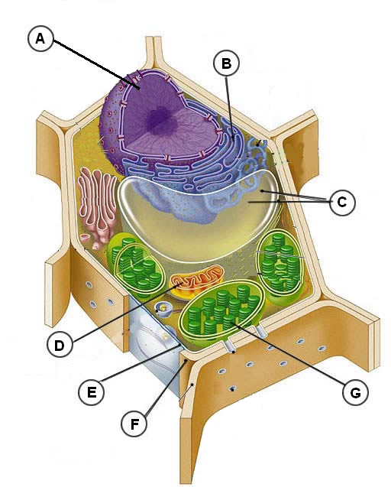
A

B

C

D

E

F

G
Would
You
also
know
the
animal
cell?

- Types of Transport Across Membranes

- Name 3 types of membranes. Give an example of each.

- Why do grocery stores spray their fresh vegetables with water?

- One remedy for a leech (bloodsucker) on your skin is to pour salt on it. Why does a leech shrivel up if you pour salt on it?

- Cut out the following and paste them under the appropriate heading in the Venn Diagram on the large paper.

Requires energy

Movement of particles (not water) from
high to low concentration

Requires carrier proteins

(large green colorful blobs you drew on your cell membrane diagram)

Movement of particles OF water from high to low concentration

Movement of particles from low to high concentration

Cell does not “spend” energy on this process;
it happens spontaneously (naturally)

Moves particles (but not water) in and out of cells

Used to remove extra water stored in vacuoles

