Seriously… Another Grade 7 Math Test Review? (Test #7)
Review B-1,

B-1: Students will be able to add and subtract integers.

1. Evaluate the following:
a) (-14) + ____ = (-5) b) (-4) + ____ = (-31)

c) ____ + (+17) = (+4) d) ____ + (-4) = (-4)

e) (-20) - ____ = (-14) f) (-6) - ____ = (-2)

g) ____ - (+7) = (-13) h) ____ - (-3) = (-15)

For each of the word problems below, show how you determined each answer.
2. The sum of two integers is (-2). The differences are (-8) and (+8). What are the two integers? Show your thinking.

3. A submarine is situated 800 metres below sea level. If it ascends 250 metres, how far below the surface of the will the submarine be located?

4. A football team moves six yards forward on its first down. It loses fifteen yards on the next down. How far forward will they have to move the ball in order to be ten yards ahead of where they started?

5. The temperature in the Sahara Desert was 58$°$ C during the day. The temperature in the Gobi Desert was -46$°$ at night. What is the difference between these two temperatures?

6. Tyler and Christina are playing a game in which each player wins, loses or draws (ties) at each turn. The winner of a turn is awarded 5 points, and the loser loses 5 points. If it is a draw, 0 points are awarded. For the first eight rounds Tyler had the following results: lose, win, lose, win, win, lose, win, and draw. What was Christina's point total for the rounds?

7. Courtney is very interested in cryogenics (the science of very low temperatures). With the help of her science teacher she is doing an experiment on the effect of low temperatures on bacteria. She cools one sample of bacteria to a temperature of -58°C and another to -85°C. What was the temperature difference in the two experiments?

C-1: Students will be able to identify and plot ordered pairs on a Cartesian plane.

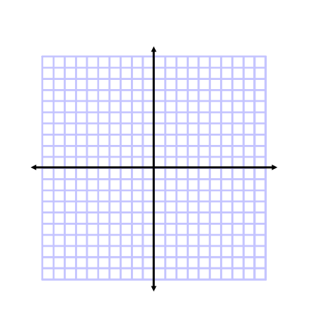
- On the grid below, label the following:

- x-axis
- y-axis
- origin
- quadrant I
- quadrant II
- quadrant III
- quadrant IV

- Plot and label the following points on the following grid:
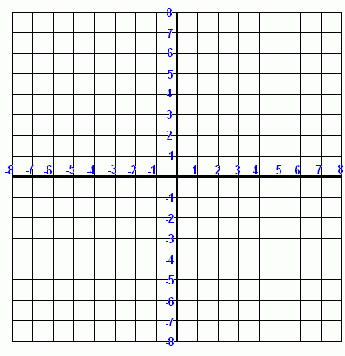

A (-4,-3)

B (6, 2)

C (-5, 8)

D (2, -5)

E (0, 0 )

F (0, 7)

G (3, 0)

- Give the coordinates for each point on the following grid:

A ( ____ , ____ ) D ( ____ , ____ ) G ( ____ , ____ )

B ( ____ , ____ ) E ( ____ , ____ ) H ( ____ , ____ )

C ( ____ , ____ ) F ( ____ , ____ ) I ( ____ , ____ )

A

C

B
D
G
F
E

I
H

- Points A and C below are the vertices of a rectangle. Plot and label the points. Find the coordinates of the final two points to complete the rectangle.

A ( 2, 3 ) B ( ____ , ____ ) C ( -5, -6 ) D ( , )

- On the grid below. Plot, label and connect four points to create a perfect square. Your square must have coordinates in each of the four quadrants.

A ( ____ , ____ ) B ( ____ , ____ ) C ( ____ , ____ ) D ( ____ , ____)

D-1: Students will be able to continue and explain a pattern as a relation.

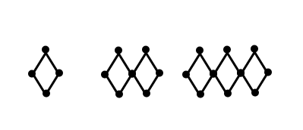
1. Given the following pattern:

Term 1 Term 2 Term 3 Term 4 Term 5

a) Draw the 4th and 5th terms.

b) Complete the table of values. c) Describe the pattern in words.

Term  Number | Number of Dots

d) Create a graph for the pattern.

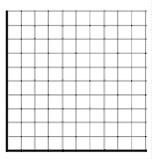

e) Write an algebraic expression for
the pattern.

f) Predict the number of dots in the
15th term. Explain how you know!

g) Which term will have 151 dots? Explain how you know!

2. Given the following pattern:

Term 5

a) Draw the 5th term.

b) Complete the table of values. c) Describe the pattern in words.

Term  Number | Number of Line Segments

d) Create a graph for the pattern.

e) Write an algebraic expression for
the pattern.

f) Predict the number of line segments in the
22th term. Explain how you know!

g) Which term will have 201 line segments? Explain how you know!

3. Write a relation (algebraic expression) to describe the pattern in each table of values.

a) b) c)

Term  Number | Number of Dots
1 | 0
2 | 3
3 | 6
4 | 9
5 | 12
Term  Number | Number of Dots
1 | 6
2 | 11
3 | 16
4 | 21
5 | 26
Term  Number | Number of Dots
1 | 7
2 | 9
3 | 11
4 | 13
5 | 15

__________________ __________________ __________________

4. Match each pattern with the algebraic expression that represents the number of squares in the n^{th}
term.

Pattern Expression

a) i) 4n

b) ii) 3n + 1

c) iii) 2n + 1

d) iv) 2n - 1

5. a) Complete the table of values.

Term  Number | Number of Dots
1
2 | 10
3
4 | 16
5
6 | 22
b) Write an equation that shows the relationship
between the term number “n” and the number
of dots (d)

d = _______________

c) How many dots will be in the 25th term? Show how you
know.

6. a) Make a table of values to show the relationship between the number of triangles and the number
of squares.

b) Write the equation that shows how to get the number of squares “s” from the number of
triangles “t”.

s = ___________

c) How many squares will there be if there are 40 triangles? Show how you know.

7. Emily sells bracelets at a booth in St. Vital mall. She earns $25 a day plus $2 for each bracelet that
she sells.

a) Create a table of values to show Emily’s daily earnings when she sells 0, 1, 2, 3, 4 and 5 bracelets.

b) Write an expression to describe Emily’s daily earnings.

c) On Monday Emily sold 17 bracelets, how much were her daily earnings? Show how you know.

8. The cost to rent skates is $3, plus $2 per hour.

a) Write an expression that shows the cost to rent skates for any number of hours.

b) Use that expression to determine the cost to rent skates for 8 hours.

9. A student company charges a $5 flat fee plus $3 per window to wash windows.

a) Write an equation that represents the cost of washing any number of windows.

b) How much more would someone pay to have 35 windows washed than 24 windows?

c) Might someone have to pay exactly $87 to have their windows washed? Explain.

D-2: From a relation, students will be able to construct a table of values, graph and analyze it.

1. a) Complete the table of values for b) Create a graph for the table of values.
the given values of d.

$$d$$ | $$4d + 2$$
1
2
3
4
5
6

2. Which set of numbers does not belong in the table of values? Explain.

$$n$$ | $$2n + 3$$
1 | 5
2 | 7
5 | 13
8 | 18
10 | 23
15 | 33

3. If $"p"$ is an odd number, is $5p -3$odd or even? Explain.

4. Explain and correct any errors in the solution.

Question: Simplify $4n – n$, if $n=3$

Solution: $4n – n = 4(3) – 3$
$= 4\left(0\right)$
$= 0$

5. Match each graph to its relation. Draw lines to connect the correct relation to its graph.

$y = x + 3$ $y = 2x + 4$ $y = 2x$
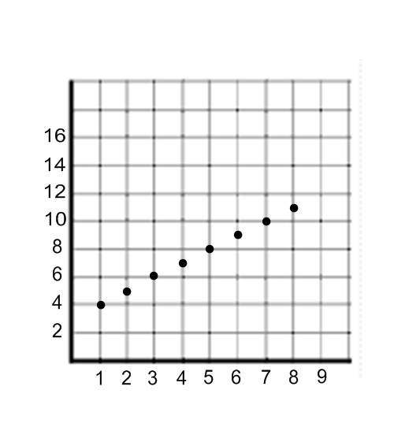
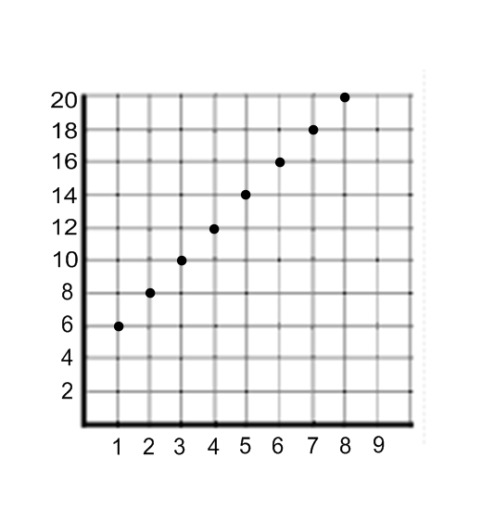
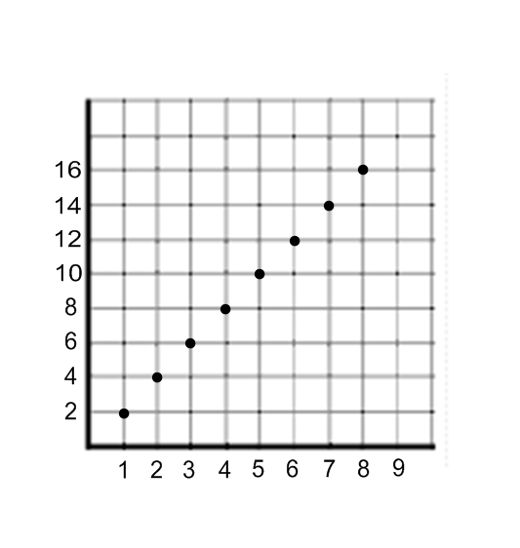

6. Graph these linear relations on the same set of axes. Use a different colour for each relation.

a) $y = n + 2$
b) $y = 2n + 2$

c) $y = 3n + 2$

